**Internship Report**

Development of an Android Application for ordering online snacks, Tea, Coffees, Cookies etc named as

*“****Yaari Dostea Cafe***”



**Computer Engineering Section**

**University Polytechnic, Faculty of Engineering and Technology**

**Jamia Millia Islamia (A Central University)**

**New Delhi-110025**

**Submitted By:** **Submitted To:**

Mohd Arifullah Mr. Sunil

16DCS034 Assistant Professor

Serial No:32 Computer Engg. section

University Polytechnic University Polytechnic

Table of Contents

1. **What is Android?**

**Dalvik Virtual Machine and Android Applications**

**Android Structure,Java and Xml**

**Android Versions**

1. **The Development Environment**

**Android SDK**

**Android Studio**

**Android Virtual Device**

1. **Hello World Application**
2. **Working With Button**
3. **Toast**
4. **Snackbar**
5. **CheckBox**
6. **Alert Dialog**
7. **WebView**
8. **Spinner**
9. **AutoComplete TextView**
10. **TimePicker**
11. **Rating Bar**
12. **Date Picker**
13. **EditText**
14. **TextView**
15. **ImageView**
16. **Progress bar**

***Final Project***

Introduction to Android Development



Whats is Android ?

Android is an open source and Linux-based **Operating System** for mobile devices such as smartphones and tablet computers. Android was developed by the *Open Handset Alliance*, led by Google, and other companies.

Android offers a unified approach to application development for mobile devices which means developers need only develop for Android, and their applications should be able to run on different devices powered by Android.

The first beta version of the Android Software Development Kit (SDK) was released by Google in 2007 where as the first commercial version, Android 1.0, was released in September 2008.

On June 27, 2012, at the Google I/O conference, Google announced the next Android version, 4.1 **Jelly Bean**. Jelly Bean is an incremental update, with the primary aim of improving the user interface, both in terms of functionality and performance.

The source code for Android is available under free and open source software licenses. Google publishes most of the code under the Apache License version 2.0 and the rest, Linux kernel changes, under the GNU General Public License version 2.

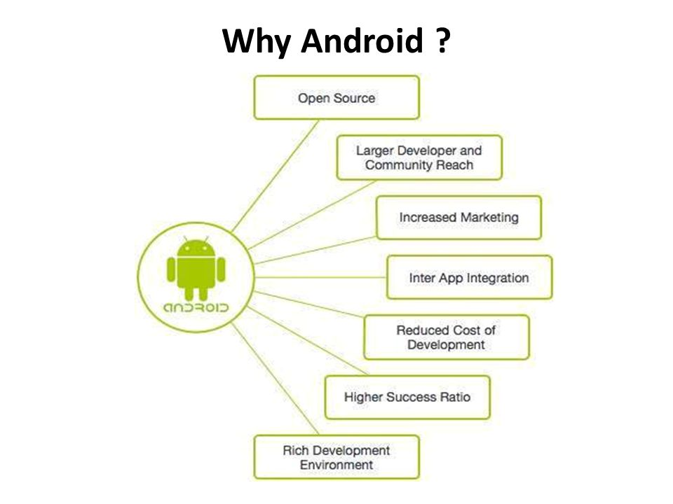

## Features of Android

Android is a powerful operating system competing with Apple 4GS and supports great features. Few of them are listed below −

## Android Applications

Android applications are usually developed in the Java language using the Android Software Development Kit.

Once developed, Android applications can be packaged easily and sold out either through a store such as **Google Play**, **SlideME**, **Opera Mobile Store**, **Mobango**, **F-droid** and the **Amazon Appstore**.

Android powers hundreds of millions of mobile devices in more than 190 countries around the world. It's the largest installed base of any mobile platform and growing fast. Every day more than 1 million new Android devices are activated worldwide.



## History of Android

The code names of android ranges from A to N currently, such as Aestro, Blender, Cupcake, Donut, Eclair, Froyo, Gingerbread, Honeycomb, Ice Cream Sandwitch, Jelly Bean, KitKat, Lollipop and Marshmallow. Let's understand the android history in a sequence.

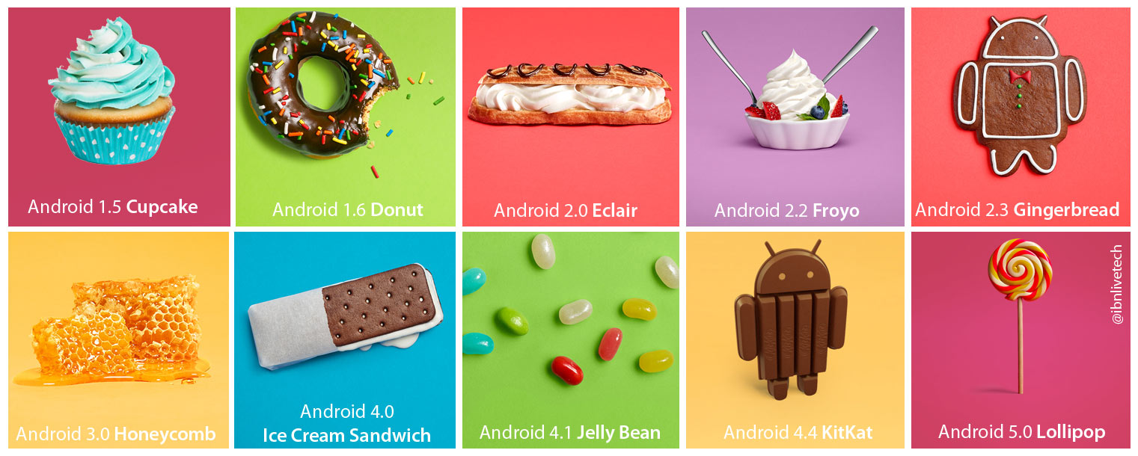

## What is API level?

API Level is an integer value that uniquely identifies the framework API revision offered by a version of the Android platform.

|  |  |  |
| --- | --- | --- |
| |  | | --- | |  |  |  | | --- | |  |   **Dalvik Virtual Machine | DVM**  As we know the modern JVM is high performance and provides excellent memory management. But it needs to be optimized for low-powered handheld devices as well.  The **Dalvik Virtual Machine (DVM)** is an android virtual machine optimized for mobile devices. It optimizes the virtual machine for memory, battery life and performance.  Dalvik is a name of a town in Iceland. The Dalvik VM was written by Dan Bornstein.  The Dex compiler converts the class files into the .dex file that run on the Dalvik VM. Multiple class files are converted into one dex file.  Let's see the compiling and packaging process from the source file:  Dalvik Virtual Machine Flow  The **javac tool** compiles the java source file into the class file.The **dx tool** takes all the class files of your application and generates a single .dex file. It is a platform-specific tool.The **Android Assets Packaging Tool (aapt)** handles the packaging process.  KNOWINNG ANDROID  We will start our Android application development on any of the following operating systems  : Microsoft Window XP or later version.  Mac OS X 10.5.8 or later version with Intel chip  Linux including GNU Library with Intel chip.  **Android App Development**  Android app is a combination of different source code in a single place whose action can be performed just by a single touch. Example:- Suppose if we want to add two no’s then we just have to click on the calculator app and enter two no’s and the operand that we have to perform. It makes our work much easier and this are much user friendly. So what happen ? How it calculated the answer. Android programming is based on java programming language so if we have basic understanding on Java programming then it will be a fun to study Android app development.  **Java in Android App Development.**  Java is a programming language that doesn’t compile to native processor code but rather it refers to virtual machine which understands an intermediate format i.e; java byte-code. Each platform that uses java to run needs a virtual device. An android app uses a android application that runs on android platform. It build on custom virtual machine that gives its user the addition usage and application power and a user friendly environment. Android actual virtual machine is called Dalvik.  **Android Software Development Kit(Android SDK) :**  Apps that extend the functionality of device is written using Android SDK and often using java programming language.The SDK includes a set of development tools, including a debugger, software libraries,a handset emulator, sample code, etc. Initially Google supported Integrated Development Environment(IDE) i.e; Eclipse using the Android Development Tools(ADT) plugins. Other development tools are also available such as Native Development Kit(NDK). Android Studio that is based on Intellij IDEA developed by Google as its primary IDE for android app development. Android is a selection of third-party application which can be acquired by users by downloading and installing the Android Application Package (APK) file.  **Android Application :**  They are generally developed in the java language using the Android SDK Android applications can be packaged easily and sold out either through a store such as Google play ,etc. There are many android applications that we already know and uses them few are music, news ,weather, etc Many android application are also available for free most of them are already available in play store. This apps are compatible with almost every platform but few are also available for the specific platform. |

## Basic Android project structure

Every Android project contains several folders:

1. *src*: This folder contains the Java source files.
2. *gen*: Generated Java library, this library is for Android internal use only.
3. *Res*: Here we can store resource files such as pictures, XML files for defining layouts, and so forth. Within this folder there are additional folders such as *Drawable*, *Layout*, and *Values*.
4. *Drawable*: Here we store the various graphic files. We can see three types of drawable folders. This is because there are many Android devices with different screen resolutions. By default, there are several versions of this folder such as: *Drawable-mdpi*, *drawable-hdpi*, and so forth. This is required in order to adapt to different screen resolutions.
5. *Layout*: This is the place for XML layout files. Layout files are XML files which define how various Android objects (such as textboxes, buttons, etc.) are organized on the screen.
6. *Values*: XML files which store various string values (titles, labels, etc.).

**Major files in the Android project:**

* *AndroidManifest.xml*: This is the Android definition file. It contains information about the Android application such as minimum Android version, permission to access Android device capabilities such as internet access permission, ability to use phone permission, etc.
* *main_activity.xml*: This file describes the layout of the page. This means the placement of every component (such as textboxes, labels, radio buttons, user defined components, etc.) on the app screen.
* *MainActivity.class*: Every application that occupies the entire device screen needs at least one class which inherits from the Activity class. One major method is called OnCreate. This method initiates the app and loads the layout page.

**Android Manifest File**

|  |
| --- |
| <?xml version="1.0" encoding="utf-8"?>  <manifest xmlns:android=<http://schemas.android.com/apk/res/android>  package="com.example.mohdarif.myapp">  <application android:allowBackup="true android:icon="@mipmap/ic_launcher  android:label="@string/Apps"  android:roundIcon="@mipmap/ic_launcher_round"  android:supportsRtl="true"  android:theme="@style/AppTheme">  <activity android:name=".MainActivity">  <intent-filter>  <action android:name="android.intent.action.MAIN" />  <category android:name="android.intent.category.LAUNCHER" />  *</intent-filter>* *</activity>* *</application>**</manifest>* |

**Main_activity.xml**

|  |
| --- |
| <?xml version="1.0" encoding="utf-8"?>  <android.support.constraint.ConstraintLayoutxmlns:android="http://schemas.android.com/apk/res/android"  xmlns:app="http://schemas.android.com/apk/res-auto"  xmlns:tools="http://schemas.android.com/tools" |
| android:layout_width="match_parent"  android:layout_height="match_parent"  tools:context=".MainActivity">  <TextView  android:layout_width="match_parent"  android:layout_height="match_parent"  android:text=" "  app:layout_constraintBottom_toBottomOf="parent"  app:layout_constraintLeft_toLeftOf="parent"  app:layout_constraintRight_toRightOf="parent"  app:layout_constraintTop_toTopOf="parent" />  </android.support.constraint.ConstraintLayout> | | |

**MainActivity.java**

|  |
| --- |
| package com.example.mohdarif.myapp1;  import android.support.v7.app.AppCompatActivity;  import android.os.Bundle;  public class MainActivity extends AppCompatActivity {  @Override  protected void onCreate(Bundle savedInstanceState) {  super.onCreate(savedInstanceState);  setContentView(R.layout.activity_main); } } |

Starting with Android Studio

Android Studio is the official Integrated Development Environment (IDE) for Android app development, based on[IntelliJ IDEA](https://www.jetbrains.com/idea/). On top of IntelliJ's powerful code editor and developer tools, Android Studio offers even more features that enhance your productivity when building Android apps, such as:

* A flexible Gradle-based build system
* A fast and feature-rich emulator
* A unified environment where you can develop for all Android devices
* Instant Run to push changes to your running app without building a new APK
* Code templates and GitHub integration to help you build common app features and import sample code
* Extensive testing tools and frameworks
* Lint tools to catch performance, usability, version compatibility, and other problems
* C++ and NDK support
* Built-in support for [Google Cloud Platform](https://cloud.google.com/tools/android-studio/docs/), making it easy to integrate Google Cloud Messaging and App Engine

**Project structure**

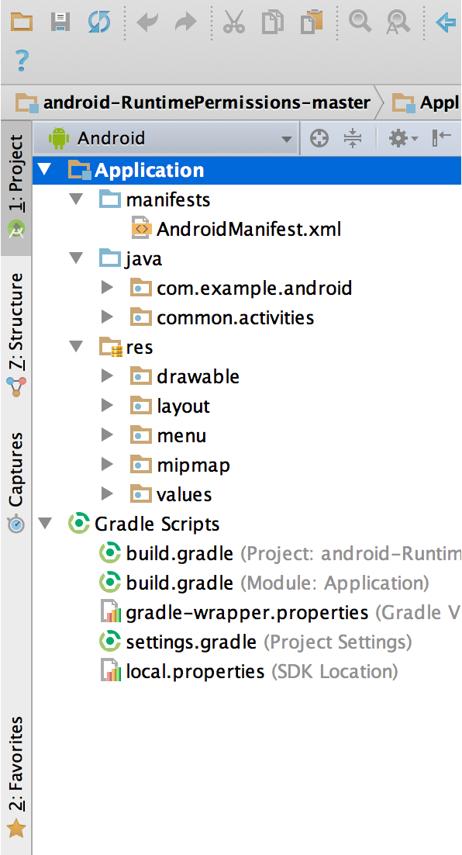

Each project in Android Studio contains one or more modules with source code files and resource files. Types of modules include:

* Android app modules
* Library modules
* Google App Engine modules

By default, Android Studio displays your project files in the Android project. This view is organized by modules to provide quick access to your project's key source files.

All the build files are visible at the top level under **Gradle Scripts**and each app module contains the following folders:

* **manifests**: Contains the AndroidManifest.xml file.
* **java**: Contains the Java source code files, including JUnit test code.
* **res**: Contains all non-code resources, such as XML layouts, UI strings, and bitmap images.

The Android project structure on disk differs from this flattened representation. To see the actual file structure of the project, select **Project** from the **Project** dropdown (in figure 1, it's showing as **Android**).

You can also customize the view of the project files to focus on specific aspects of your app development. For example, selecting the **Problems** view of your project displays links to the source files containing any recognized coding and syntax errors, such as a missing XML element closing tag in a layout file.

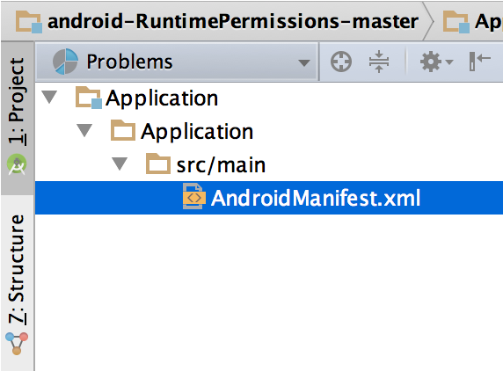

**The user interface**

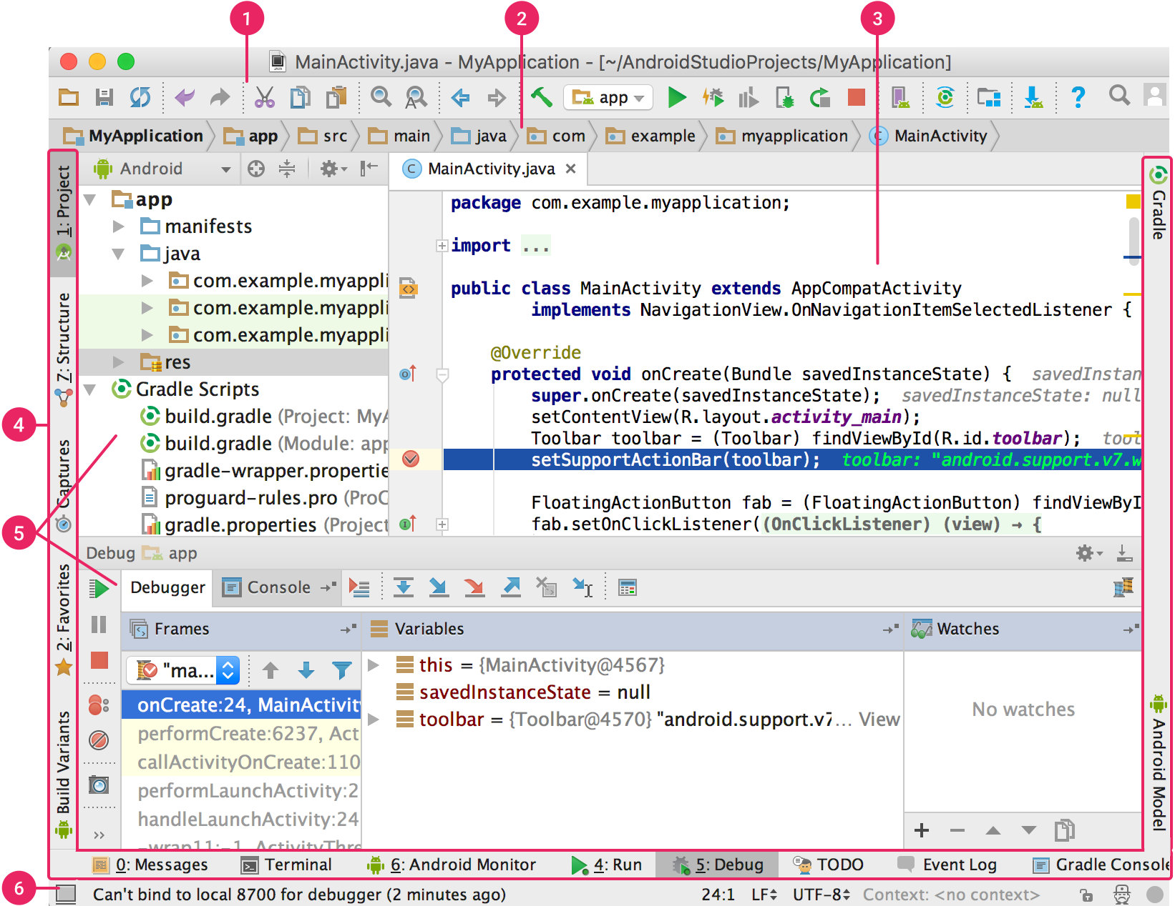

1. The **toolbar** lets you carry out a wide range of actions, including running your app and launching Android tools.
2. The **navigation bar** helps you navigate through your project and open files for editing. It provides a more compact view of the structure visible in the **Project** window.
3. The **editor window** is where you create and modify code. Depending on the current file type, the editor can change. For example, when viewing a layout file, the editor displays the Layout Editor.
4. The **tool window bar** runs around the outside of the IDE window and contains the buttons that allow you to expand or collapse individual tool windows.
5. The **tool windows** give you access to specific tasks like project management, search, version control, and more. You can expand them and collapse them.
6. The **status bar** displays the status of your project and the IDE itself, as well as any warnings or messages.

You can organize the main window to give yourself more screen space by hiding or moving toolbars and tool windows. You can also use keyboard shortcuts to access most IDE features.

At any time, you can search across your source code, databases, actions, elements of the user interface, and so on, by double-pressing the Shift key, or clicking the magnifying glass in the upper right-hand corner of the Android Studio window. This can be very useful if, for example, you are trying to locate a particular IDE action that you have forgotten how to trigger.

**Tool windows**

Instead of using preset perspectives, Android Studio follows your context and automatically brings up relevant tool windows as you work. By default, the most commonly used tool windows are pinned to the tool window bar at the edges of the application window.

* To expand or collapse a tool window, click the tool’s name in the tool window bar. You can also drag, pin, unpin, attach, and detach tool windows.
* To return to the current default tool window layout, click **Window > Restore Default Layout** or customize your default layout by clicking **Window > Store Current Layout as Default**.
* To show or hide the entire tool window bar, click the window icon  in the bottom left-hand corner of the Android Studio window.
* To locate a specific tool window, hover over the window icon and select the tool window from the menu.

You can also use keyboard shortcuts to open tool windows. Table 1 lists the shortcuts for the most common windows.

If you want to hide all toolbars, tool windows, and editor tabs, click **View > Enter Distraction Free Mode**. This enables Distraction Free Mode. To exit Distraction Free Mode, click **View > Exit Distraction Free Mode**.

You can use Speed Search to search and filter within most tool windows in Android Studio. To use Speed Search, select the tool window and then type your search query.

.**Code completion**

Android Studio has three types of code completion, which you can access using keyboard shortcuts.

You can also perform quick fixes and show intention actions by pressing **Alt+Enter**.

**Find sample code**

The Code Sample Browser in Android Studio helps you find high-quality, Google-provided Android code samples based on the currently highlighted symbol in your project. For more information, see [Find sample code](https://developer.android.com/studio/write/sample-code.html).

**Navigation**

Here are some tips to help you move around Android Studio.

* Switch between your recently accessed files using the Recent Files action. Press **Control+E** (**Command+E** on a Mac) to bring up the Recent Files action. By default, the last accessed file is selected. You can also access any tool window through the left column in this action.
* View the structure of the current file using the File Structure action. Bring up the File Structure action by pressing **Control+F12** (**Command+F12** on a Mac). Using this action, you can quickly navigate to any part of your current file.
* Search for and navigate to a specific class in your project using the Navigate to Class action. Bring up the action by pressing **Control+N** (**Command+O** on a Mac). Navigate to Class supports sophisticated expressions, including camel humps, paths, line navigate to, middle name matching, and many more. If you call it twice in a row, it shows you the results out of the project classes.
* Navigate to a file or folder using the Navigate to File action. Bring up the Navigate to File action by pressing **Control+Shift+N** (**Command+Shift+O** on a Mac). To search for folders rather than files, add a / at the end of your expression.
* Navigate to a method or field by name using the Navigate to Symbol action. Bring up the Navigate to Symbol action by pressing **Control+Shift+Alt+N** (**Command+Option+O** on a Mac).
* Find all the pieces of code referencing the class, method, field, parameter, or statement at the current cursor position by pressing **Alt+F7** (**Option+F7** on a Mac).

Style and formatting

As you edit, Android Studio automatically applies formatting and styles as specified in your code style settings. You can customize the code style settings by programming language, including specifying conventions for tabs and indents, spaces, wrapping and braces, and blank lines. To customize your code style settings, click **File > Settings > Editor > Code Style** (**Android Studio > Preferences > Editor > Code Style** on a Mac.)

Although the IDE automatically applies formatting as you work, you can also explicitly call the Reformat Codeaction by pressing **Control+Alt+L** (**Opt+Command+L** on a Mac), or auto-indent all lines by pressing **Control+Alt+I**(**Control+Option+I** on a Mac).

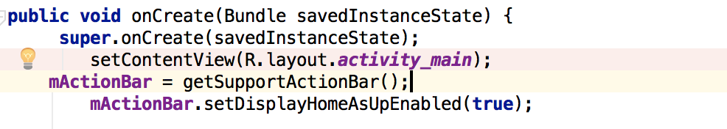

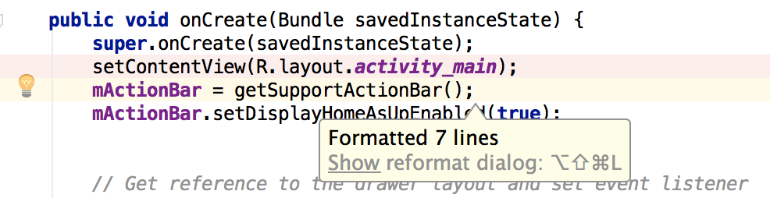

**Version control basics**

Android Studio supports a variety of version control systems (VCS’s), including Git, GitHub, CVS, Mercurial, Subversion, and Google Cloud Source Repositories.

After importing your app into Android Studio, use the Android Studio VCS menu options to enable VCS support for the desired version control system, create a repository, import the new files into version control, and perform other version control operations:

1. From the Android Studio **VCS** menu, click **Enable Version Control Integration**.
2. From the drop-down menu, select a version control system to associate with the project root, and then click **OK**.

The VCS menu now displays a number of version control options based on the system you selected.

**Note:** You can also use the **File > Settings > Version Control** menu option to set up and modify the version control settings.

**Gradle build system**

Android Studio uses Gradle as the foundation of the build system, with more Android-specific capabilities provided by the [Android plugin for Gradle](https://developer.android.com/studio/releases/gradle-plugin.html). This build system runs as an integrated tool from the Android Studio menu, and independently from the command line. You can use the features of the build system to do the following:

* Customize, configure, and extend the build process.
* Create multiple APKs for your app, with different features using the same project and modules.
* Reuse code and resources across sourcesets.

By employing the flexibility of Gradle, you can achieve all of this without modifying your app's core source files. Android Studio build files are named build.gradle. They are plain text files that use [Groovy](http://groovy-lang.org/) syntax to configure the build with elements provided by the Android plugin for Gradle. Each project has one top-level build file for the entire project and separate module-level build files for each module. When you import an existing project, Android Studio automatically generates the necessary build files.

**Build variants**

The build system can help you create different versions of the same application from a single project. This is useful when you have both a free version and a paid version of your app, or if you want to distribute multiple APKs for different device configurations on Google Play.

**Multiple APK support**

Multiple APK support allows you to efficiently create multiple APKs based on screen density or ABI. For example, you can create separate APKs of an app for the hdpi and mdpi screen densities, while still considering them a single variant and allowing them to share test APK, javac, dx, and ProGuard settings..

**Resource shrinking**

Resource shrinking in Android Studio automatically removes unused resources from your packaged app and library dependencies. For example, if your application is using [Google Play services](https://developers.google.com/android/guides/overview) to access Google Drive functionality, and you are not currently using [Google Sign-In](https://developer.android.com/training/sign-in/index.html), then resource shrinking can remove the various drawable assets for theSignInButton buttons..

**Managing dependencies**

Dependencies for your project are specified by name in the build.gradle file. Gradle takes care of finding your dependencies and making them available in your build. You can declare module dependencies, remote binary dependencies, and local binary dependencies in your build.gradle file. Android Studio configures projects to use the Maven Central Repository by default. (This configuration is included in the top-level build file for the project.) For more information about configuring dependencies, read [Add build dependencies](https://developer.android.com/studio/build/dependencies.html).

**Debug and profile tools**

Android Studio assists you in debugging and improving the performance of your code, including inline debugging and performance analysis tools.

**Inline debugging**

Use inline debugging to enhance your code walk-throughs in the debugger view with inline verification of references, expressions, and variable values. Inline debug information includes:

* Inline variable values
* Referring objects that reference a selected object
* Method return values
* Lambda and operator expressions
* Tooltip values

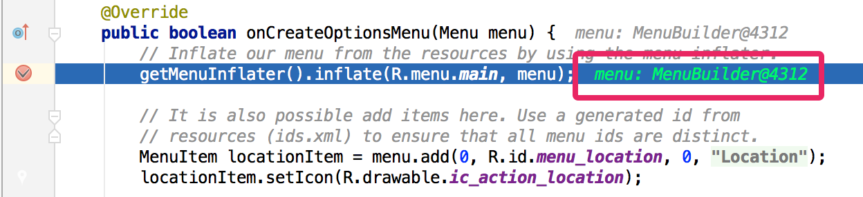To enable inline debugging, in the **Debug** window, click **Settings** and select the checkbox for **Show Values Inline**.

**Performance profilers**

Android Studio provides performance profilers so you can more easily track your app’s memory and CPU usage, find deallocated objects, locate memory leaks, optimize graphics performance, and analyze network requests. With your app running on a device or emulator, open the **Android Profiler** tab.

**Heap dump**

When you’re profiling memory usage in Android Studio, you can simultaneously initiate garbage collection and dump the Java heap to a heap snapshot in an Android-specific HPROF binary format file. The HPROF viewer displays classes, instances of each class, and a reference tree to help you track memory usage and find memory leaks.

**Memory Profiler**

You can use Memory Profiler to track memory allocation and watch where objects are being allocated when you perform certain actions. Knowing these allocations enables you to optimize your app’s performance and memory use by adjusting the method calls related to those actions.

.**Data file access**

The Android SDK tools, such as [Systrace](https://developer.android.com/studio/profile/systrace-commandline.html), and [logcat](https://developer.android.com/studio/debug/am-logcat.html), generate performance and debugging data for detailed app analysis.

To view the available generated data files, open the Captures tool window. In the list of the generated files, double-click a file to view the data. Right-click any .hprof files to convert them to the standard [Investigate your RAM usage](https://developer.android.com/studio/profile/investigate-ram.html) file format.

**Code inspections**

Whenever you compile your program, Android Studio automatically runs configured [Lint](https://developer.android.com/studio/write/lint.html) and other [IDE inspections](https://www.jetbrains.com/help/idea/2017.3/code-inspection.html) to help you easily identify and correct problems with the structural quality of your code.

The Lint tool checks your Android project source files for potential bugs and optimization improvements for correctness, security, performance, usability, accessibility, and internationalization.

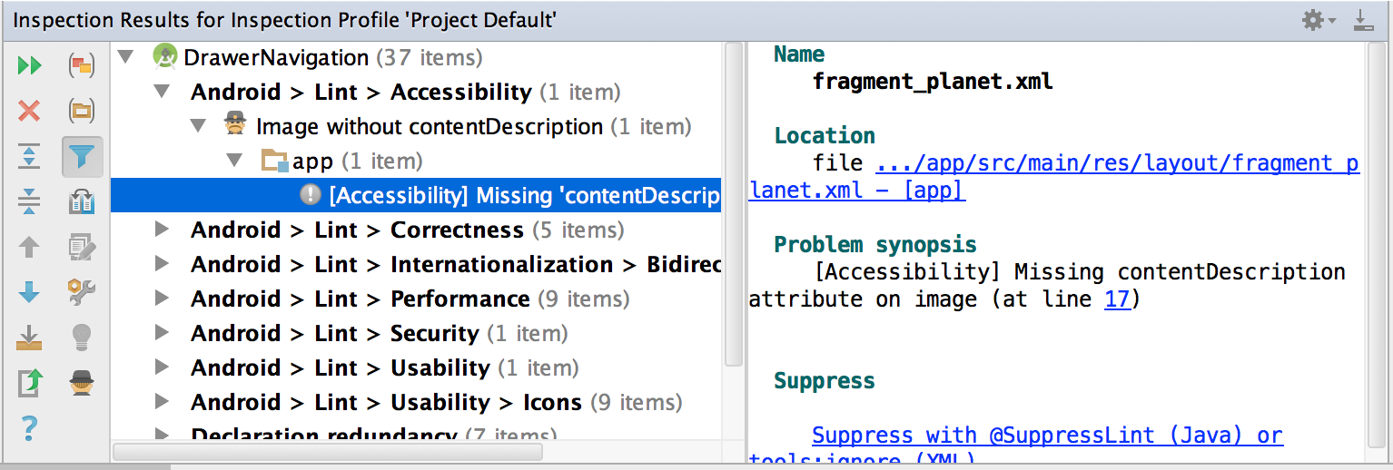

In addition to Lint checks, Android Studio also performs IntelliJ code inspections and validates annotations to streamline your coding workflow.

**Annotations in Android Studio**

Android Studio supports annotations for variables, parameters, and return values to help you catch bugs, such as null pointer exceptions and resource type conflicts. The Android SDK Manager packages the Support-Annotations library in the Android Support Repository for use with Android Studio. Android Studio validates the configured annotations during code inspection.

**Log messages**

When you build and run your app with Android Studio, you can view [adb](https://developer.android.com/studio/command-line/adb.html) output and device log messages in the [**Logcat** window](https://developer.android.com/studio/debug/am-logcat.html).

**Performance profiling**

If you want to profile your app's CPU, memory, and network performance, open the [Android Profiler](https://developer.android.com/studio/profile/android-profiler.html), by clicking **View > Tool Windows > Android Profiler**.

**Creating Hello World Application in Android**

The first step is to create a simple Android Application using Android studio. When you click on Android studio icon, it will show screen as shown below

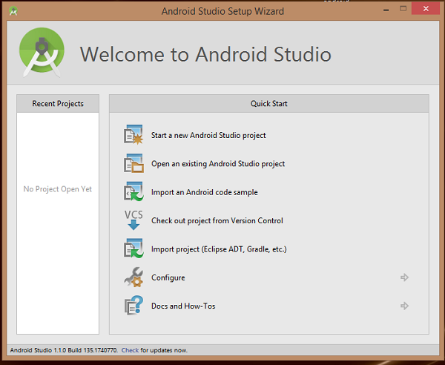

You can start your application development by calling start a new android studio project. in a new installation frame should ask Application name, package information and location of the project.−

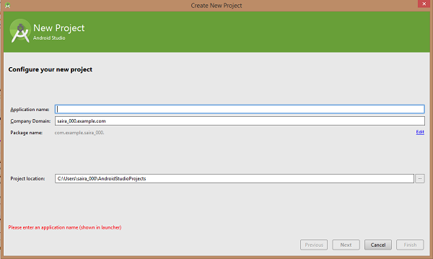

After entered application name.

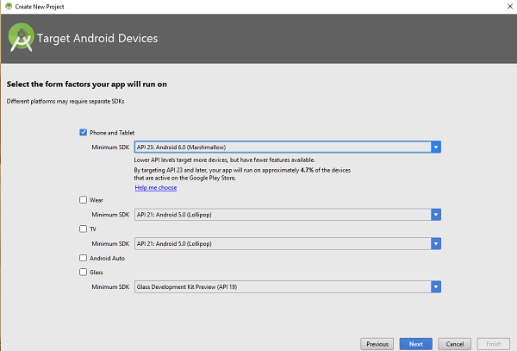

The next level of installation should contain selecting the activity to mobile, it specifies the default layout for Applications.

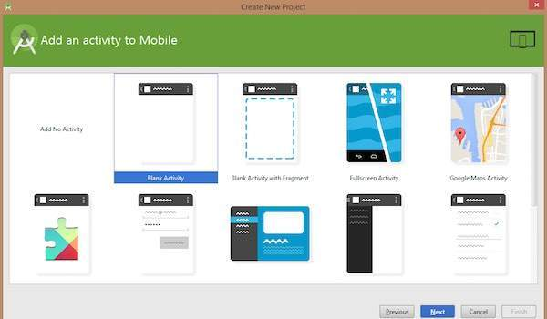

At the final stage it going to be open development tool to write the application code.

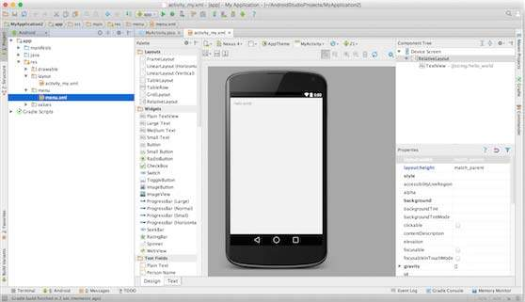

**Anatomy of Android Application**

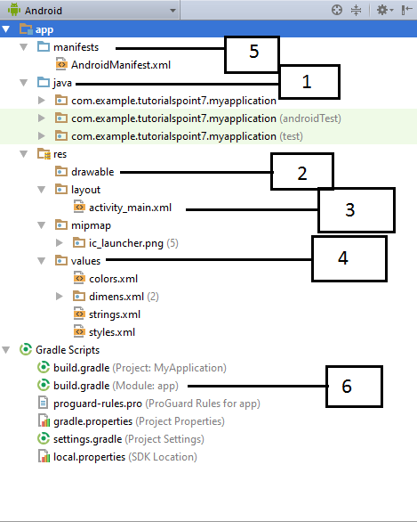

**The Main Activity File**

The main activity code is a Java file **MainActivity.java**. This is the actual application file which ultimately gets converted to a Dalvik executable and runs your application

|  |
| --- |
| *package com.example.helloworld;*  *import android.support.v7.app.AppCompatActivity;*  *import android.os.Bundle;*  *public class MainActivity extends AppCompatActivity {*  *@Override*  *protected void onCreate(Bundle savedInstanceState) {*  *super.onCreate(savedInstanceState);*  *setContentView(R.layout.activity_main);*  *}}* |

Here, R.layout.activity_main refers to the activity_main.xml file located in the res/layout folder. The onCreate() method is one of many methods that are figured when an activity is loaded.

**The Manifest File**

Whatever component you develop as a part of your application, you must declare all its components in a manifest.xml which resides at the root of the application project directory. This file works as an interface between Android OS and your application, so if you do not declare your component in this file, then it will not be considered by the OS. For example, a default manifest file will look like as following file −

|  |
| --- |
| *<?xml version="1.0" encoding="utf-8"?>*  *<manifest xmlns:android="http://schemas.android.com/apk/res/android"*  *package="com.example.helloworld">*  *<application*  *android:allowBackup="true"*  *android:icon="@mipmap/ic_launcher"*  *android:label="@string/app_name"*  *android:supportsRtl="true"*  *android:theme="@style/AppTheme">*  *<activity android:name=".MainActivity">*  *<intent-filter>*  *<action android:name="android.intent.action.MAIN" />*  *<category android:name="android.intent.category.LAUNCHER" />*  *</intent-filter>*  *</activity>*  *</application>*  *</manifest>* |

Here <application>...</application> tags enclosed the components related to the application. Attribute android:icon will point to the application icon available under res/drawable-hdpi. The application uses the image named ic_launcher.png located in the drawable folders

The <activity> tag is used to specify an activity and android:name attribute specifies the fully qualified class name of the Activity subclass and the android:label attributes specifies a string to use as the label for the activity. You can specify multiple activities using <activity> tags.

The **action** for the intent filter is named android.intent.action.MAIN to indicate that this activity serves as the entry point for the application. The **category**for the intent-filter is named android.intent.category.LAUNCHER to indicate that the application can be launched from the device's launcher icon.The @string refers to the strings.xml file explained below.

Hence, @string/app_name refers to the app_name string defined in the strings.xml file, which is "HelloWorld". Similar way, other strings get populated in the application.

Following is the list of tags which you will use in your manifest file to specify different Android application components −

<activity>elements for activities

<service> elements for services

<receiver> elements for broadcast receivers

<provider> elements for content providers

**The Strings File**

The **strings.xml** file is located in the res/values folder and it contains all the text that your application uses. For example, the names of buttons, labels, default text, and similar types of strings go into this file. This file is responsible for their textual content. For example, a default *strings file will look like as following file −*

|  |
| --- |
| *<resources>*  *<string name="app_name">HelloWorld</string>*  *<string name="hello_world">Hello world!</string>*  *<string name="menu_settings">Settings</string>*  *<string name="title_activity_main">MainActivity</string>*  *</resources>* |

**The Layout File**

The **activity_main.xml** is a layout file available in res/layout directory, that is referenced by your application when building its interface. You will modify this file very frequently to change the layout of your application. For your "Hello World!" application, this file will have following content related to default layout −

|  |
| --- |
| *<RelativeLayout xmlns:android="http://schemas.android.com/apk/res/android"*  *xmlns:tools="http://schemas.android.com/tools"*  *android:layout_width="match_parent"*  *android:layout_height="match_parent" >*  *<TextView*  *android:layout_width="wrap_content"*  *android:layout_height="wrap_content"*  *android:layout_centerHorizontal="true"*  *android:layout_centerVertical="true"*  *android:padding="@dimen/padding_medium"*  *android:text="@string/hello_world"*  *tools:context=".MainActivity" />*  *</RelativeLayout>* |

This is an example of simple RelativeLayout which we will study in a separate chapter. The TextView is an Android control used to build the GUI and it have various attributes like android:layout_width, android:layout_height etc which are being used to set its width and height etc.. The @string refers to the strings.xml file located in the res/values folder. Hence, @string/hello_world refers to the hello string defined in the strings.xml file, which is "Hello World!".

**Running the Application**

Let's try to run our **Hello World!** application we just created. I assume you had created your **AVD** while doing environment set-up. To run the app from Android studio, open one of your project's activity files and click Run  icon from the tool bar. Android studio installs the app on your AVD and starts it and if everything is fine with your set-up and application, it will display following Emulator window –

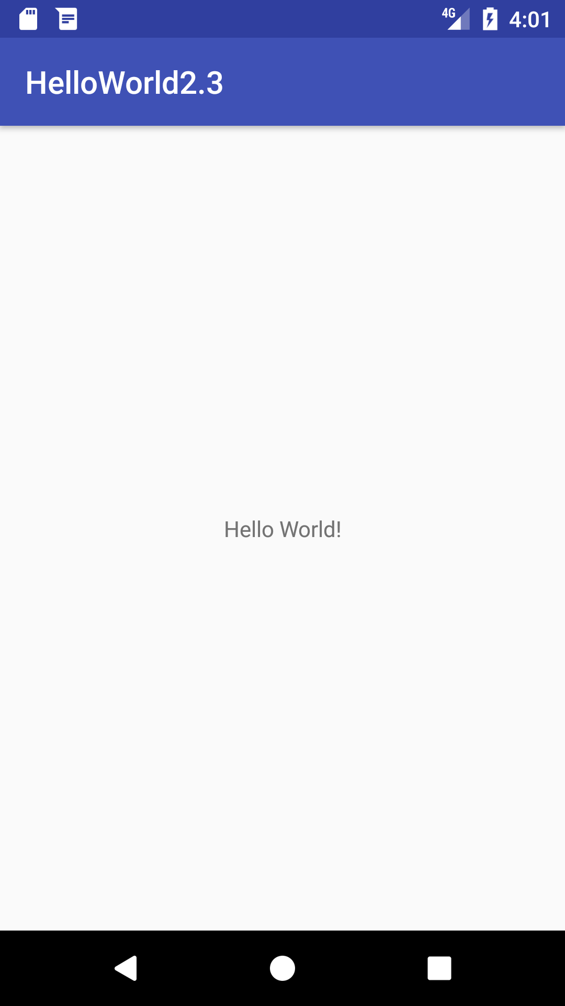

**Working with Button**

**(Addition of two numbers on click)**

***activity_main.xml***

|  |
| --- |
| *<?xml version="1.0" encoding="utf-8"?>*  *<RelativeLayout xmlns:android="http://schemas.android.com/apk/res/android"     xmlns:app="http://schemas.android.com/apk/res-auto"*  *xmlns:tools="http://schemas.android.com/tools"*  *android:layout_width="match_parent"*  *android:layout_height="match_parent"*  *tools:context="example.arif.com.sumoftwonumber.MainActivity">*  *<EditText*  *android:id="@+id/editText1"*  *android:layout_width="wrap_content"*  *android:layout_height="wrap_content"*  *android:layout_alignParentTop="true"*  *android:layout_centerHorizontal="true"*  *android:layout_marginTop="61dp"*  *android:ems="10"*  *android:inputType="number"*  *tools:layout_editor_absoluteX="84dp"*  *tools:layout_editor_absoluteY="53dp" />* |

|  |
| --- |
| *<EditText*  *android:id="@+id/editText2"*  *android:layout_width="wrap_content"*  *android:layout_height="wrap_content"*  *android:layout_below="@+id/editText1"*  *android:layout_centerHorizontal="true"*  *android:layout_marginTop="32dp"*  *android:ems="10"*  *android:inputType="number"*  *tools:layout_editor_absoluteX="84dp"*  *tools:layout_editor_absoluteY="127dp" />*    *<Button*  *android:id="@+id/button"*  *android:layout_width="wrap_content"*  *android:layout_height="wrap_content"*  *android:layout_below="@+id/editText2"*  *android:layout_centerHorizontal="true"*  *android:layout_marginTop="109dp"*  *android:text="ADD"*  *tools:layout_editor_absoluteX="148dp"*  *tools:layout_editor_absoluteY="266dp" />*  *</RelativeLayout>* |

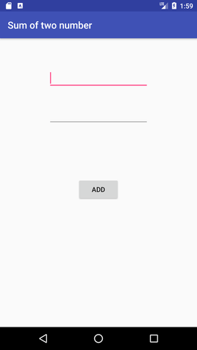

***MainActivity.java***

|  |
| --- |
| *import android.support.v7.app.AppCompatActivity;*  *import android.os.Bundle;*  *import android.view.View;*  *import android.widget.Button;*  *import android.widget.EditText;*  *import android.widget.Toast;*  *public class MainActivity extends AppCompatActivity {*  *private EditText edittext1, edittext2;*  *private Button buttonSum;* |
| *@Override*  *protected void onCreate(Bundle savedInstanceState) {*  *super.onCreate(savedInstanceState);*  *setContentView(R.layout.activity_main);*  *addListenerOnButton();*  *}*  *public void addListenerOnButton() {*  *edittext1 = (EditText) findViewById(R.id.editText1);*  *edittext2 = (EditText) findViewById(R.id.editText2);*  *buttonSum = (Button) findViewById(R.id.button);*  *buttonSum.setOnClickListener(new View.OnClickListener() {*  *@Override*  *public void onClick(View view) {*  *String value1=edittext1.getText().toString();*  *String value2=edittext2.getText().toString();*  *int a=Integer.parseInt(value1);*  *int b=Integer.parseInt(value2);*  *int sum=a+b;*  *Toast.makeText(getApplicationContext(),String.valueOf(sum), Toast.LENGTH_LONG).show();*  *}*  *});*  *}*  } |

**Output**

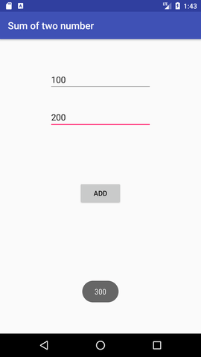

**Toast Class**

Toast class is used to show notification for a particular interval of time. After sometime it disappears. It doesn't block the user interaction.

|  |
| --- |
| ***MainActivity.java***  *import android.support.v7.app.AppCompatActivity;*  *import android.os.Bundle;*  *import android.widget.Toast;*  *public class MainActivity extends AppCompatActivity {*  *@Override*  *protected void onCreate(Bundle savedInstanceState) {*  *super.onCreate(savedInstanceState);*  *setContentView(R.layout.activity_main);*  *//Displaying Toast with Hello Arif message*  *Toast.makeText(getApplicationContext(),"Hello Arif",Toast.LENGTH_SHORT).show();*  *}*  *}* |

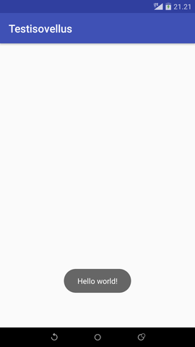

**CheckBox**

**activity_main.xml file**

|  |
| --- |
| *<?xml version="1.0" encoding="utf-8"?>*  *<android.support.constraint.ConstraintLayout*  *xmlns:android="http://schemas.android.com/apk/res/android"*  *xmlns:app="http://schemas.android.com/apk/res-auto"*  *xmlns:tools="http://schemas.android.com/tools"*  *android:layout_width="match_parent"*  *android:layout_height="match_parent"* |

|  |
| --- |
| *tools:context="example.arif.com.checkbox.MainActivity">*  *<CheckBox*  *android:id="@+id/checkBox"*  *android:layout_width="wrap_content"*  *android:layout_height="wrap_content"*  *android:layout_marginLeft="144dp"*  *android:layout_marginTop="68dp"*  *android:text="Pizza"*  *app:layout_constraintStart_toStartOf="parent"*  *app:layout_constraintTop_toTopOf="parent" />*    *<CheckBox*  *android:id="@+id/checkBox2"*  *android:layout_width="wrap_content"*  *android:layout_height="wrap_content"*  *android:layout_marginLeft="144dp"*  *android:layout_marginTop="28dp"*  *android:text="Coffee"*  *app:layout_constraintStart_toStartOf="parent"*  *app:layout_constraintTop_toBottomOf="@+id/checkBox" />*    *<CheckBox*  *android:id="@+id/checkBox3"*  *android:layout_width="wrap_content"*  *android:layout_height="wrap_content"* |
| *android:layout_marginLeft="144dp"*  *android:layout_marginTop="28dp"*  *android:text="Burger"*  *app:layout_constraintStart_toStartOf="parent"*  *app:layout_constraintTop_toBottomOf="@+id/checkBox2" />*  *<Button*  *android:id="@+id/button"*  *android:layout_width="wrap_content"*  *android:layout_height="wrap_content"*  *android:layout_marginLeft="144dp"*  *android:layout_marginTop="184dp"*  *android:text="Order"*  *app:layout_constraintStart_toStartOf="parent"*  *app:layout_constraintTop_toBottomOf="@+id/checkBox3" />*  *</android.support.constraint.ConstraintLayout>* | |

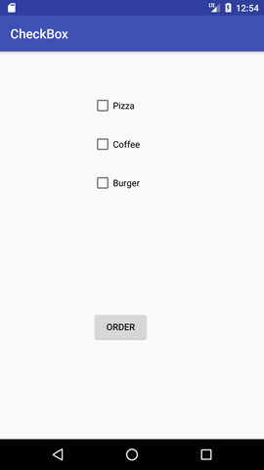

**MainActivity.java file**

|  |
| --- |
| *import android.support.v7.app.AppCompatActivity;*  *import android.os.Bundle;*  *import android.view.View;*  *import android.widget.Button;*  *import android.widget.CheckBox;*  *import android.widget.Toast;*    *public class MainActivity extends AppCompatActivity {*  *CheckBox pizza,coffe,burger;*  *Button buttonOrder;*  *@Override*  *protected void onCreate(Bundle savedInstanceState) {*  *super.onCreate(savedInstanceState);*  *setContentView(R.layout.activity_main);*  *addListenerOnButtonClick();*  *}*  *public void addListenerOnButtonClick(){*  *//Getting instance of CheckBoxes and Button from the activty_main.xml file*  *pizza=(CheckBox)findViewById(R.id.checkBox);*  *coffe=(CheckBox)findViewById(R.id.checkBox2);*  *burger=(CheckBox)findViewById(R.id.checkBox3);*  *buttonOrder=(Button)findViewById(R.id.button);* |

|  |
| --- |
| *buttonOrder.setOnClickListener(new View.OnClickListener(){*  *@Override*  *public void onClick(View view) {*  *int totalamount=0;*  *StringBuilder result=new StringBuilder();*  *result.append("Selected Items:");*  *if(pizza.isChecked()){*  *result.append("\nPizza 100Rs");*  *totalamount+=100;*  *}*  *if(coffe.isChecked()){*  *result.append("\nCoffe 50Rs");*  *totalamount+=50;*  *}*  *if(burger.isChecked()){*  *result.append("\nBurger 120Rs");*  *totalamount+=120;*  *}        result.append("\nTotal: "+totalamount+"Rs");*  *Toast.makeText(getApplicationContext(), result.toString(), Toast.LENGTH_LONG).show();*  *}*    *});  } }* |

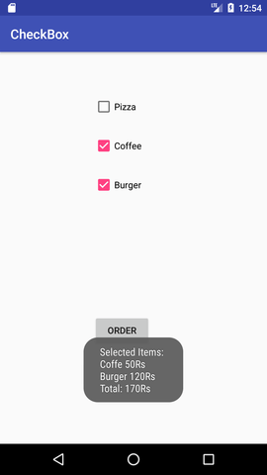

**RadioButton**

|  |
| --- |
| ***activity_main.xml***  *<?xml version="1.0" encoding="utf-8"?>*  *<LinearLayout*  *xmlns:android="http://schemas.android.com/apk/res/android"*  *xmlns:tools="http://schemas.android.com/tools"*  *android:layout_width="match_parent"*  *android:layout_height="match_parent"*  *android:orientation="vertical"*  *tools:context="example.arif.com.radiobutton.MainActivity">*  *<TextView*  *android:id="@+id/textView1"*  *android:layout_width="fill_parent"*  *android:layout_height="wrap_content"*  *android:layout_marginTop="30dp"*  *android:gravity="center_horizontal"*  *android:textSize="22dp"*  *android:text="Single Radio Buttons" />*  *<RadioButton*  *android:id="@+id/radioButton1"*  *android:layout_width="fill_parent"*  *android:layout_height="wrap_content"*  *android:layout_gravity="center_horizontal"*  *android:text="Radio Button 1"*  *android:layout_marginTop="20dp"*  *android:textSize="20dp" />*  *<RadioButton*  *android:id="@+id/radioButton2"*  *android:layout_width="fill_parent"*  *android:layout_height="wrap_content"*  *android:text="Radio Button 2"*  *android:layout_marginTop="10dp"*  *android:textSize="20dp" />*  *<View*  *android:layout_width="fill_parent"*  *android:layout_height="1dp"*  *android:layout_marginTop="20dp"*  *android:background="#B8B894" />*  *<TextView*  *android:id="@+id/textView2"*  *android:layout_width="fill_parent"*  *android:layout_height="wrap_content"*  *android:layout_marginTop="30dp"*  *android:gravity="center_horizontal"*  *android:textSize="22dp"*  *android:text="Radio button inside RadioGroup" />*  *<RadioGroup*  *android:layout_width="wrap_content"*  *android:layout_height="wrap_content"*  *android:id="@+id/radioGroup">*  *<RadioButton*  *android:id="@+id/radioMale"*  *android:layout_width="fill_parent"*  *android:layout_height="wrap_content"*  *android:text="  Male"*  *android:layout_marginTop="10dp"*  *android:checked="false"*  *android:textSize="20dp" />*  *<RadioButton     android:id="@+id/radioFemale"*  *android:layout_width="fill_parent"*  *android:layout_height="wrap_content"*  *android:text="   Female"*  *android:layout_marginTop="20dp"*  *android:checked="false"*  *android:textSize="20dp" />*  *</RadioGroup>*  *<Button*  *android:layout_width="wrap_content"*  *android:layout_height="wrap_content"*  *android:text="Show Selected"*  *android:id="@+id/button"*  *android:onClick="onclickbuttonMethod"*  *android:layout_gravity="center_horizontal" />    </LinearLayout>* |

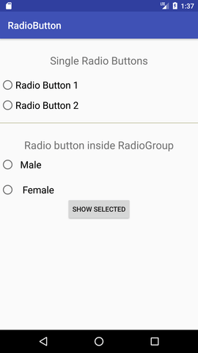

**MainActivity.java**

|  |
| --- |
| *import android.support.v7.app.AppCompatActivity;*  *import android.os.Bundle;*  *import android.view.View;*  *import android.widget.Button;*  *import android.widget.RadioButton;*  *import android.widget.RadioGroup;*  *import android.widget.Toast;* |
| *public class MainActivity extends AppCompatActivity {*  *Button button;*  *RadioButton genderradioButton;*  *RadioGroup radioGroup;*  *@Override*  *protected void onCreate(Bundle savedInstanceState) {*  *super.onCreate(savedInstanceState);*  *setContentView(R.layout.activity_main);*  *radioGroup=(RadioGroup)findViewById(R.id.radioGroup);*  *}*  *public void onclickbuttonMethod(View v){*  *int selectedId = radioGroup.getCheckedRadioButtonId();*  *genderradioButton = (RadioButton) findViewById(selectedId);*  *if(selectedId==-1){*  *Toast.makeText(MainActivity.this,"Nothing selected", Toast.LENGTH_SHORT).show();*  *}*  *else{*  *Toast.makeText(MainActivity.this,genderradioButton.getText(), Toast.LENGTH_SHORT).show();*  *}*  *}*  *}* | |

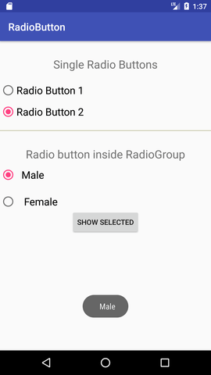

**AlertDialog**

**activity_main.xml**

|  |  |  |
| --- | --- | --- |
| *<?xml version="1.0" encoding="utf-8"?>*  *<android.support.constraint.ConstraintLayout*  *xmlns:android="http://schemas.android.com/apk/res/android"*  *xmlns:app="http://schemas.android.com/apk/res-auto"*  *xmlns:tools="http://schemas.android.com/tools"*  *android:layout_width="match_parent"*  *android:layout_height="match_parent"*  *tools:context="example.arif.com.alertdialog.MainActivity">* | | |
| *<Button*  *android:layout_width="wrap_content"*  *android:layout_height="wrap_content"*  *android:id="@+id/button"*  *android:text="Close app"*  *app:layout_constraintBottom_toBottomOf="parent"*  *app:layout_constraintLeft_toLeftOf="parent"*  *app:layout_constraintRight_toRightOf="parent"*  *app:layout_constraintTop_toTopOf="parent" />*  *</android.support.constraint.ConstraintLayout>* |

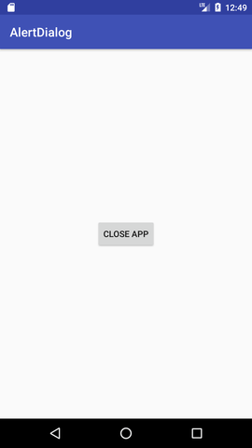

**MainActivity.java**

|  |
| --- |
| *import android.content.DialogInterface;*  *import android.support.v7.app.AppCompatActivity;*  *import android.os.Bundle;*  *import android.view.View;*  *import android.widget.Button;*  *import android.app.AlertDialog;*  *import android.widget.Toast;*  *public class MainActivity extends AppCompatActivity {*  *Button closeButton;*  *AlertDialog.Builder builder;*  *@Override*  *protected void onCreate(Bundle savedInstanceState) {*  *super.onCreate(savedInstanceState);*  *setContentView(R.layout.activity_main);*  *closeButton = (Button) findViewById(R.id.button);*  *builder = new AlertDialog.Builder(this);*  *closeButton.setOnClickListener(new View.OnClickListener() {*  *@Override*  *public void onClick(View v) {*  *builder.setMessage(R.string.dialog_message) .setTitle(R.string.dialog_title);*  *builder.setMessage("Do you want to close this application ?")*  *.setCancelable(false)* |

|  |
| --- |
| *.setPositiveButton("Yes", new DialogInterface.OnClickListener() {*  *public void onClick(DialogInterface dialog, int id) {*  *finish();*  *Toast.makeText(getApplicationContext(),"you choose yes action for alertbox",*  *Toast.LENGTH_SHORT).show();*  *}*  *})*  *.setNegativeButton("No", new DialogInterface.OnClickListener() {*  *public void onClick(DialogInterface dialog, int id) {*  *//  Action for 'NO' Button*  *dialog.cancel();*  *Toast.makeText(getApplicationContext(),"you choose no action for alertbox",*  *Toast.LENGTH_SHORT).show();*  *}*  *});*  *//Creating dialog box*  *AlertDialog alert = builder.create();*  *//Setting the title manually*  *alert.setTitle("AlertDialogExample");*  *alert.show();*  *}*  *});  } }* |

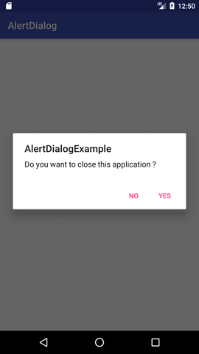

**Spinner**

**activity_main.xml**

|  |
| --- |
| *<?xml version="1.0" encoding="utf-8"?>*  *<android.support.constraint.ConstraintLayout*  *xmlns:android="http://schemas.android.com/apk/res/android"*  *xmlns:app="http://schemas.android.com/apk/res-auto"*  *xmlns:tools="http://schemas.android.com/tools"*  *android:layout_width="match_parent"*  *android:layout_height="match_parent"*  *tools:context="example.arif.com.spinner.MainActivity">*  *<Spinner*  *android:id="@+id/spinner"*  *android:layout_width="149dp"*  *android:layout_height="40dp"*  *android:layout_marginBottom="8dp"*  *android:layout_marginEnd="8dp"*  *android:layout_marginStart="8dp"*  *android:layout_marginTop="8dp"*  *app:layout_constraintBottom_toBottomOf="parent"*  *app:layout_constraintEnd_toEndOf="parent"*  *app:layout_constraintHorizontal_bias="0.502"*  *app:layout_constraintStart_toStartOf="parent"*  *app:layout_constraintTop_toTopOf="parent"*  *app:layout_constraintVertical_bias="0.498" />     </android.support.constraint.ConstraintLayout>* |

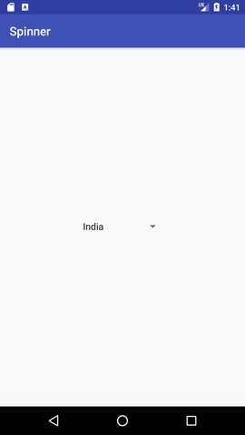

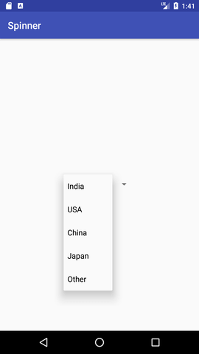

***MainActivity.java***

|  |  |
| --- | --- |
| *import android.support.v7.app.AppCompatActivity;*  *import android.os.Bundle;*  *import android.view.View;*  *import android.widget.AdapterView;*  *import android.widget.ArrayAdapter;*  *import android.widget.Spinner;*  *import android.widget.Toast;*  *public class MainActivity extends AppCompatActivity implements*  *AdapterView.OnItemSelectedListener {*  *String[] country = { "India", "USA", "China", "Japan", "Other"};*  *@Override*  *protected void onCreate(Bundle savedInstanceState) {*  *super.onCreate(savedInstanceState);*  *setContentView(R.layout.activity_main);*  *//Getting the instance of Spinner and applying OnItemSelectedListener on it*  *Spinner spin = (Spinner) findViewById(R.id.spinner);*  *spin.setOnItemSelectedListener(this);*  *//Creating the ArrayAdapter instance having the country list*  *ArrayAdapter aa = new ArrayAdapter(this,android.R.layout.simple_spinner_item,country);*  *aa.setDropDownViewResource(android.R.layout.simple_spinner_dropdown_item);*  *//Setting the ArrayAdapter data on the Spinner*  *spin.setAdapter(aa);*  *}* | |
| *//Performing action onItemSelected and onNothing selected*  *@Override*  *public void onItemSelected(AdapterView<?> arg0, View arg1, int position, long id) {*  *Toast.makeText(getApplicationContext(),country[position] , Toast.LENGTH_LONG).show();*  *}*  *@Override*  *public void onNothingSelected(AdapterView<?> arg0) {*  *// TODO Auto-generated method stub*  *}*  *}* | |

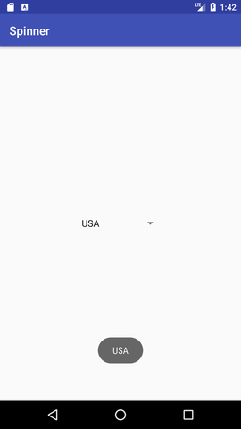

**AutoCompleteTextView**

|  |
| --- |
| **activity_main.xml**  *<?xml version="1.0" encoding="utf-8"?>*  *<android.support.constraint.ConstraintLayout*  *xmlns:android="http://schemas.android.com/apk/res/android"*  *xmlns:app="http://schemas.android.com/apk/res-auto"*  *xmlns:tools="http://schemas.android.com/tools"*  *android:layout_width="match_parent"*  *android:layout_height="match_parent"*  *tools:context="example.arif.com.autocompletetextview.MainActivity">*  *<TextView*  *android:layout_width="wrap_content"*  *android:layout_height="wrap_content"*  *android:text="What is your favourite programming language?"*  *app:layout_constraintBottom_toBottomOf="parent"*  *app:layout_constraintLeft_toLeftOf="parent"*  *app:layout_constraintRight_toRightOf="parent"*  *app:layout_constraintTop_toTopOf="parent"*  *app:layout_constraintVertical_bias="0.032" />*  *<AutoCompleteTextView*  *android:id="@+id/autoCompleteTextView"*  *android:layout_width="200dp"*  *android:layout_height="wrap_content"*  *android:layout_marginLeft="92dp"* |

|  |
| --- |
| *android:layout_marginTop="144dp"*  *android:text=""*  *app:layout_constraintStart_toStartOf="parent"*  *app:layout_constraintTop_toTopOf="parent" />*  *</android.support.constraint.ConstraintLayout>* |

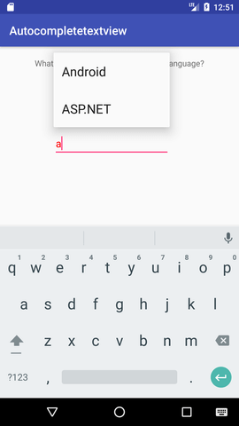

**MainActivity.java**

|  |
| --- |
| *import android.graphics.Color;*  *import android.support.v7.app.AppCompatActivity;*  *import android.os.Bundle;*  *import android.widget.ArrayAdapter;*  *import android.widget.AutoCompleteTextView;*    *public class MainActivity extends AppCompatActivity {*  *String[] language ={"C","C++","Java",".NET","iPhone","Android","ASP.NET","PHP"};*  *@Override*  *protected void onCreate(Bundle savedInstanceState) {*  *super.onCreate(savedInstanceState);*  *setContentView(R.layout.activity_main);*  *//Creating the instance of ArrayAdapter containing list of language names*  *ArrayAdapter<String> adapter = new ArrayAdapter<String>*  *(this,android.R.layout.select_dialog_item,language);*  *//Getting the instance of AutoCompleteTextView*  *AutoCompleteTextView actv =  (AutoCompleteTextView)findViewById(R.id.autoCompleteTextView);*  *actv.setThreshold(1);//will start working from first character*  *actv.setAdapter(adapter);//setting the adapter data into the AutoCompleteTextView*  *actv.setTextColor(Color.RED);*  *}*  *}* |

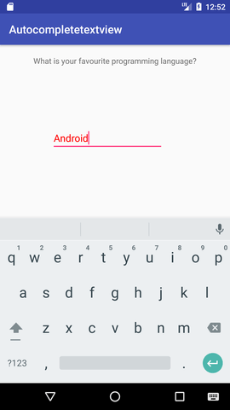

**ListView**

**activity_main.xml**

|  |  |  |
| --- | --- | --- |
| *<?xml version="1.0" encoding="utf-8"?>*  *<android.support.constraint.ConstraintLayout xmlns:android="http://schemas.android.com/apk/res/android"*  *xmlns:app="http://schemas.android.com/apk/res-auto"*  *xmlns:tools="http://schemas.android.com/tools"*  *android:layout_width="match_parent"*  *android:layout_height="match_parent"* | | |
| *tools:context="listview.example.com.listview.MainActivity">*  *<ListView*  *android:id="@+id/listView"*  *android:layout_width="match_parent"*  *android:layout_height="fill_parent"*  */>*  *</android.support.constraint.ConstraintLayout>* |

**mylist.xml**

|  |
| --- |
| *<?xml version="1.0" encoding="utf-8"?>*  *<TextView xmlns:android="http://schemas.android.com/apk/res/android"*  *android:id="@+id/textView"*  *android:layout_width="wrap_content"*  *android:layout_height="wrap_content"*  *android:text="Medium Text"*  *android:textStyle="bold"*  *android:textAppearance="?android:attr/textAppearanceMedium"*  *android:layout_marginLeft="10dp"*  *android:layout_marginTop="5dp"*  *android:padding="2dp"*  *android:textColor="#4d4d4d"       />* |

**stringxml**

|  |
| --- |
| .*<resources>*  *<string name="app_name">ListView</string>*  *<string-array name="array_technology">*  *<item>Android</item>*  *<item>Java</item>*  *<item>Php</item>*  *<item>Hadoop</item>*  *<item>Sap</item>*  *<item>Python</item>*  *<item>Ajax</item>*  *<item>C++</item>*  *<item>Ruby</item>*  *<item>Rails</item>*  *<item>.Net</item>*  *<item>Perl</item>*  *</string-array>*  *</resources>* |

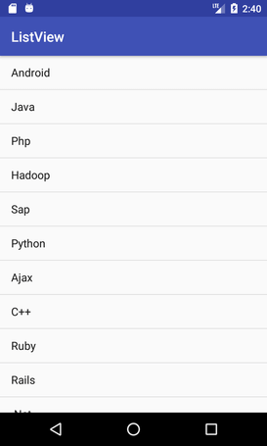

**MainActivity.java**

|  |  |
| --- | --- |
| *import android.support.v7.app.AppCompatActivity;*  *import android.os.Bundle;*  *import android.view.View;*  *import android.widget.AdapterView;*  *import android.widget.ArrayAdapter;*  *import android.widget.ListView;*  *import android.widget.TextView;*  *import android.widget.Toast;*  *public class MainActivity extends AppCompatActivity {*  *ListView listView;* | |
| *TextView textView;*  *String[] listItem;*  *@Override*  *protected void onCreate(Bundle savedInstanceState) {*  *super.onCreate(savedInstanceState);*  *setContentView(R.layout.activity_main);*  *listView=(ListView)findViewById(R.id.listView);*  *textView=(TextView)findViewById(R.id.textView);*  *listItem = getResources().getStringArray(R.array.array_technology);*  *final ArrayAdapter<String> adapter = new ArrayAdapter<String>(this,*  *android.R.layout.simple_list_item_1, android.R.id.text1, listItem);* | | |
| *listView.setAdapter(adapter);*  *listView.setOnItemClickListener(new AdapterView.OnItemClickListener() {*  *@Override*  *public void onItemClick(AdapterView<?> adapterView, View view, int position, long l)*  *{*  *// TODO Auto-generated method stub*  *String value=adapter.getItem(position);*  *Toast.makeText(getApplicationContext(),value,Toast.LENGTH_SHORT).show();*  *}*  *});*  *}*  *}* | |

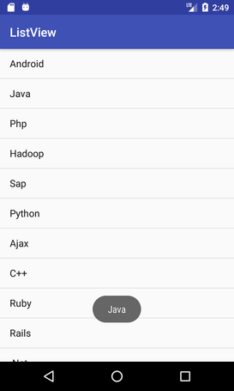  **RatingBar**

***activity­_main.xml***

|  |  |
| --- | --- |
| *<?xml version="1.0" encoding="utf-8"?>*  *<android.support.constraint.ConstraintLayout xmlns:android="http://schemas.android.com/apk/res/android"*  *xmlns:app="http://schemas.android.com/apk/res-auto"*  *xmlns:tools="http://schemas.android.com/tools"*  *android:layout_width="match_parent"*  *android:layout_height="match_parent"*  *tools:context="example.arif.com.ratingbar.MainActivity">* | |
| *<Button*  *android:layout_width="wrap_content"*  *android:layout_height="wrap_content"*  *android:text="submit"*  *android:id="@+id/button"*  *app:layout_constraintBottom_toBottomOf="parent"*  *app:layout_constraintLeft_toLeftOf="parent"*  *app:layout_constraintRight_toRightOf="parent"*  *app:layout_constraintTop_toTopOf="parent"*  *app:layout_constraintVertical_bias="0.615" />*    *<RatingBar*  *android:id="@+id/ratingBar"*  *android:layout_width="wrap_content"*  *android:layout_height="wrap_content"* |
| *android:layout_marginLeft="72dp"*  *android:layout_marginTop="60dp"*  *app:layout_constraintStart_toStartOf="parent"*  *app:layout_constraintTop_toTopOf="parent" />*  *</android.support.constraint.ConstraintLayout>* |

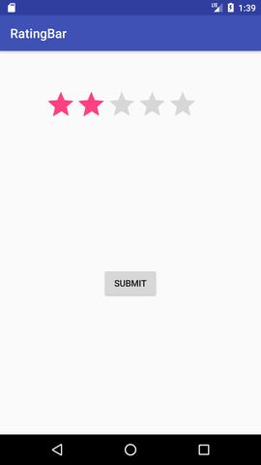

**MainActivity.java**

|  |  |
| --- | --- |
| *import android.support.v7.app.AppCompatActivity;*  *import android.os.Bundle;*  *import android.view.View;*  *import android.widget.Button;*  *import android.widget.RatingBar;*  *import android.widget.Toast;*  *public class MainActivity extends AppCompatActivity {*  *RatingBar ratingbar;*  *Button button;*  *@Override*  *protected void onCreate(Bundle savedInstanceState) {*  *super.onCreate(savedInstanceState);*  *setContentView(R.layout.activity_main);*  *addListenerOnButtonClick();*  *}*  *public void addListenerOnButtonClick(){*  *ratingbar=(RatingBar)findViewById(R.id.ratingBar);*  *button=(Button)findViewById(R.id.button);*  *//Performing action on Button Click*  *button.setOnClickListener(new View.OnClickListener(){*  *@Override*  *public void onClick(View arg0) {* | |
| *//Getting the rating and displaying it on the toast*  *String rating=String.valueOf(ratingbar.getRating());*  *Toast.makeText(getApplicationContext(), rating, Toast.LENGTH_LONG).show();*  *}*    *});*  *}  }* | |

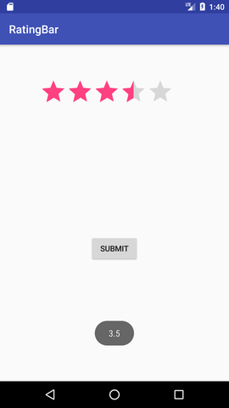

**WebView**

***ActivityManifest.xml***

|  |
| --- |
| *<?xml version="1.0" encoding="utf-8"?>*  *<manifest xmlns:android="*[*http://schemas.android.com/apk/res/android*](http://schemas.android.com/apk/res/android)*"*  *<uses-permission android:name="android.permission.INTERNET"/>*  *<application*  *android:allowBackup="true"*  *android:icon="@mipmap/ic_launcher"*  *android:label="@string/app_name"*  *android:supportsRtl="true"*  *android:theme="@style/AppTheme.NoActionBar" >*  *<activity android:name=".MainActivity" >*  *<intent-filter>*  *<action android:name="android.intent.action.MAIN" />*  *<category android:name="android.intent.category.LAUNCHER" />*  *</intent-filter>*  *</activity>*  *</application>*  *</manifest>*  ***activity_main.xml***  *<?xml version="1.0" encoding="utf-8"?>*  *<LinearLayout xmlns:android="http://schemas.android.com/apk/res/android"*  *android:layout_width="fill_parent"*  *android:layout_height="fill_parent"*  *android:orientation="vertical" >*  *<Button*  *android:id="@+id/buttonUrl"*  *android:layout_gravity="center*  *android:layout_width="wrap_content"*  *android:layout_height="wrap_content"*  *android:text="www.google.com" />*  *</LinearLayout>*  **web_view.xml**  *<?xml version="1.0" encoding="utf-8"?>*  *<WebView  xmlns:android="http://schemas.android.com/apk/res/android"*  *android:id="@+id/webView"*  *android:layout_width="fill_parent"*  *android:layout_height="fill_parent"*  */>* |

|  |
| --- |
| ***MainActivity.java***  *import android.app.Activity;*  *import android.content.Context;*  *import android.content.Intent;*  *import android.os.Bundle;*  *import android.view.View;*  *import android.view.View.OnClickListener;*  *import android.widget.Button;*  *public class MainActivity extends Activity {*  *private Button button;*  *public void onCreate(Bundle savedInstanceState) {*  *final Context context = this;*  *super.onCreate(savedInstanceState);*  *setContentView(R.layout.activity_main);*  *button = (Button) findViewById(R.id.buttonUrl);*  *button.setOnClickListener(new OnClickListener() {*  *@Override*  *public void onClick(View arg0) {*  *Intent intent = new Intent(context, WebViewActivity.class);*  *startActivity(intent);*  *}*  *});*  *}*  *}*  **Web_view.java**  *import android.app.Activity;*  *import android.os.Bundle;*  *import android.webkit.WebView;*  *public class WebViewActivity extends Activity {*  *private WebView webView;*  *public void onCreate(Bundle savedInstanceState) {super.onCreate(savedInstanceState);*  *setContentView(R.layout.web_view);*  *webView = (WebView) findViewById(R.id.webView);*  *webView.getSettings().setJavaScriptEnabled(true);*  *webView.loadUrl("https://www.google.com");*  *}}* |

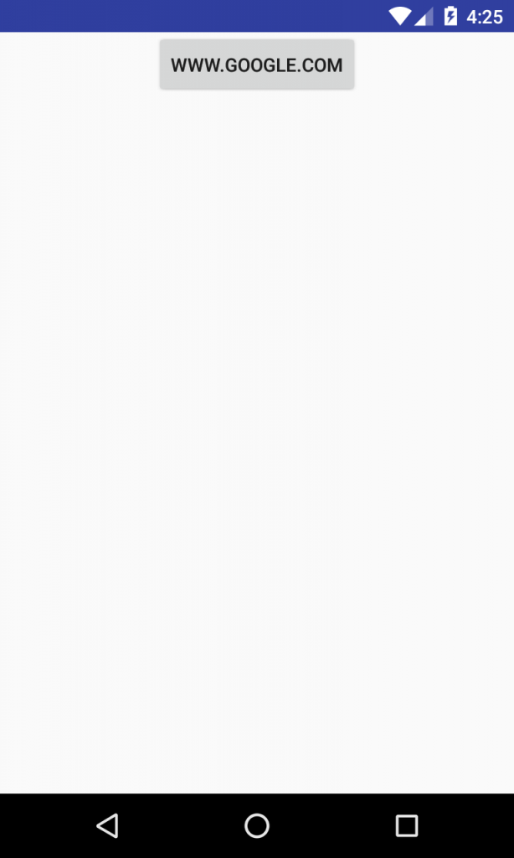

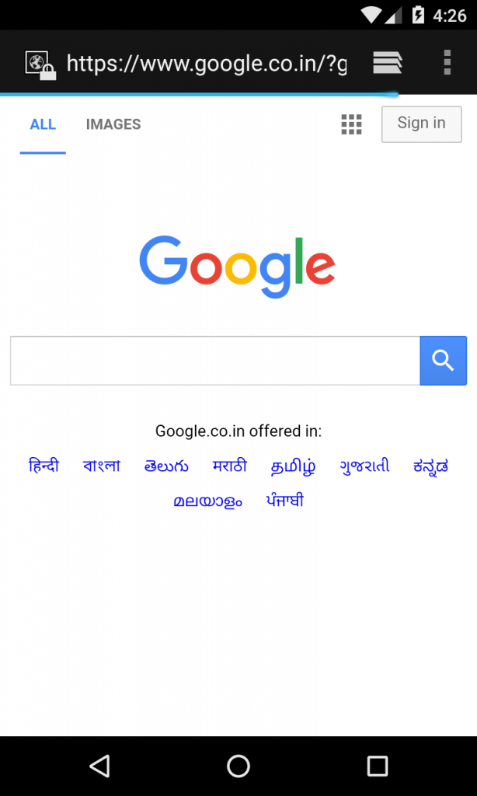

**DatePicker**

**activity_main.xml**

|  |  |
| --- | --- |
| *<?xml version="1.0" encoding="utf-8"?>*  *<RelativeLayout xmlns:android="http://schemas.android.com/apk/res/android"*  *xmlns:app="http://schemas.android.com/apk/res-auto"*  *xmlns:tools="http://schemas.android.com/tools"*  *android:layout_width="match_parent"*  *android:layout_height="match_parent"*  *tools:context="example.arif.com.datepicker.MainActivity">* | |
| *<TextView*  *android:id="@+id/textView1"*  *android:layout_width="wrap_content"*  *android:layout_height="wrap_content"*  *android:layout_above="@+id/button1"*  *android:layout_alignParentLeft="true"*  *android:layout_alignParentStart="true"*  *android:layout_marginBottom="102dp"*  *android:layout_marginLeft="30dp"*  *android:layout_marginStart="30dp"*  *android:text="" />*  *<Button*  *android:id="@+id/button1"*  *android:layout_width="wrap_content"*  *android:layout_height="wrap_content"*  *android:layout_alignParentBottom="true"*  *android:layout_centerHorizontal="true"*  *android:layout_marginBottom="20dp"*  *android:text="Change Date" />*  *<DatePicker*  *android:id="@+id/datePicker"*  *android:layout_width="wrap_content"*  *android:layout_height="wrap_content"* | |

|  |
| --- |
| *android:layout_above="@+id/textView1"*  *android:layout_centerHorizontal="true"*  *android:layout_marginBottom="36dp" />*  *</RelativeLayout>* |

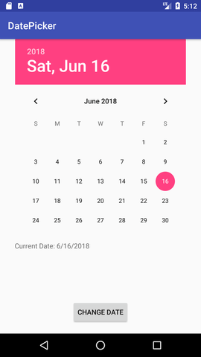

|  |  |
| --- | --- |
| **MainActivity.java**  *import android.support.v7.app.AppCompatActivity;*  *import android.os.Bundle;*  *import android.view.View;*  *import android.widget.Button;*  *import android.widget.DatePicker;*  *import android.widget.TextView;*  *public class MainActivity extends AppCompatActivity {*  *DatePicker picker;*  *Button displayDate;*  *TextView textview1;*  *@Override      protected void onCreate(Bundle savedInstanceState) {*  *super.onCreate(savedInstanceState);*  *setContentView(R.layout.activity_main);*  *textview1=(TextView)findViewById(R.id.textView1);*  *picker=(DatePicker)findViewById(R.id.datePicker);*  *displayDate=(Button)findViewById(R.id.button1);*  *textview1.setText("Current Date: "+getCurrentDate());*  *displayDate.setOnClickListener(new View.OnClickListener(){*  *@Override*  *public void onClick(View view) {*  *textview1.setText("Change Date: "+getCurrentDate());*  *}*  *});* | |
| *}*  *public String getCurrentDate(){*  *StringBuilder builder=new StringBuilder();;*  *builder.append((picker.getMonth() + 1)+"/");//month is 0 based*  *builder.append(picker.getDayOfMonth()+"/");*  *builder.append(picker.getYear());*  *return builder.toString();     }*  *}* | |

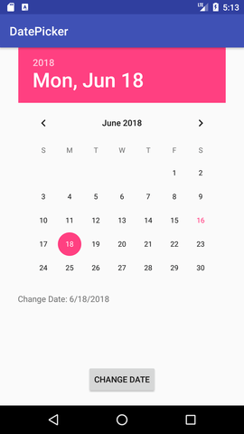

**TimePicker**

**activity_main.xm**

|  |
| --- |
| *<?xml version="1.0" encoding="utf-8"?>*  *<RelativeLayout xmlns:android="http://schemas.android.com/apk/res/android"*  *xmlns:app="http://schemas.android.com/apk/res-auto"*  *xmlns:tools="http://schemas.android.com/tools"*  *android:layout_width="match_parent"*  *android:layout_height="match_parent"* |
| *tools:context="example.arif.com.timepicker.MainActivity">*  *<TextView*  *android:id="@+id/textView1"*  *android:layout_width="wrap_content"*  *android:layout_height="wrap_content"*  *android:layout_above="@+id/button1"*  *android:layout_alignParentLeft="true"*  *android:layout_alignParentStart="true"*  *android:layout_marginBottom="102dp"*  *android:layout_marginLeft="30dp"*  *android:layout_marginStart="30dp"*  *android:text="" />*  *<Button*  *android:id="@+id/button1"*  *android:layout_width="wrap_content"* |
| *android:layout_height="wrap_content"*  *android:layout_alignParentBottom="true"*  *android:layout_centerHorizontal="true"*  *android:layout_marginBottom="20dp"*  *android:text="Change Time" />*  *<TimePicker* |
| *android:id="@+id/timePicker"*  *android:layout_width="wrap_content"*  *android:layout_height="wrap_content"*  *android:layout_above="@+id/textView1"*  *android:layout_centerHorizontal="true"*  *android:layout_marginBottom="36dp" />*  *</RelativeLayout>* |

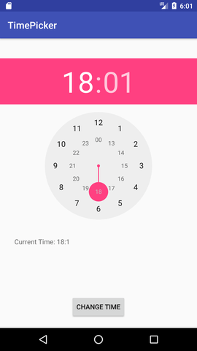

|  |
| --- |
| **MainActivity.java**  *import android.support.v7.app.AppCompatActivity;*  *import android.os.Bundle;*  *import android.view.View;*  *import android.widget.Button;*  *import android.widget.TextView;*  *import android.widget.TimePicker;*  *public class MainActivity extends AppCompatActivity {*  *TextView textview1;*  *TimePicker timepicker;*  *Button changetime;*  *@Override*  *protected void onCreate(Bundle savedInstanceState) {*  *super.onCreate(savedInstanceState);*  *setContentView(R.layout.activity_main);*  *textview1=(TextView)findViewById(R.id.textView1);*  *timepicker=(TimePicker)findViewById(R.id.timePicker);          timepicker.setIs24HourView(true);*  *changetime=(Button)findViewById(R.id.button1);*  *textview1.setText(getCurrentTime());*  *changetime.setOnClickListener(new View.OnClickListener(){*  *@Override*  *public void onClick(View view) {* |
| *textview1.setText(getCurrentTime());*  *}*  *});*  *}*  *public String getCurrentTime(){*  *String currentTime="Current Time: "+timepicker.getCurrentHour()+":"+timepicker.getCurrentMinute();*  *return currentTime;*  *}    }* |

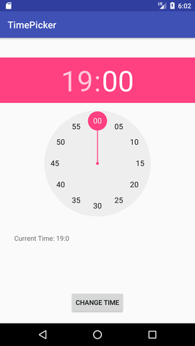

**Working With Intent**

**Types of Android Intents**

**1) Implicit Intent**

***activity_main.xml***

|  |
| --- |
| *<?xml version="1.0" encoding="utf-8"?>  <android.support.constraint.ConstraintLayout*  *xmlns:android="http://schemas.android.com/apk/res/android"*  *xmlns:app="http://schemas.android.com/apk/res-auto"*  *xmlns:tools="http://schemas.android.com/tools"*  *android:layout_width="match_parent"*  *android:layout_height="match_parent"*  *tools:context="example.arif.com.implicitintent.MainActivity">*  *<EditText   android:id="@+id/editText"*  *android:layout_width="wrap_content"*  *android:layout_height="wrap_content"*  *app:layout_constraintStart_toStartOf="parent"*  *app:layout_constraintTop_toTopOf="parent" />     <Button*  *android:id="@+id/button"*  *android:layout_width="wrap_content"*  *android:layout_height="wrap_content"* |
| *android:layout_marginRight="8dp"*  *android:layout_marginLeft="156dp"*  *android:layout_marginTop="172dp"*  *android:text="Visit"*  *app:layout_constraintEnd_toEndOf="parent"*  *app:layout_constraintHorizontal_bias="0.0"*  *app:layout_constraintStart_toStartOf="parent"*  *app:layout_constraintTop_toBottomOf="@+id/editText" />*  *</android.support.constraint.ConstraintLayout>* |

*.*

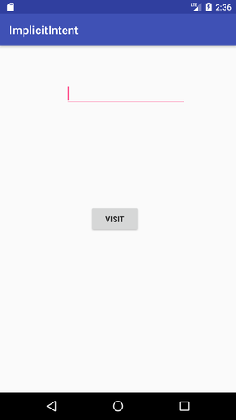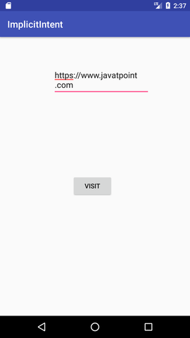

|  |
| --- |
| **MainActivity.java**  *import android.content.Intent;*  *import android.net.Uri;*  *import android.support.v7.app.AppCompatActivity;*  *import android.os.Bundle;*  *import android.view.View;*  *import android.widget.Button;*  *import android.widget.EditText;* |

|  |
| --- |
| *public class MainActivity extends AppCompatActivity {*  *Button button;*  *EditText editText;*  *@Override*  *protected void onCreate(Bundle savedInstanceState) {*  *super.onCreate(savedInstanceState);*  *setContentView(R.layout.activity_main);*  *button = findViewById(R.id.button);*  *editText =  findViewById(R.id.editText);*  *button.setOnClickListener(new View.OnClickListener() {*  *@Override*  *public void onClick(View view) {*  *String url=editText.getText().toString();*  *Intent intent=new Intent(Intent.ACTION_VIEW, Uri.parse(url));*  *startActivity(intent);*  *}*  *});*  *}*  *}* |

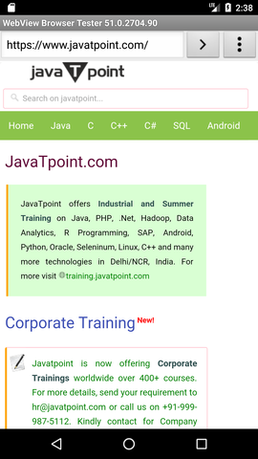

2) **Android Explicit intent**

|  |
| --- |
| *<?xml version="1.0" encoding="utf-8"?>*  *<android.support.constraint.ConstraintLayout*  *xmlns:android="http://schemas.android.com/apk/res/android"*  *xmlns:app="http://schemas.android.com/apk/res-auto"*  *xmlns:tools="http://schemas.android.com/tools"*  *android:layout_width="match_parent"*  *android:layout_height="match_parent"* |
| *tools:context="example.arif.com.explicitintent.FirstActivity">*  *<TextView*  *android:layout_width="wrap_content"*  *android:layout_height="wrap_content"*  *android:layout_marginEnd="8dp"*  *android:layout_marginStart="8dp"*  *android:layout_marginTop="8dp"*  *android:text="First Activity"*  *app:layout_constraintBottom_toBottomOf="parent"*  *app:layout_constraintEnd_toEndOf="parent"*  *app:layout_constraintHorizontal_bias="0.454"*  *app:layout_constraintLeft_toLeftOf="parent"*  *app:layout_constraintRight_toRightOf="parent"*  *app:layout_constraintStart_toStartOf="parent"*  *app:layout_constraintTop_toTopOf="parent"*  *app:layout_constraintVertical_bias="0.06" />* |
| *<Button*  *android:id="@+id/button"*  *android:layout_width="wrap_content"*  *android:layout_height="wrap_content"*  *android:layout_marginEnd="8dp"*  *android:layout_marginStart="8dp"*  *android:layout_marginTop="392dp"*  *android:onClick="callSecondActivity"* |
| *android:text="Call second activity"*  *app:layout_constraintEnd_toEndOf="parent"*  *app:layout_constraintStart_toStartOf="parent"*  *app:layout_constraintTop_toTopOf="parent" />  </android.support.constraint.ConstraintLayout>* |

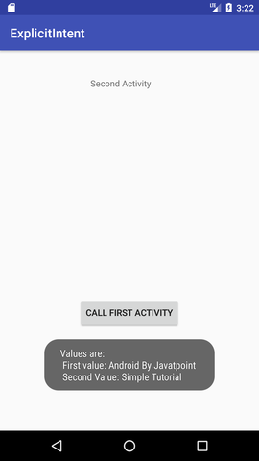

|  |
| --- |
| ***MainActivityOne.java***  *import android.content.Intent;*  *import android.support.v7.app.AppCompatActivity;*  *import android.os.Bundle;*  *import android.view.View;*  *public class FirstActivity extends AppCompatActivity {*  *@Override*  *protected void onCreate(Bundle savedInstanceState) {*  *super.onCreate(savedInstanceState);*  *setContentView(R.layout.activity_first);*  *}*  *public void callSecondActivity(View view){*  *Intent i = new Intent(getApplicationContext(), SecondActivity.class);*  *i.putExtra("Value1", "Android By Arif");*  *i.putExtra("Value2", "Simple Tutorial");*  *startActivity(i);*  *}*  *}* |

***activitytwo_main.xml***

|  |
| --- |
| *<?xml version="1.0" encoding="utf-8"?>*  *<android.support.constraint.ConstraintLayout*  *xmlns:android="http://schemas.android.com/apk/res/android"*  *xmlns:app="http://schemas.android.com/apk/res-auto"*  *xmlns:tools="http://schemas.android.com/tools"*  *android:layout_width="match_parent"*  *android:layout_height="match_parent"*  *tools:context="example.arif.com.explicitintent.SecondActivity">*  *<TextView*  *android:layout_width="wrap_content"*  *android:layout_height="wrap_content"* |
| *android:layout_marginEnd="8dp"*  *android:layout_marginStart="8dp"*  *android:layout_marginTop="8dp"*  *android:text="Second Activity"*  *app:layout_constraintBottom_toBottomOf="parent"*  *app:layout_constraintEnd_toEndOf="parent"*  *app:layout_constraintHorizontal_bias="0.454"*  *app:layout_constraintLeft_toLeftOf="parent"*  *app:layout_constraintRight_toRightOf="parent"*  *app:layout_constraintStart_toStartOf="parent"*  *app:layout_constraintTop_toTopOf="parent"* |
| *app:layout_constraintVertical_bias="0.06" />     <Button*  *android:id="@+id/button"          android:layout_width="wrap_content"*  *android:layout_height="wrap_content"*  *android:layout_marginEnd="8dp"*  *android:layout_marginStart="8dp"*  *android:onClick="callFirstActivity"*  *android:text="Call first activity"*  *app:layout_constraintEnd_toEndOf="parent"*  *app:layout_constraintStart_toStartOf="parent"*  *app:layout_constraintTop_toTopOf="parent" />*  *</android.support.constraint.ConstraintLayout>* |

|  |
| --- |
| **MainActivity2.java**  *import android.content.Intent;*  *import android.support.v7.app.AppCompatActivity;*  *import android.os.Bundle;*  *import android.view.View;*  *import android.widget.Toast;*  *public class SecondActivity extends AppCompatActivity {*  *@Override*  *protected void onCreate(Bundle savedInstanceState) {*  *super.onCreate(savedInstanceState);*  *setContentView(R.layout.activity_second);*  *Bundle extras = getIntent().getExtras();*  *String value1 = extras.getString("Value1");*  *String value2 = extras.getString("Value2");*  *Toast.makeText(getApplicationContext(),"Values are:\n First value: "+value1+*  *"\n Second Value: "+value2, Toast.LENGTH_LONG).show();*  *}*  *public void callFirstActivity(View view){*  *Intent i = new Intent(getApplicationContext(), FirstActivity.class);*  *startActivity(i);*  *} }* |

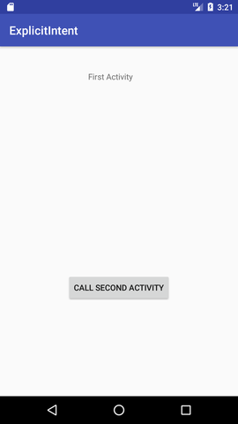

**Hide Title bar and FullScreen**

**activity_main.xml**

|  |
| --- |
| *<?xml version="1.0" encoding="utf-8"?>*  *<android.support.constraint.ConstraintLayout xmlns:android="http://schemas.android.com/apk/res/android"*  *xmlns:app="http://schemas.android.com/apk/res-auto"*  *xmlns:tools="http://schemas.android.com/tools"*  *android:layout_width="match_parent"*  *android:layout_height="match_parent"*  *tools:context="first.javatpoint.com.hidetitlebar.MainActivity">*    *<TextView*  *android:layout_width="wrap_content"*  *android:layout_height="wrap_content"*  *android:text="Hello World!"*  *app:layout_constraintBottom_toBottomOf="parent"*  *app:layout_constraintLeft_toLeftOf="parent"*  *app:layout_constraintRight_toRightOf="parent"*  *app:layout_constraintTop_toTopOf="parent" />*    *</android.support.constraint.ConstraintLayout>* |

**MainActivity.java**

|  |
| --- |
| *import android.support.v7.app.AppCompatActivity;*  *import android.os.Bundle;*  *import android.view.Window;*  *import android.view.WindowManager;*    *public class MainActivity extends AppCompatActivity {*  *@Override*  *protected void onCreate(Bundle savedInstanceState) {*  *super.onCreate(savedInstanceState);*  *requestWindowFeature(Window.FEATURE_NO_TITLE); //will hide the title*  *getSupportActionBar().hide(); // hide the title bar*  *this.getWindow().setFlags(WindowManager.LayoutParams.FLAG_FULLSCREEN,*  *WindowManager.LayoutParams.FLAG_FULLSCREEN); //enable full screen*  *setContentView(R.layout.activity_main);*  *}*  *}* |

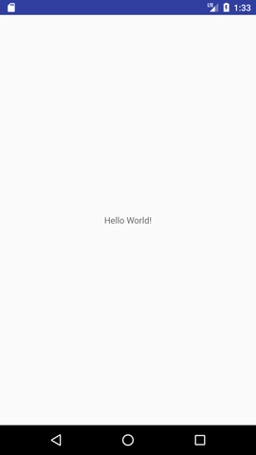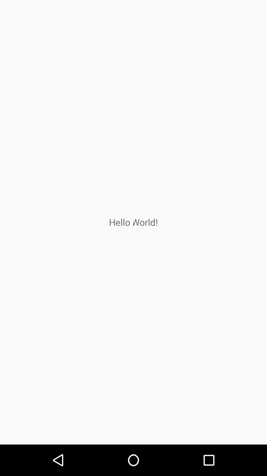

(*Hiding title only) ( Fullscreeen)*

Project (Yaari Dostea Cafe)

People love to eat out. In fact, it seems there's a different café or restaurant on just about every block these days. But I chose this subject, because I also love to enjoy café items. So first we have better understand the reality because it's exciting and it also takes a lot of hard work. We have to understand, what this all about before making an application like this.



*“This application is made for ordering online beverages like tea, coffee, cookies, ice creams etc. It contains all the information regarding the items that is to be ordered and is totally secured. I made this application as I’m also fond of ordering snacks etc from online and enjoy at low prices that is the beneficial for everyone. This application is very easy to understand and can be used by everyone even technical one or not.”*

Getting started with the app

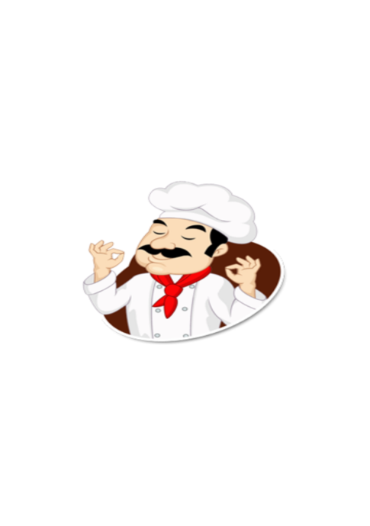

***First open the app (Splash Screen)***

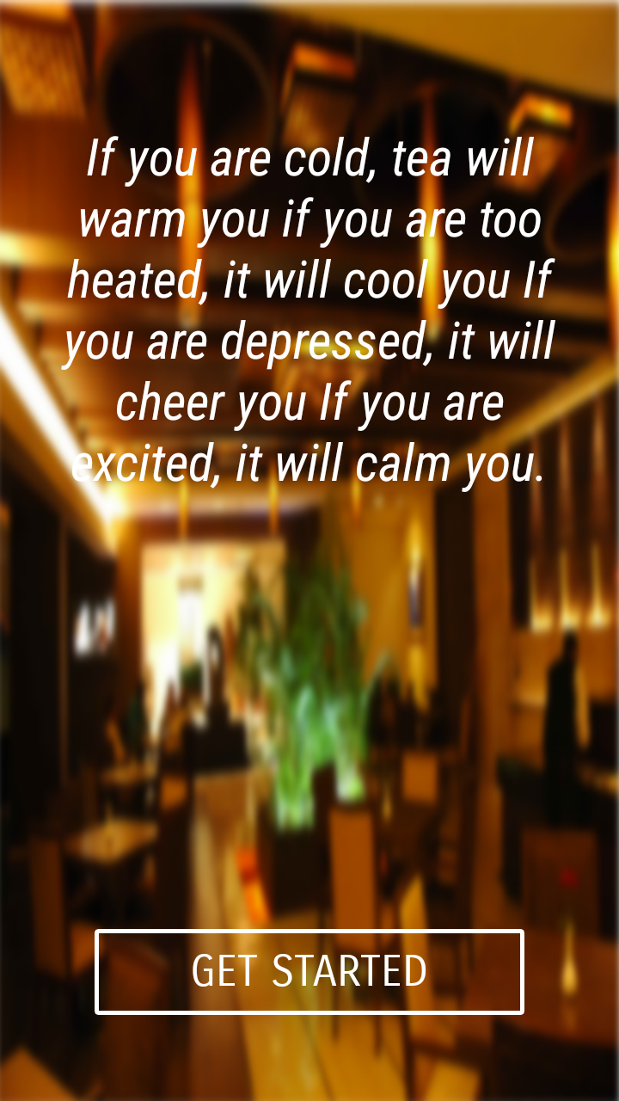

***The Welcome Page, Click on the Button to get start with the application***

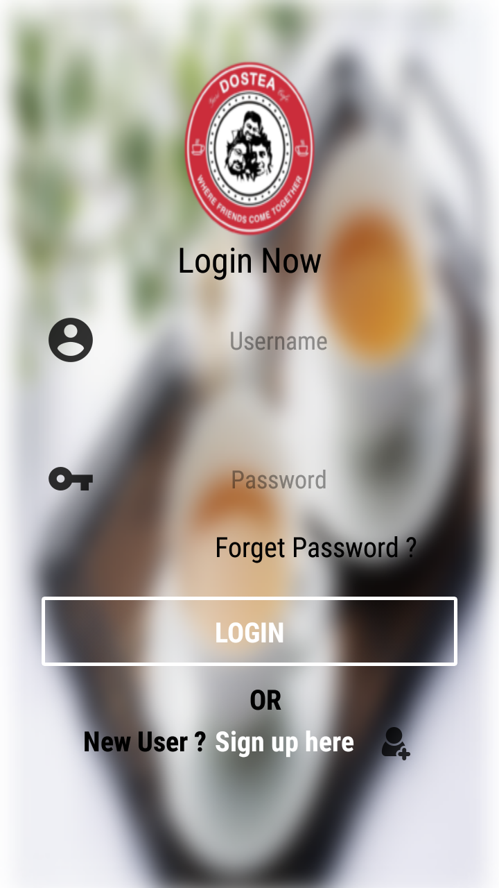

***Login page (don’t have a account create one)***

***Click on the “sign up here” button and register yourself***

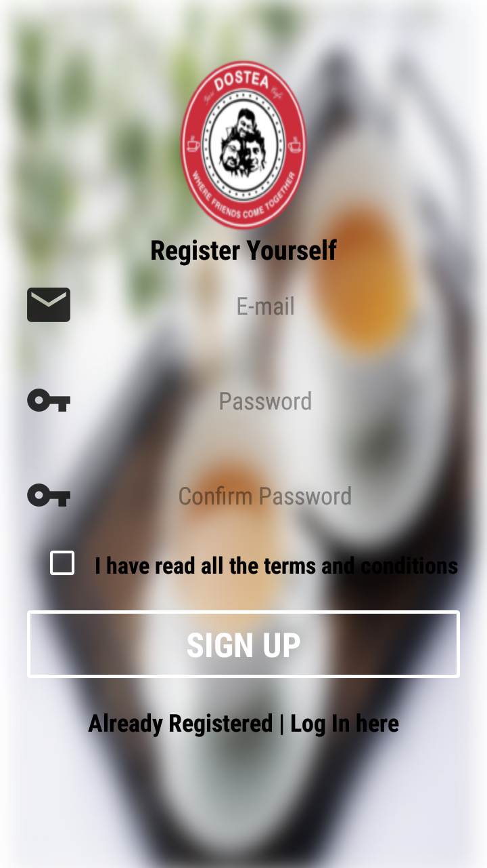

***Registration Page***

***Here you can register yourself***

***Just Enter your E-mail id and password and accept our terms and conditions and sign up***



***After that come back to the login page and login to continue..***

***“In case you forget your password then you can click on the “forget password” link and reset your password.”***

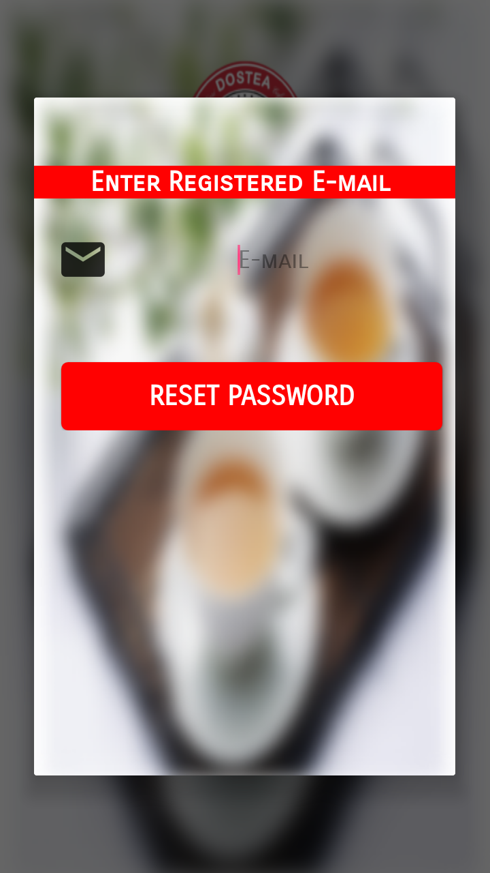

***Forget password link page***

***Here you can enter your registered email id address and reset your password***

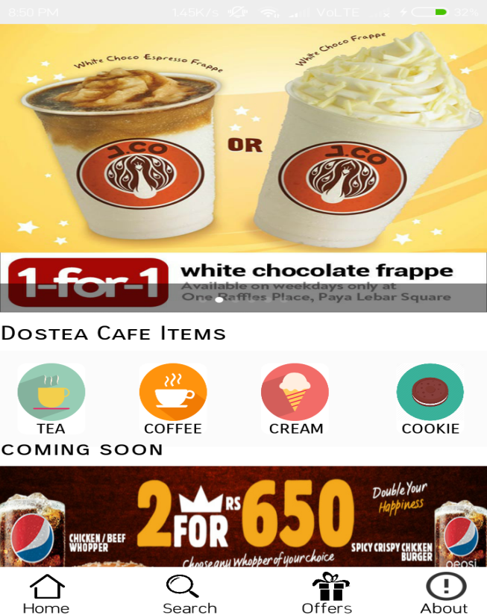

***Home Page***

***From this page you can do all the things like ordering, managing etc.***

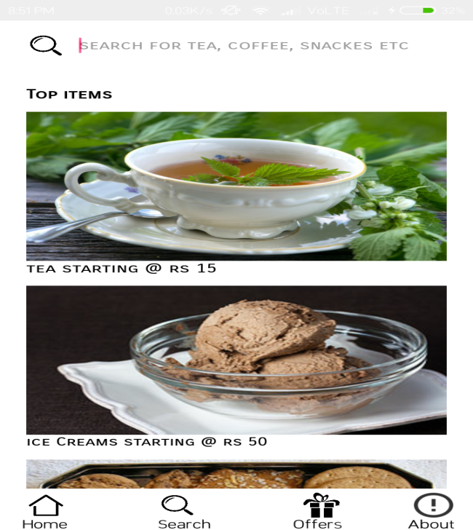

***Search page***

***I this page you can search your favourate items such as tea, coffee, ice cream etc.***

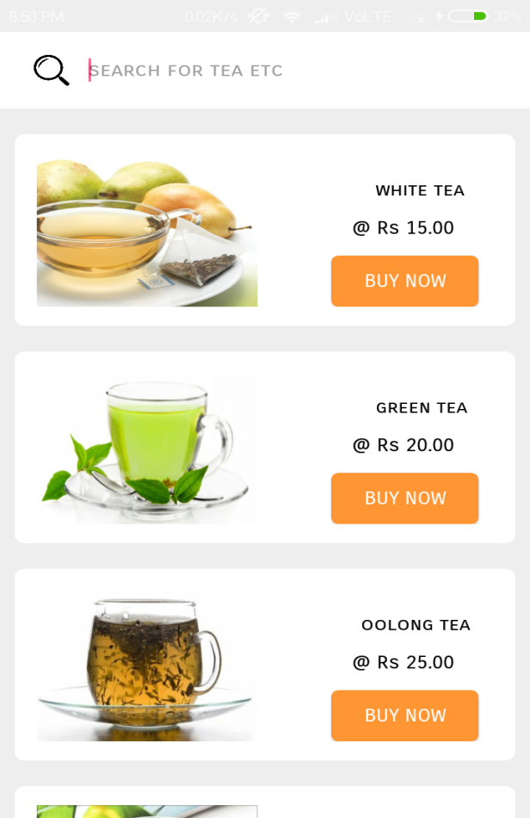

***Tea ordering Page***

***In this page you can found different variety of Tea available such as White Tea, Black Tea, Green Tea etc.***

***When clicking on “buy now option”***

***you will get…***

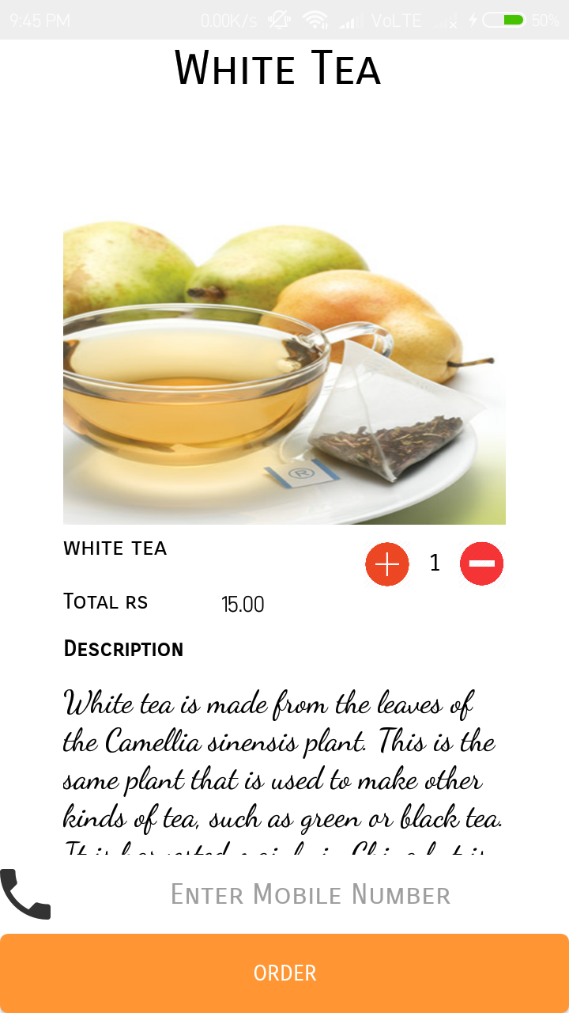

***Ordering page***

***In this page you can order the selected items and select the quantity and you can also read the description about that item while scrolling down.***

***After that you can order your item by providing your Mobile Number and if you get a successfully message, confirming your order, that means your order I s confirmed.***

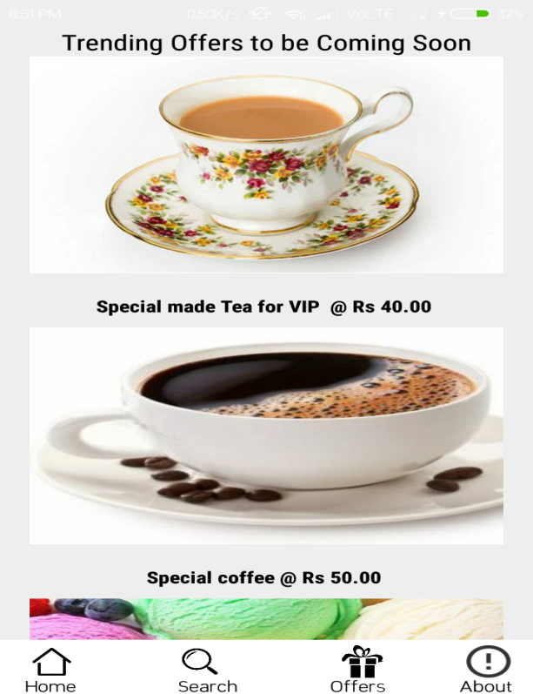

***Offers Page***

***In this page you can see the listed items that is to be coming soon***

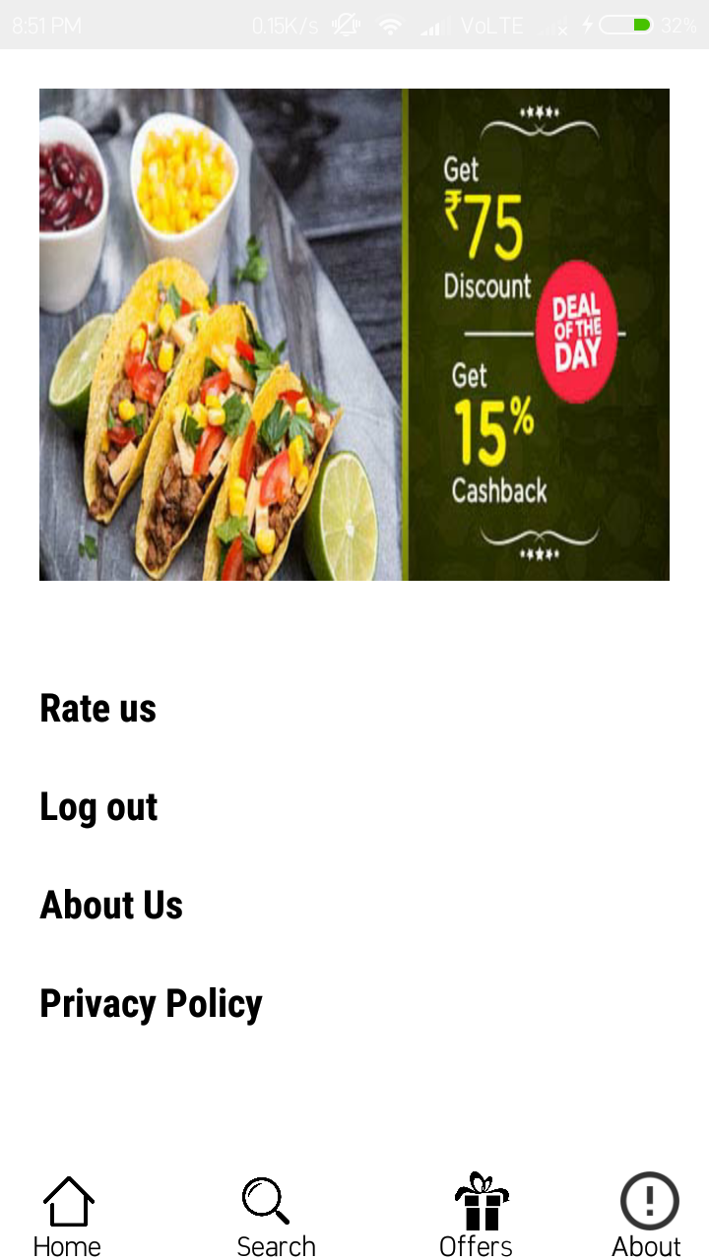

***About us Page***

***In this page you can rate our application and give feedback, logout your account, view our privacy policy and see about us.***

Project With Source Code

***Gradle biuld App***

|  |
| --- |
| *apply plugin: 'com.android.application'*  *android {*  *compileSdkVersion 27*  *defaultConfig {*  *applicationId "com.example.mohdarif.dostea"*  *minSdkVersion 22*  *targetSdkVersion 27*  *versionCode 1*  *versionName "1.0"*  *testInstrumentationRunner "android.support.test.runner.AndroidJUnitRunner"*  *}*  *buildTypes {*  *release {*  *minifyEnabled false*  *proguardFiles getDefaultProguardFile('proguard-android.txt'), 'proguard-rules.pro'*  *}*  *}*  *}*  *repositories {*  *mavenCentral()*  *}*  *dependencies {*  *implementation fileTree(dir: 'libs', include: ['*.jar'])*  *implementation 'com.android.support:appcompat-v7:27.1.1'*  *implementation 'com.android.support:design:27.1.1'*  *implementation 'com.android.support.constraint:constraint-layout:1.1.2'*  *testImplementation 'junit:junit:4.12'*  *compile 'com.google.firebase:firebase-core:16.0.0'*  *androidTestImplementation 'com.android.support.test:runner:1.0.2'*  *implementation 'com.facebook.android:facebook-login:[4,5)'*  *androidTestImplementation 'com.android.support.test.espresso:espresso-core:3.0.2'*  *implementation 'com.android.support:design:27.1.1'*  *compile 'com.google.firebase:firebase-auth:16.0.2'*  *compile 'com.google.firebase:firebase-database:16.0.1'*  *compile 'com.github.JakeWharton:ViewPagerIndicator:2.4.1'*  *compile 'com.android.support:appcompat-v7:24.2.1'*  *compile 'com.squareup.picasso:picasso:2.3.2'*  *compile 'com.nineoldandroids:library:2.4.0'*  *compile 'com.daimajia.slider:library:1.1.5@aar'*  *}*  *apply plugin: 'com.google.gms.google-services'* |

***AndroidManifest.xml***

|  |
| --- |
| *<?xml version="1.0" encoding="utf-8"?>*  *<manifest xmlns:android="http://schemas.android.com/apk/res/android"*  *package="com.example.mohdarif.dostea">*  *<uses-permission android:name="android.permission.INTERNET"/>*  *<uses-permission android:name="android.permission.READ_EXTERNAL_STORAGE" />*  *<uses-permission android:name="android.permission.SEND_SMS"/>*  *<uses-permission android:name="android.permission.RECEIVE_SMS"/>*  *<application*  *android:allowBackup="true"*  *android:icon="@mipmap/ic_launcher"*  *android:label="@string/app_name"*  *android:roundIcon="@drawable/logo"*  *android:supportsRtl="true"*  *android:theme="@style/AppTheme.NoActionBar">*  *<activity android:name=".SplashScreen">*  *<intent-filter>*  *<action android:name="android.intent.action.MAIN" />*  *<category android:name="android.intent.category.LAUNCHER" />*  *</intent-filter>*  *</activity>*  *<activity android:name=".LoginPage" />*  *<activity android:name=".RegistrationPage" />*  *<activity android:name=".ForgetPassword" />*  *<activity android:name=".MainActivity"></activity>*  *<activity android:name=".HomePage"></activity>*  *<activity android:name=".IceCream"></activity>*  *<activity android:name=".ConfirmOrder"></activity>*  *<activity android:name=".MenuPage"></activity>*  *<activity android:name=".ProfilePage"></activity>*  *<activity android:name=".AboutPage"></activity>*  *<activity android:name=".Tea"></activity>*  *<activity android:name=".Coffee"></activity>*  *<activity android:name=".Coffee1"></activity>*  *<activity android:name=".Coffee2"></activity>*  *<activity android:name=".Coffee3"></activity>*  *<activity android:name=".Coffee4"></activity>*  *<activity android:name=".Coffee5"></activity>*  *<activity android:name=".Coffee6"></activity>*  *<activity android:name=".Coffee7"></activity>*  *<activity android:name=".Coffee8"></activity>*  *<activity android:name=".NotFound"></activity>*  *<activity android:name=".Tea1"></activity>*  *<activity android:name=".Tea2"></activity>*  *<activity android:name=".Tea3"></activity>*  *<activity android:name=".Tea4"></activity>*  *<activity android:name=".Tea5"></activity>*  *<activity android:name="Tea6"></activity>*  *<activity android:name=".Tea7"></activity>*  *<activity android:name=".Tea8"></activity>*  *<activity android:name=".IceCream1"></activity>*  *<activity android:name=".IceCream2"></activity>*  *<activity android:name=".IceCream3"></activity>*  *<activity android:name=".IceCream4"></activity>*  *<activity android:name=".IceCream5"></activity>*  *<activity android:name=".IceCream6"></activity>*  *<activity android:name=".IceCream7"></activity>*  *<activity android:name=".IceCream8"></activity>*  *<activity android:name=".Cookie"></activity>*  *<activity android:name=".Cookie1"></activity>*  *<activity android:name=".Cookie2"></activity>*  *<activity android:name=".Cookie3"></activity>*  *<activity android:name=".Cookie4"></activity>*  *<activity android:name=".Cookie5"></activity>*  *<activity android:name=".Cookie6"></activity>*  *<activity android:name=".Cookie7"></activity>*  *<activity android:name=".Cookie8"></activity>*  *<activity android:name=".RateUs"></activity>*  *<activity android:name=".Offers"></activity>*  *<activity android:name=".PPolicy"></activity>*  *</application>*  *</manifest>* |

***Drawable username.xml (for giving shape to Button)***

|  |
| --- |
| *<?xml version="1.0" encoding="utf-8"?>*  *<shape xmlns:android="http://schemas.android.com/apk/res/android">*  *<solid android:color="#f01f05"></solid>*  *<corners android:radius="6dp"></corners>*  *</shape>* |

***Splash Screen***

***splash.xml***

|  |
| --- |
| *<?xml version="1.0" encoding="utf-8"?>*  *<RelativeLayout*  *xmlns:android="http://schemas.android.com/apk/res/android"*  *xmlns:tools="http://schemas.android.com/tools"*  *android:layout_width="match_parent"*  *android:layout_height="match_parent"*  *android:background="#ffffff"*  *android:layout_marginLeft="0dp"*  *>*  *<ImageView*  *android:layout_width="200dp"*  *android:id="@+id/welcome"*  *android:layout_height="200dp"*  *android:layout_marginLeft="-0dp"*  *android:background="@drawable/frontphoto"*  *android:foregroundGravity="center"*  *android:layout_centerInParent="true"*  */>*  *</RelativeLayout>* |

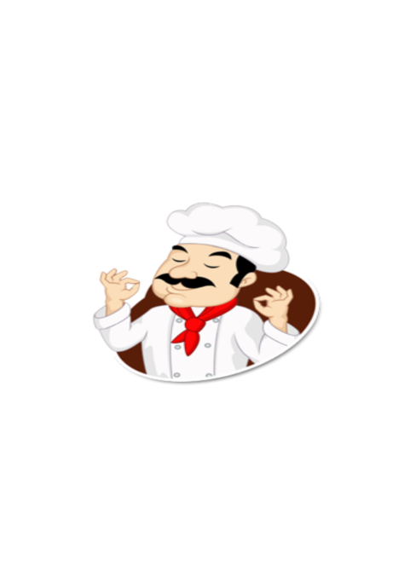

***SplashScreen.java***

|  |
| --- |
| *package com.example.mohdarif.dostea;*  *import android.content.Intent;*  *import android.os.Bundle;*  *import android.os.Handler;*  *import android.support.v7.app.AppCompatActivity;*  *import android.view.Window;*  *import android.view.WindowManager;*  *import android.widget.TextView;*  *public class SplashScreen extends AppCompatActivity{*  *private static int splashTimeOut = 2000;*  *@Override*  *protected void onCreate(Bundle savedInstanceState) {*  *super.onCreate(savedInstanceState);*  *this.getWindow().setFlags(WindowManager.LayoutParams.FLAG_FULLSCREEN,WindowManager.LayoutParams.FLAG_FULLSCREEN);*  *setContentView(R.layout.splash);*  *new Handler().postDelayed(new Runnable() {*  *@Override*  *public void run() {*  *Intent intent = new Intent(getApplicationContext(),MainActivity.class);*  *startActivity(intent);*  *finish();*  *}*  *},splashTimeOut);*  *}*  *}* |

***GetStartedPage***



***activity_main.xml***

|  |
| --- |
| *<?xml version="1.0" encoding="utf-8"?>*  *<RelativeLayout xmlns:android="http://schemas.android.com/apk/res/android"*  *xmlns:app="http://schemas.android.com/apk/res-auto"*  *xmlns:tools="http://schemas.android.com/tools"*  *android:layout_width="match_parent"*  *android:layout_height="match_parent"*  *tools:context=".MainActivity">*  *<RelativeLayout*  *android:layout_width="380dp"*  *android:background="@drawable/mainphoto"*  *android:layout_height="match_parent"*  *>*  *<TextView*  *android:padding="20dp"*  *android:layout_centerHorizontal="true"*  *android:layout_width="wrap_content"*  *android:layout_height="wrap_content"*  *android:text="If you are cold, tea will warm you if you are too heated, it will cool you If you are depressed, it will cheer you If you are excited, it will calm you."*  *android:textColor="#ffffff"*  *android:fontFamily="sans-serif-condensed"*  *android:textSize="30dp"*  *android:textAlignment="center"*  *android:textStyle="italic"*  *android:layout_marginTop="50dp"*  */>*  *</RelativeLayout>*  *<Button*  *android:id="@+id/getstart"*  *android:layout_width="250dp"*  *android:layout_height="50dp"*  *android:text="GET STARTED"*  *android:background="@drawable/mybutton"*  *android:layout_alignParentBottom="true"*  *android:textColor="#ffffff"*  *android:fontFamily="sans-serif-smallcaps"*  *android:textSize="25dp"*  *android:layout_marginBottom="50dp"*  *android:layout_centerHorizontal="true"*  */>*  *</RelativeLayout>* |

***MainActivity.java***

|  |
| --- |
| *package com.example.mohdarif.dostea;*  *import android.content.Intent;*  *import android.support.v7.app.AppCompatActivity;*  *import android.os.Bundle;*  *import android.view.View;*  *import android.view.Window;*  *import android.view.WindowManager;*  *import android.widget.Button;*  *import android.widget.ImageView;*  *import android.widget.TextView;*  *import com.daimajia.slider.library.Animations.DescriptionAnimation;*  *import com.daimajia.slider.library.SliderLayout;*  *import com.daimajia.slider.library.SliderTypes.BaseSliderView;*  *import com.daimajia.slider.library.SliderTypes.TextSliderView;*  *import com.daimajia.slider.library.Tricks.ViewPagerEx;*  *import java.util.HashMap;*  *public class MainActivity extends AppCompatActivity{*  *Button button;*  *SliderLayout sliderLayout;*  *@Override*  *protected void onCreate(Bundle savedInstanceState) {*  *super.onCreate(savedInstanceState);*  *setContentView(R.layout.activity_main);*  *this.getWindow().setFlags(WindowManager.LayoutParams.FLAG_FULLSCREEN, WindowManager.LayoutParams.FLAG_FULLSCREEN);*  *button = (Button) findViewById(R.id.getstart);*  *button.setOnClickListener(new View.OnClickListener() {*  *@Override*  *public void onClick(View v) {*  *Intent intent = new Intent(getApplicationContext(), LoginPage.class);*  *startActivity(intent);*  *finish();*  *}*  *});*  *}*  *}* |

***Login Page***



***login.xml***

|  |
| --- |
| *<?xml version="1.0" encoding="utf-8"?>*  *<ScrollView*  *xmlns:android="http://schemas.android.com/apk/res/android"*  *android:layout_width="match_parent"*  *android:background="@drawable/tea"*  *android:alpha="5"*  *android:layout_height="match_parent">*  *<RelativeLayout*  *android:layout_width="wrap_content"*  *android:orientation="vertical"*  *android:layout_height="wrap_content"*  *>*  *<ImageView*  *android:layout_width="150dp"*  *android:layout_height="150dp"*  *android:background="@drawable/logo"*  *android:layout_marginTop="30dp"*  *android:layout_centerHorizontal="true"*  */>*  *<TextView*  *android:layout_width="400dp"*  *android:layout_height="wrap_content"*  *android:layout_marginTop="170dp"*  *android:text="Login Now"*  *android:textColor="#000000"*  *android:textAlignment="center"*  *android:textSize="25dp"*  *android:fontFamily="sans-serif-condensed"*  */>*  *<EditText*  *android:id="@+id/username"*  *android:layout_width="300dp"*  *android:layout_height="50dp"*  *android:hint="@string/username"*  *android:background="@null"*  *android:textAlignment="center"*  *android:drawableLeft="@drawable/usericon"*  *android:layout_marginLeft="70px"*  *android:fontFamily="sans-serif-condensed"*  *android:textColor="#000000"*  *android:layout_marginTop="220dp"*  */>*  *<EditText*  *android:id="@+id/password"*  *android:layout_width="300dp"*  *android:layout_height="50dp"*  *android:textAlignment="center"*  *android:hint="@string/password"*  *android:drawableLeft="@drawable/passicon"*  *android:background="@null"*  *android:layout_marginLeft="70px"*  *android:textColor="#000000"*  *android:layout_marginTop="320dp"*  *android:fontFamily="sans-serif-condensed"*  *android:inputType="textPassword"*  */>*  *<TextView*  *android:id="@+id/forgetpassword"*  *android:layout_width="match_parent"*  *android:layout_height="match_parent"*  *android:text="Forget Password ?"*  *android:textSize="20dp"*  *android:textColor="#000000"*  *android:layout_marginTop="380dp"*  *android:fontFamily="sans-serif-condensed"*  *android:layout_marginLeft="155dp"*  */>*  *<Button*  *android:id="@+id/login"*  *android:layout_width="300dp"*  *android:layout_height="50dp"*  *android:text="Login"*  *android:textSize="20dp"*  *android:layout_marginTop="430dp"*  *android:textColor="#ffffff"*  *android:textStyle="bold"*  *android:layout_centerHorizontal="true"*  *android:background="@drawable/mybutton"*  *android:layout_marginLeft="40dp"*  *android:fontFamily="sans-serif-condensed"*  */>*  *<TextView*  *android:layout_width="match_parent"*  *android:layout_height="match_parent"*  *android:text="OR"*  *android:textStyle="bold"*  *android:fontFamily="sans-serif-condensed"*  *android:textColor="#000000"*  *android:layout_marginLeft="180dp"*  *android:textSize="20dp"*  *android:layout_marginTop="490dp"*  */>*  *<TextView*  *android:layout_width="match_parent"*  *android:layout_height="match_parent"*  *android:drawableLeft="@drawable/newaccount"*  *android:layout_marginTop="520dp"*  *android:layout_marginLeft="270dp"*  */>*  *<TextView*  *android:layout_width="match_parent"*  *android:layout_height="match_parent"*  *android:text="New User ?"*  *android:textColor="#000000"*  *android:textStyle="bold"*  *android:textSize="20dp"*  *android:fontFamily="sans-serif-condensed"*  *android:layout_marginTop="520dp"*  *android:layout_marginLeft="60dp"*  */>*  *<TextView*  *android:id="@+id/newaccount"*  *android:layout_width="match_parent"*  *android:layout_height="match_parent"*  *android:text="Sign up here"*  *android:textColor="#ffffff"*  *android:textStyle="bold"*  *android:textSize="20dp"*  *android:fontFamily="sans-serif-condensed"*  *android:layout_marginTop="520dp"*  *android:layout_marginLeft="155dp"*  */>*  *<ProgressBar*  *android:id="@+id/progressBar"*  *android:layout_width="30dp"*  *android:layout_height="30dp"*  *android:layout_centerHorizontal="true"*  *android:layout_gravity="center|bottom"*  *android:layout_marginTop="500dp"*  *android:visibility="gone" />*  *</RelativeLayout>*  *</ScrollView>* |

***LoginPage.java***

|  |
| --- |
| *package com.example.mohdarif.dostea;*  *import android.content.Intent;*  *import android.os.Bundle;*  *import android.support.annotation.NonNull;*  *import android.support.design.widget.Snackbar;*  *import android.support.v7.app.AlertDialog;*  *import android.support.v7.app.AppCompatActivity;*  *import android.text.TextUtils;*  *import android.util.Base64;*  *import android.util.Log;*  *import android.view.LayoutInflater;*  *import android.view.MotionEvent;*  *import android.view.View;*  *import android.view.Window;*  *import android.view.WindowManager;*  *import android.widget.Button;*  *import android.widget.EditText;*  *import android.widget.ProgressBar;*  *import android.widget.TextView;*  *import android.widget.Toast;*  *import com.google.android.gms.tasks.OnCompleteListener;*  *import com.google.android.gms.tasks.Task;*  *import com.google.firebase.auth.AuthResult;*  *import com.google.firebase.auth.FirebaseAuth;*  *import com.google.firebase.auth.FirebaseUser;*  *import com.google.firebase.database.DatabaseReference;*  *import java.security.MessageDigest;*  *import java.security.NoSuchAlgorithmException;*  *public class LoginPage extends AppCompatActivity {*  *Button login,facebook,google;*  *DatabaseReference demoRef;*  *TextView newAccount,forgetpassword;*  *EditText username,password;*  *String Username;*  *String Password;*  *private FirebaseAuth auth;*  *private ProgressBar progressBar;*  *@Override*  *protected void onCreate(Bundle savedInstanceState) {*  *super.onCreate(savedInstanceState);*  *auth = FirebaseAuth.getInstance();*  *if (auth.getCurrentUser() != null) {*  *startActivity(new Intent(LoginPage.this, HomePage.class));*  *finish();*  *}*  *setContentView(R.layout.loginpage);*  *this.getWindow().setFlags(WindowManager.LayoutParams.FLAG_FULLSCREEN,*  *WindowManager.LayoutParams.FLAG_FULLSCREEN);*  *login = (Button)findViewById(R.id.login);*  *progressBar = (ProgressBar) findViewById(R.id.progressBar);*  *newAccount = (TextView)findViewById(R.id.newaccount);*  *forgetpassword = (TextView)findViewById(R.id.forgetpassword);*  *forgetpassword.setOnClickListener(new View.OnClickListener() {*  *@Override*  *public void onClick(View v) {*  *resetPassword();*  *}*  *});*  *username = (EditText)findViewById(R.id.username);*  *password = (EditText)findViewById(R.id.password);*  *auth = FirebaseAuth.getInstance();*  *login.setOnClickListener(new View.OnClickListener() {*  *@Override*  *public void onClick (View v){*  *String Email = username.getText().toString();*  *final String Password = password.getText().toString();*  *if (TextUtils.isEmpty(Email)) {*  *Toast.makeText(getApplicationContext(), "Enter email address!", Toast.LENGTH_SHORT).show();*  *return;*  *}*  *if (TextUtils.isEmpty(Password)) {*  *Toast.makeText(getApplicationContext(), "Enter password!", Toast.LENGTH_SHORT).show();*  *return;*  *}*  *progressBar.setVisibility(View.VISIBLE);*  *auth.signInWithEmailAndPassword(Email, Password)*  *.addOnCompleteListener(LoginPage.this, new OnCompleteListener<AuthResult>() {*  *@Override*  *public void onComplete(@NonNull Task<AuthResult> task) {*  *progressBar.setVisibility(View.GONE);*  *if (!task.isSuccessful()) {*  *if (password.length() < 6) {*  *Toast.makeText(getApplicationContext(), "Password must of minimun 6 words", Toast.LENGTH_LONG).show();*  *} else {*  *username.setText("");*  *password.setText("");*  *Toast.makeText(getApplicationContext(), "Invalid username or password", Toast.LENGTH_LONG).show();*  *}*  *} else {*  *Intent intent = new Intent(getApplicationContext(), HomePage.class);*  *startActivity(intent);*  *finish();*  *}*  *}*  *});*  *}*  *});*  *newAccount.setOnClickListener(new View.OnClickListener() {*  *@Override*  *public void onClick(View v) {*  *Intent intent = new Intent(getApplicationContext(),RegistrationPage.class);*  *startActivity(intent);*  *}*  *});*  *}*  *@Override*  *public void onBackPressed() {*  *super.onBackPressed();*  *finish();*  *}*  *private void resetPassword() {*  *final AlertDialog.Builder dialogBuilder = new AlertDialog.Builder(this);*  *LayoutInflater inflater = getLayoutInflater();*  *final View dialogView = inflater.inflate(R.layout.forget_password, null);*  *dialogBuilder.setView(dialogView);*  *final EditText editEmail = (EditText) dialogView.findViewById(R.id.email1);*  *final Button btnReset = (Button) dialogView.findViewById(R.id.resetPassword);*  *final ProgressBar progressBar1 = (ProgressBar) dialogView.findViewById(R.id.progressBar);*  *//dialogBuilder.setTitle("Send Photos");*  *final AlertDialog dialog = dialogBuilder.create();*  *btnReset.setOnClickListener(new View.OnClickListener() {*  *public void onClick(View v) {*  *String email = editEmail.getText().toString().trim();*  *if (TextUtils.isEmpty(email)) {*  *Toast.makeText(getApplication(), "Enter your registered email id", Toast.LENGTH_SHORT).show();*  *return;*  *}*  *progressBar1.setVisibility(View.VISIBLE);*  *auth.sendPasswordResetEmail(email)*  *.addOnCompleteListener(new OnCompleteListener<Void>() {*  *@Override*  *public void onComplete(@NonNull Task<Void> task) {*  *if (task.isSuccessful()) {*  *Toast.makeText(getApplicationContext(), "We have sent you instructions to reset your password!", Toast.LENGTH_SHORT).show();*  *} else {*  *Toast.makeText(getApplicationContext(), "Failed to send reset email!", Toast.LENGTH_SHORT).show();*  *}*  *progressBar1.setVisibility(View.GONE);*  *dialog.dismiss();*  *}*  *});*  *}*  *});*  *dialog.show();*  *}*  *}* |

***Forget Password pag***



***forget_password.xml***

|  |
| --- |
| *<?xml version="1.0" encoding="utf-8"?>*  *<ScrollView*  *xmlns:android="http://schemas.android.com/apk/res/android"*  *android:layout_width="320dp"*  *android:background="@drawable/tea"*  *android:layout_height="match_parent">*  *<LinearLayout*  *android:layout_width="match_parent"*  *android:layout_height="match_parent"*  *android:orientation="vertical">*  *<TextView*  *android:layout_width="match_parent"*  *android:layout_height="match_parent"*  *android:text="Enter Registered E-mail "*  *android:textColor="#ffffff"*  *android:textStyle="bold"*  *android:fontFamily="sans-serif-smallcaps"*  *android:textSize="20dp"*  *android:background="#ff0101"*  *android:textAlignment="center"*  *android:layout_marginTop="50dp"*  */>*  *<EditText*  *android:id="@+id/email1"*  *android:layout_width="280dp"*  *android:layout_height="50dp"*  *android:background="@null"*  *android:hint="@string/email"*  *android:textAlignment="center"*  *android:fontFamily="sans-serif-smallcaps"*  *android:textColor="#000000"*  *android:drawableLeft="@drawable/emailicon"*  *android:layout_marginTop="20dp"*  *android:inputType="textEmailAddress"*  *android:layout_marginLeft="20dp"*  */>*  *<Button*  *android:id="@+id/resetPassword"*  *android:layout_width="280dp"*  *android:layout_height="50dp"*  *android:text="Reset Password"*  *android:fontFamily="sans-serif-smallcaps"*  *android:textColor="#ffffff"*  *android:background="@drawable/signup"*  *android:layout_marginLeft="20dp"*  *android:layout_marginTop="50dp"*  *android:textStyle="bold"*  *android:textSize="20dp"*  */>*  *<ProgressBar*  *android:id="@+id/progressBar"*  *android:layout_width="30dp"*  *android:layout_height="30dp"*  *android:layout_marginBottom="10dp"*  *android:visibility="gone" />*  *</LinearLayout>*  *</ScrollView>* |

***ForgetPassword.java***

|  |
| --- |
| *package com.example.mohdarif.dostea;*  *import android.os.Bundle;*  *import android.support.v7.app.AppCompatActivity;*  *import android.view.Window;*  *import android.view.WindowManager;*  *public class ForgetPassword extends AppCompatActivity {*  *@Override*  *protected void onCreate(Bundle savedInstanceState) {*  *super.onCreate(savedInstanceState);*  *requestWindowFeature(Window.FEATURE_NO_TITLE);*  *getSupportActionBar().hide();*  *setContentView(R.layout.forget_password);*  *this.getWindow().setFlags(WindowManager.LayoutParams.FLAG_FULLSCREEN,WindowManager.LayoutParams.FLAG_FULLSCREEN);*  *}*  *}* |

***Registration Page***



***registration.xml***

|  |
| --- |
| *<?xml version="1.0" encoding="utf-8"?>*  *<ScrollView*  *xmlns:android="http://schemas.android.com/apk/res/android"*  *android:layout_width="match_parent"*  *android:layout_height="match_parent"*  *android:background="@drawable/tea"*  *>*  *<RelativeLayout*  *android:layout_width="match_parent"*  *android:layout_height="match_parent"*  *>*  *<ImageView*  *android:layout_width="150dp"*  *android:layout_height="150dp"*  *android:layout_centerHorizontal="true"*  *android:background="@drawable/logo"*  *android:layout_marginLeft="100dp"*  *android:layout_marginTop="30dp"*  */>*  *<TextView*  *android:layout_width="wrap_content"*  *android:layout_height="wrap_content"*  *android:text="Register Yourself"*  *android:textStyle="bold"*  *android:textColor="#000000"*  *android:layout_marginLeft="100dp"*  *android:fontFamily="sans-serif-condensed"*  *android:textSize="20dp"*  *android:textAlignment="center"*  *android:layout_marginTop="170dp"*  *android:layout_centerHorizontal="true"*  */>*  *<EditText*  *android:id="@+id/email"*  *android:layout_width="320dp"*  *android:layout_height="50dp"*  *android:layout_marginTop="200dp"*  *android:layout_centerHorizontal="true"*  *android:background="@null"*  *android:textColor="#000000"*  *android:drawableLeft="@drawable/emailicon"*  *android:hint="@string/email"*  *android:fontFamily="sans-serif-condensed"*  *android:textAlignment="center"*  *android:layout_marginLeft="20dp"*  *android:inputType="textEmailAddress"*  */>*  *<EditText*  *android:id="@+id/password"*  *android:layout_width="320dp"*  *android:layout_height="50dp"*  *android:layout_marginTop="270dp"*  *android:layout_centerHorizontal="true"*  *android:layout_marginLeft="20dp"*  *android:drawableLeft="@drawable/passicon"*  *android:background="@null"*  *android:textColor="#000000"*  *android:hint="@string/password"*  *android:textAlignment="center"*  *android:inputType="textPassword"*  *android:fontFamily="sans-serif-condensed"*  */>*  *<EditText*  *android:id="@+id/cpassword"*  *android:layout_width="320dp"*  *android:layout_height="50dp"*  *android:layout_marginTop="340dp"*  *android:layout_marginLeft="20dp"*  *android:background="@null"*  *android:layout_centerHorizontal="true"*  *android:drawableLeft="@drawable/passicon"*  *android:textColor="#000000"*  *android:hint="@string/cpassword"*  *android:textAlignment="center"*  *android:inputType="textPassword"*  *android:fontFamily="sans-serif-condensed"*  */>*  *<CheckBox*  *android:id="@+id/accept"*  *android:layout_width="30dp"*  *android:layout_height="30dp"*  *android:layout_marginTop="400dp"*  *android:layout_marginLeft="30dp"*  *android:buttonTint="#ffffff"*  */>*  *<TextView*  *android:layout_width="match_parent"*  *android:layout_height="match_parent"*  *android:text="I have read all the terms and conditions"*  *android:fontFamily="sans-serif-condensed"*  *android:textColor="#000000"*  *android:layout_marginLeft="70dp"*  *android:textStyle="bold"*  *android:textSize="17dp"*  *android:layout_marginTop="405dp"*  */>*  *<Button*  *android:id="@+id/signup"*  *android:layout_width="320dp"*  *android:layout_height="50dp"*  *android:text="Sign Up"*  *android:layout_centerHorizontal="true"*  *android:fontFamily="sans-serif-condensed"*  *android:background="@drawable/mybutton"*  *android:layout_marginTop="450dp"*  *android:layout_marginLeft="20dp"*  *android:textColor="#ffffff"*  *android:textStyle="bold"*  *android:textSize="25dp"*  */>*  *<TextView*  *android:id="@+id/login"*  *android:layout_width="match_parent"*  *android:layout_height="match_parent"*  *android:layout_centerHorizontal="true"*  *android:text="Already Registered | Log In here"*  *android:fontFamily="sans-serif-condensed"*  *android:textColor="#000000"*  *android:textSize="18dp"*  *android:layout_marginTop="520dp"*  *android:layout_marginLeft="130dp"*  *android:textStyle="bold"*  */>*  *<ProgressBar*  *android:id="@+id/progressBar"*  *android:layout_width="30dp"*  *android:layout_height="30dp"*  *android:layout_gravity="center|bottom"*  *android:layout_marginBottom="50dp"*  *android:visibility="gone" />*  *</RelativeLayout>*  *</ScrollView>* |

***RegistrationPage.java***

|  |
| --- |
| *package com.example.mohdarif.dostea;*  *import android.content.Intent;*  *import android.os.Bundle;*  *import android.support.annotation.NonNull;*  *import android.support.v7.app.AlertDialog;*  *import android.support.v7.app.AppCompatActivity;*  *import android.text.TextUtils;*  *import android.util.Log;*  *import android.view.LayoutInflater;*  *import android.view.View;*  *import android.view.WindowManager;*  *import android.widget.Button;*  *import android.widget.CheckBox;*  *import android.widget.EditText;*  *import android.widget.ProgressBar;*  *import android.widget.TextView;*  *import android.widget.Toast;*  *import com.google.android.gms.tasks.OnCompleteListener;*  *import com.google.android.gms.tasks.Task;*  *import com.google.firebase.auth.AuthResult;*  *import com.google.firebase.auth.FirebaseAuth;*  *import com.google.firebase.auth.FirebaseUser;*  *import com.google.firebase.database.DatabaseReference;*  *import com.google.firebase.database.FirebaseDatabase;*  *public class RegistrationPage extends AppCompatActivity {*  *EditText email, password, cpassword;*  *Button signup;*  *TextView login;*  *CheckBox accept;*  *AlertDialog.Builder builder;*  *private ProgressBar progressBar;*  *private FirebaseAuth auth;*  *private DatabaseReference mDatabase;*  *private FirebaseDatabase firebaseDatabase;*  *@Override*  *protected void onCreate(Bundle savedInstanceState) {*  *super.onCreate(savedInstanceState);*  *setContentView(R.layout.registration_page);*  *this.getWindow().setFlags(WindowManager.LayoutParams.FLAG_FULLSCREEN, WindowManager.LayoutParams.FLAG_FULLSCREEN);*  *email = (EditText) findViewById(R.id.email);*  *password = (EditText) findViewById(R.id.password);*  *cpassword = (EditText) findViewById(R.id.cpassword);*  *accept = (CheckBox) findViewById(R.id.accept);*  *signup = (Button) findViewById(R.id.signup);*  *login = (TextView) findViewById(R.id.login);*  *progressBar = (ProgressBar) findViewById(R.id.progressBar);*  *builder = new AlertDialog.Builder(this);*  *auth = FirebaseAuth.getInstance();*  *firebaseDatabase = FirebaseDatabase.getInstance();*  *mDatabase = firebaseDatabase.getInstance().getReference("Users");*  *login.setOnClickListener(new View.OnClickListener() {*  *@Override*  *public void onClick(View v) {*  *Intent intent = new Intent(getApplicationContext(), LoginPage.class);*  *startActivity(intent);*  *finish();*  *}*  *});*  *signup.setOnClickListener(new View.OnClickListener() {*  *@Override*  *public void onClick(View v) {*  *String Email = email.getText().toString().trim();*  *String Password = password.getText().toString().trim();*  *String Cpassword = cpassword.getText().toString().trim();*  *if (TextUtils.isEmpty(Email)) {*  *email.setError("this field cannot be empty");*  *Toast.makeText(getApplicationContext(), "Enter email address!", Toast.LENGTH_SHORT).show();*  *return;*  *}*  *else if (TextUtils.isEmpty(Password)) {*  *password.setError("this field cannot be empty");*  *Toast.makeText(getApplicationContext(), "Enter password!", Toast.LENGTH_SHORT).show();*  *return;*  *}*  *else if (TextUtils.isEmpty(Cpassword)) {*  *cpassword.setError("this field cannot be empty");*  *Toast.makeText(getApplicationContext(), "Confirm password!", Toast.LENGTH_SHORT).show();*  *return;*  *}*  *else if (accept.isChecked()==false) {*  *Toast.makeText(getApplicationContext(),"Accept our terms and conditions",Toast.LENGTH_SHORT).show();*  *}*  *else if (password.length() < 6) {*  *Toast.makeText(getApplicationContext(), "Password too short, enter minimum 6 characters!", Toast.LENGTH_SHORT).show();*  *return;*  *}*  *else if (Password.equals(Cpassword)==false) {*  *Toast.makeText(getApplicationContext(),"Password not matching",Toast.LENGTH_LONG).show();*  *}*  *else {*  *auth.createUserWithEmailAndPassword(Email,Password)*  *.addOnCompleteListener(RegistrationPage.this, new OnCompleteListener<AuthResult>() {*  *@Override*  *public void onComplete(@NonNull Task<AuthResult> task) {*  *if (!task.isSuccessful()) {*  *Toast.makeText(getApplicationContext(), "Authentication failed." + task.getException(),*  *Toast.LENGTH_SHORT).show();*  *} else {*  *Toast.makeText(getApplicationContext(), "Account Created", Toast.LENGTH_SHORT).show();*  *startActivity(new Intent(getApplicationContext(), LoginPage.class));*  *finish();*  *}*  *}*  *});*  *}*  *}*  *});*  *}*  *@Override*  *public void onBackPressed() {*  *finish();*  *}*  *protected void onResume() {*  *super.onResume();*  *progressBar.setVisibility(View.GONE);*  *}*  *}* |

***Home Page***

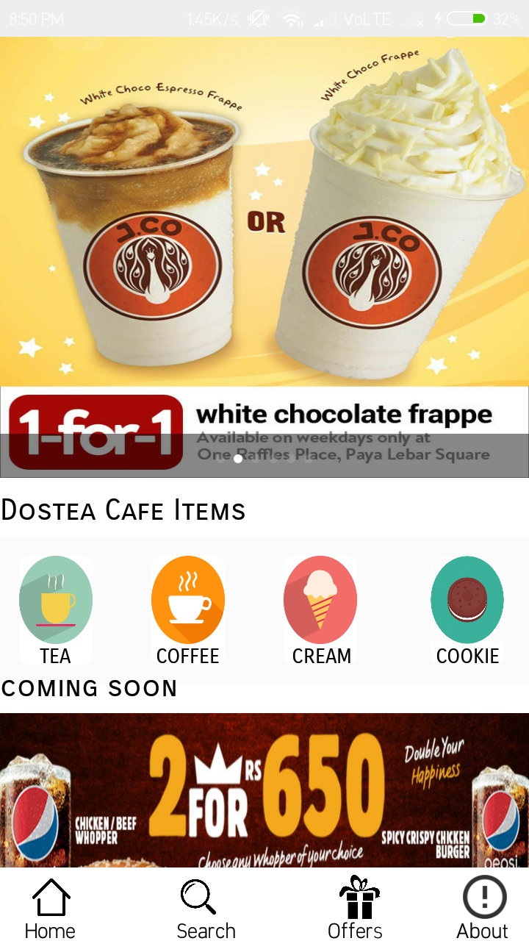

***home_page.xml***

|  |
| --- |
| *<?xml version="1.0" encoding="utf-8"?>*  *<RelativeLayout android:layout_width="match_parent"*  *android:layout_height="match_parent"*  *xmlns:android="http://schemas.android.com/apk/res/android"*  *xmlns:app="http://schemas.android.com/apk/res-auto"*  *android:background="#ffffff">*  *<ScrollView*  *android:layout_width="match_parent"*  *android:layout_height="match_parent"*  *>*  *<RelativeLayout*  *android:layout_width="match_parent"*  *android:layout_height="match_parent"*  *android:layout_marginTop="0dp"*  *>*  *<RelativeLayout*  *android:layout_width="fill_parent"*  *android:layout_height="300dp"*  *android:layout_alignParentTop="true"*  *>*  *<com.daimajia.slider.library.SliderLayout*  *android:id="@+id/slider"*  *android:layout_width="match_parent"*  *android:background="@drawable/homepagemenuitems"*  *android:layout_height="300dp"*  */>*  *</RelativeLayout>*  *<TextView*  *android:layout_width="wrap_content"*  *android:layout_height="wrap_content"*  *android:text="Dostea Cafe Items"*  *android:textAlignment="textStart"*  *android:fontFamily="sans-serif-smallcaps"*  *android:textColor="#000000"*  *android:textSize="20dp"*  *android:layout_marginTop="310dp"*  */>*  *<RelativeLayout*  *android:layout_width="match_parent"*  *android:background="#fbfbfb"*  *android:layout_height="100dp"*  *android:layout_marginTop="340dp"*  *android:padding="13dp"*  *android:fadingEdge="horizontal"*  *>*  *<RelativeLayout*  *android:layout_width="50dp"*  *android:layout_height="80dp"*  *android:background="@drawable/homepagemenuitems"*  *android:layout_marginLeft="0dp"*  *android:layout_marginTop="0dp"*  *>*  *<ImageView*  *android:id="@+id/tea"*  *android:layout_width="match_parent"*  *android:layout_height="60dp"*  *android:background="@drawable/teaicon"*  */>*  *<TextView*  *android:layout_width="wrap_content"*  *android:layout_height="wrap_content"*  *android:text="TEA"*  *android:textColor="#000000"*  *android:textAlignment="center"*  *android:fontFamily="sans-serif-smallcaps"*  *android:layout_marginTop="60dp"*  *android:layout_marginLeft="14dp"*  */>*  *</RelativeLayout>*  *<RelativeLayout*  *android:layout_width="50dp"*  *android:layout_height="80dp"*  *android:background="@drawable/homepagemenuitems"*  *android:layout_marginLeft="90dp"*  *>*  *<ImageView*  *android:id="@+id/coffee"*  *android:layout_width="match_parent"*  *android:layout_height="60dp"*  *android:background="@drawable/coffeeicon"*  */>*  *<TextView*  *android:layout_width="wrap_content"*  *android:layout_height="wrap_content"*  *android:text="COFFEE"*  *android:textColor="#000000"*  *android:textAlignment="center"*  *android:fontFamily="sans-serif-smallcaps"*  *android:layout_marginTop="60dp"*  *android:layout_marginLeft="3dp"*  */>*  *</RelativeLayout>*  *<RelativeLayout*  *android:layout_width="50dp"*  *android:layout_height="80dp"*  *android:background="@drawable/homepagemenuitems"*  *android:layout_marginLeft="180dp"*  *>*  *<ImageView*  *android:id="@+id/icecream"*  *android:layout_width="match_parent"*  *android:layout_height="60dp"*  *android:background="@drawable/icecreamicon"*  */>*  *<TextView*  *android:layout_width="wrap_content"*  *android:layout_height="wrap_content"*  *android:text="CREAMS"*  *android:textColor="#000000"*  *android:textAlignment="center"*  *android:fontFamily="sans-serif-smallcaps"*  *android:layout_marginTop="60dp"*  *android:layout_marginLeft="2dp"*  */>*  *</RelativeLayout>*  *<RelativeLayout*  *android:layout_width="50dp"*  *android:layout_height="80dp"*  *android:background="@drawable/homepagemenuitems"*  *android:layout_marginLeft="280dp"*  *>*  *<ImageView*  *android:id="@+id/cookie"*  *android:layout_width="match_parent"*  *android:layout_height="60dp"*  *android:background="@drawable/biscuiticon"*  */>*  *<TextView*  *android:layout_width="wrap_content"*  *android:layout_height="wrap_content"*  *android:text="COOKIES"*  *android:textColor="#000000"*  *android:textAlignment="center"*  *android:fontFamily="sans-serif-smallcaps"*  *android:layout_marginTop="60dp"*  *android:layout_marginLeft="0dp"*  */>*  *</RelativeLayout>*  *</RelativeLayout>*  *<TextView*  *android:layout_width="wrap_content"*  *android:layout_height="900dp"*  *android:text="coming soon"*  *android:layout_marginTop="430dp"*  *android:textColor="#000000"*  *android:fontFamily="sans-serif-smallcaps"*  *android:textSize="20dp"*  */>*  *<RelativeLayout*  *android:layout_width="match_parent"*  *android:layout_height="wrap_content"*  *android:layout_marginTop="460dp"*  *>*  *<ImageView*  *android:id="@+id/comingitems"*  *android:background="@drawable/homepagecoming"*  *android:layout_width="match_parent"*  *android:layout_height="250dp" />*  *<ImageView*  *android:layout_marginTop="270dp"*  *android:layout_width="match_parent"*  *android:layout_height="250dp"*  *android:background="@drawable/comingsoon2"*  */>*  *<ImageView*  *android:layout_marginTop="550dp"*  *android:layout_width="match_parent"*  *android:layout_height="250dp"*  *android:background="@drawable/comingsoon3"*  */>*  *</RelativeLayout>*  *</RelativeLayout>*  *</ScrollView>*  *<RelativeLayout*  *android:layout_width="match_parent"*  *android:layout_height="50dp"*  *android:layout_alignParentBottom="true"*  *android:id="@+id/nav_bar"*  *android:background="#ffffff"*  *android:paddingTop="5dp"*  *android:paddingLeft="0dp"*  *android:layout_marginLeft="0dp"*  *>*  *<ImageView*  *android:id="@+id/home"*  *android:layout_marginLeft="20dp"*  *android:layout_width="30dp"*  *android:layout_height="30dp"*  *android:background="@drawable/homeicon"*  */>*  *<TextView*  *android:layout_width="wrap_content"*  *android:layout_height="wrap_content"*  *android:text="Home"*  *android:textColor="#000000"*  *android:layout_marginLeft="17dp"*  *android:layout_marginTop="28dp"*  */>*  *<ImageView*  *android:id="@+id/menu"*  *android:layout_width="30dp"*  *android:layout_height="30dp"*  *android:background="@drawable/searchicon"*  *android:layout_marginLeft="120dp"*  */>*  *<TextView*  *android:layout_width="wrap_content"*  *android:layout_height="wrap_content"*  *android:text="Search"*  *android:textColor="#000000"*  *android:layout_marginLeft="120dp"*  *android:layout_marginTop="28dp"*  */>*  *<ImageView*  *android:id="@+id/offer"*  *android:layout_width="30dp"*  *android:layout_height="30dp"*  *android:background="@drawable/offersicon"*  *android:layout_marginLeft="230dp"*  */>*  *<TextView*  *android:layout_width="wrap_content"*  *android:layout_height="wrap_content"*  *android:text="Offers"*  *android:textColor="#000000"*  *android:layout_marginLeft="223dp"*  *android:layout_marginTop="28dp"*  */>*  *<ImageView*  *android:id="@+id/account"*  *android:layout_width="30dp"*  *android:layout_height="30dp"*  *android:background="@drawable/abouticon"*  *android:layout_marginLeft="315dp"*  */>*  *<TextView*  *android:layout_width="wrap_content"*  *android:layout_height="wrap_content"*  *android:text="About"*  *android:textColor="#000000"*  *android:layout_marginLeft="310dp"*  *android:layout_marginTop="28dp"*  */>*  *</RelativeLayout>*  *</RelativeLayout>* |

***HomePage.java***

|  |
| --- |
| *package com.example.mohdarif.dostea;*  *import android.content.DialogInterface;*  *import android.content.Intent;*  *import android.graphics.Color;*  *import android.os.Build;*  *import android.os.Bundle;*  *import android.support.annotation.RequiresApi;*  *import android.support.design.widget.Snackbar;*  *import android.support.v4.app.NotificationCompat;*  *import android.support.v4.view.ViewPager;*  *import android.support.v7.app.AlertDialog;*  *import android.support.v7.app.AppCompatActivity;*  *import android.view.View;*  *import android.widget.ImageView;*  *import android.widget.TextView;*  *import android.widget.Toast;*  *import com.daimajia.slider.library.Animations.DescriptionAnimation;*  *import com.daimajia.slider.library.SliderLayout;*  *import com.daimajia.slider.library.SliderTypes.BaseSliderView;*  *import com.daimajia.slider.library.SliderTypes.TextSliderView;*  *import com.daimajia.slider.library.Tricks.ViewPagerEx;*  *import java.util.HashMap;*  *public class HomePage extends AppCompatActivity implements BaseSliderView.OnSliderClickListener, ViewPagerEx.OnPageChangeListener {*  *ImageView home,offer,account, menu, about,icecream,tea,coffee,cookie;*  *AlertDialog.Builder builder;*  *NotificationCompat.Builder notify;*  *SliderLayout sliderLayout;*  *HashMap<String,String> Hash_file_maps ;*  *ImageView comingitems;*  *@Override*  *protected void onCreate(Bundle savedInstanceState) {*  *super.onCreate(savedInstanceState);*  *setContentView(R.layout.home_page);*  *home = (ImageView) findViewById(R.id.home);*  *builder = new AlertDialog.Builder(this);*  *home.setOnClickListener(new View.OnClickListener() {*  *@Override*  *public void onClick(View v) {*  *Intent intent = new Intent(getApplicationContext(), HomePage.class);*  *startActivity(intent);*  *finish();*  *}*  *});*  *menu = (ImageView)findViewById(R.id.menu);*  *menu.setOnClickListener(new View.OnClickListener() {*  *@Override*  *public void onClick(View v) {*  *Intent intent = new Intent(getApplicationContext(),MenuPage.class);*  *startActivity(intent);*  *finish();*  *}*  *});*  *offer = findViewById(R.id.offer);*  *offer.setOnClickListener(new View.OnClickListener() {*  *@Override*  *public void onClick(View v) {*  *Intent intent = new Intent(getApplicationContext(),Offers.class);*  *startActivity(intent);*  *finish();*  *}*  *});*  *account = (ImageView) findViewById(R.id.account);*  *account.setOnClickListener(new View.OnClickListener() {*  *@Override*  *public void onClick(View v) {*  *Intent intent = new Intent(getApplicationContext(), ProfilePage.class);*  *startActivity(intent);*  *finish();*  *}*  *});*  *icecream = (ImageView) findViewById(R.id.icecream);*  *icecream.setOnClickListener(new View.OnClickListener() {*  *@Override*  *public void onClick(View v) {*  *Intent intent = new Intent(getApplicationContext(),IceCream.class);*  *startActivity(intent);*  *finish();*  *}*  *});*  *tea = findViewById(R.id.tea);*  *tea.setOnClickListener(new View.OnClickListener() {*  *@RequiresApi(api = Build.VERSION_CODES.M)*  *@Override*  *public void onClick(View v) {*  *Intent intent = new Intent(getApplicationContext(),Tea.class);*  *startActivity(intent);*  *finish();*  *}*  *});*  *coffee = findViewById(R.id.coffee);*  *coffee.setOnClickListener(new View.OnClickListener() {*  *@Override*  *public void onClick(View v) {*  *Intent intent = new Intent(getApplicationContext(),Coffee.class);*  *startActivity(intent);*  *finish();*  *}*  *});*  *comingitems = findViewById(R.id.comingitems);*  *cookie = findViewById(R.id.cookie);*  *cookie.setOnClickListener(new View.OnClickListener() {*  *@Override*  *public void onClick(View v) {*  *Intent intent = new Intent(getApplicationContext(),Cookie.class);*  *startActivity(intent);*  *finish();*  *}*  *});*  *Hash_file_maps = new HashMap<String, String>();*  *sliderLayout = (SliderLayout)findViewById(R.id.slider);*  *Hash_file_maps.put("1", "https://gardenhotel.co.nz/wp-content/uploads/2014/05/Muffin-Toatie-7.50_thumbnail.jpg");*  *Hash_file_maps.put("2", "http://4.bp.blogspot.com/-CeQshM2xv30/T-SGagXYbkI/AAAAAAAAAHA/YC6usXVgh7g/s1600/Combo+-+Midias+1.jpg");*  *Hash_file_maps.put("3", "http://www.malaysiadealsales.com/wp-content/myuploads/2013/8/2013832354373761980.jpg");*  *Hash_file_maps.put("4", "http://x2.sdimgs.com/sd_static/u/201503/54fd6ab63ff8b.jpg");*  *Hash_file_maps.put("5", "https://assetscdn1.paytm.com/images/catalog/product/D/DE/DEACAFE-COFFEE-LITT73DF063A58/0x1920/70/18.jpg");*  *Hash_file_maps.put("6", "https://www.bigtricks.in/wp-content/uploads/2017/01/15384585_1245131602191678_2781319075270543496_o.jpg");*  *for(String name : Hash_file_maps.keySet()){*  *TextSliderView textSliderView = new TextSliderView(HomePage.this);*  *textSliderView*  *.image(Hash_file_maps.get(name))*  *.setScaleType(BaseSliderView.ScaleType.Fit)*  *.setOnSliderClickListener(this);*  *sliderLayout.addSlider(textSliderView);*  *}*  *sliderLayout.setPresetTransformer(SliderLayout.Transformer.Accordion);*  *sliderLayout.setPresetIndicator(SliderLayout.PresetIndicators.Center_Bottom);*  *sliderLayout.setCustomAnimation(new DescriptionAnimation());*  *sliderLayout.setDuration(4000);*  *sliderLayout.addOnPageChangeListener(this);*  *}*  *public void onBackPressed() {*  *builder.setMessage("Do you want to exit").setCancelable(false).setPositiveButton("YES", new DialogInterface.OnClickListener() {*  *@Override*  *public void onClick(DialogInterface dialog, int which) {*  *Toast.makeText(getApplicationContext(), "Exiting the app", Toast.LENGTH_LONG).show();*  *finish();*  *}*  *}).setNegativeButton("No", new DialogInterface.OnClickListener() {*  *@Override*  *public void onClick(DialogInterface dialog, int which) {*  *dialog.cancel();*  *Snackbar.make(home, "Welcome back !!", Snackbar.LENGTH_LONG).show();*  *}*  *});*  *AlertDialog alertDialog = builder.create();*  *alertDialog.show();*  *}*  *protected void onStop() {*  *sliderLayout.stopAutoCycle();*  *super.onStop();*  *}*  *public void onSliderClick(BaseSliderView slider) {*  *}*  *public void onPageScrolled(int position, float positionOffset, int positionOffsetPixels) {}*  *public void onPageSelected(int position) {*  *}*  *public void onPageScrollStateChanged(int state) {}*  *}* |

***Menu Page***

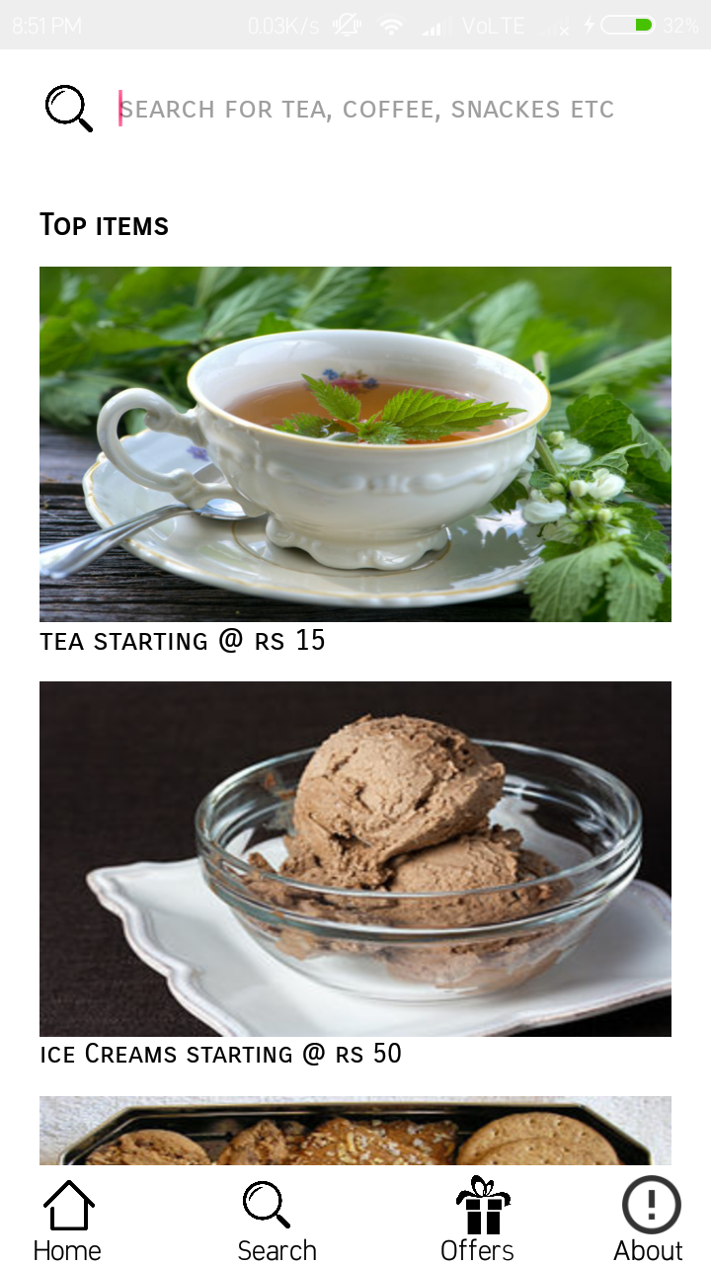

***menu_page.xml***

|  |
| --- |
| *<?xml version="1.0" encoding="utf-8"?>*  *<RelativeLayout*  *xmlns:android="http://schemas.android.com/apk/res/android" android:layout_width="match_parent"*  *android:background="#ffffff"*  *android:layout_height="match_parent">*  *<RelativeLayout*  *android:layout_width="match_parent"*  *android:layout_height="60dp"*  *>*  *<EditText*  *android:id="@+id/searchitem"*  *android:layout_width="280dp"*  *android:layout_marginLeft="60dp"*  *android:layout_marginTop="10dp"*  *android:layout_height="40dp"*  *android:background="@null"*  *android:hint="search for tea, coffee, snackes etc"*  *android:textColor="#000000"*  *android:fontFamily="sans-serif-smallcaps"*  *android:textSize="15dp"*  *android:layout_alignParentTop="true"*  */>*  *<ImageView*  *android:id="@+id/search"*  *android:layout_width="30dp"*  *android:layout_height="30dp"*  *android:background="@drawable/searchicon"*  *android:layout_marginLeft="20dp"*  *android:layout_marginTop="15dp"*  */>*  *</RelativeLayout>*  *<ScrollView*  *android:layout_width="match_parent"*  *android:layout_height="match_parent"*  *android:background="@null"*  *android:layout_marginTop="60dp"*  *>*  *<RelativeLayout*  *android:layout_width="match_parent"*  *android:layout_height="match_parent"*  *>*  *<TextView*  *android:layout_width="wrap_content"*  *android:layout_height="wrap_content"*  *android:text="Top items"*  *android:textColor="#000000"*  *android:fontFamily="sans-serif-smallcaps"*  *android:textSize="15dp"*  *android:textStyle="bold"*  *android:layout_marginLeft="20dp"*  *android:layout_marginTop="20dp"*  */>*  *<RelativeLayout*  *android:layout_width="320dp"*  *android:layout_height="210dp"*  *android:layout_marginTop="50dp"*  *android:layout_marginLeft="20dp"*  *>*  *<ImageView*  *android:id="@+id/tea"*  *android:layout_width="match_parent"*  *android:layout_height="180dp"*  *android:background="@drawable/newtea"*  */>*  *<TextView*  *android:layout_width="wrap_content"*  *android:layout_height="wrap_content"*  *android:text="tea starting @ rs 15"*  *android:textSize="15dp"*  *android:textColor="#000000"*  *android:fontFamily="sans-serif-smallcaps"*  *android:layout_marginTop="180dp"*  */>*  *</RelativeLayout>*  *<RelativeLayout*  *android:layout_width="320dp"*  *android:layout_height="210dp"*  *android:layout_marginTop="260dp"*  *android:layout_marginLeft="20dp"*  *>*  *<ImageView*  *android:id="@+id/ice_cream"*  *android:layout_width="match_parent"*  *android:layout_height="180dp"*  *android:background="@drawable/newicecream"*  */>*  *<TextView*  *android:layout_width="wrap_content"*  *android:layout_height="wrap_content"*  *android:text="ice Creams starting @ rs 50"*  *android:textColor="#000000"*  *android:fontFamily="sans-serif-smallcaps"*  *android:layout_marginTop="180dp"*  */>*  *</RelativeLayout>*  *<RelativeLayout*  *android:layout_width="320dp"*  *android:layout_height="230dp"*  *android:layout_marginTop="470dp"*  *android:layout_marginLeft="20dp"*  *>*  *<ImageView*  *android:id="@+id/cookie"*  *android:layout_width="match_parent"*  *android:layout_height="180dp"*  *android:background="@drawable/newbiscuits"*  */>*  *<TextView*  *android:layout_width="wrap_content"*  *android:layout_height="wrap_content"*  *android:text="baked cookies starting @ rs 100"*  *android:textSize="15dp"*  *android:textColor="#000000"*  *android:fontFamily="sans-serif-smallcaps"*  *android:layout_marginTop="180dp"*  */>*  *</RelativeLayout>*  *<RelativeLayout*  *android:layout_width="320dp"*  *android:layout_height="300dp"*  *android:layout_marginTop="680dp"*  *android:layout_marginLeft="20dp"*  *>*  *<ImageView*  *android:id="@+id/coffee"*  *android:layout_width="match_parent"*  *android:layout_height="180dp"*  *android:background="@drawable/newhotcoffee"*  */>*  *<TextView*  *android:layout_width="wrap_content"*  *android:layout_height="wrap_content"*  *android:text="hot coffee starting @ rs 49"*  *android:textSize="15dp"*  *android:textColor="#000000"*  *android:fontFamily="sans-serif-smallcaps"*  *android:layout_marginTop="180dp"*  */>*  *</RelativeLayout>*  *</RelativeLayout>*  *</ScrollView>*  *<RelativeLayout*  *android:layout_width="match_parent"*  *android:layout_height="50dp"*  *android:layout_alignParentBottom="true"*  *android:id="@+id/nav_bar"*  *android:background="#ffffff"*  *android:paddingTop="5dp"*  *android:paddingLeft="0dp"*  *android:layout_marginLeft="0dp"*  *>*  *<ImageView*  *android:id="@+id/home"*  *android:layout_marginLeft="20dp"*  *android:layout_width="30dp"*  *android:layout_height="30dp"*  *android:background="@drawable/homeicon"*  */>*  *<TextView*  *android:layout_width="wrap_content"*  *android:layout_height="wrap_content"*  *android:text="Home"*  *android:textColor="#000000"*  *android:layout_marginLeft="17dp"*  *android:layout_marginTop="28dp"*  */>*  *<ImageView*  *android:id="@+id/menu"*  *android:layout_width="30dp"*  *android:layout_height="30dp"*  *android:background="@drawable/searchicon"*  *android:layout_marginLeft="120dp"*  */>*  *<TextView*  *android:layout_width="wrap_content"*  *android:layout_height="wrap_content"*  *android:text="Search"*  *android:textColor="#000000"*  *android:layout_marginLeft="120dp"*  *android:layout_marginTop="28dp"*  */>*  *<ImageView*  *android:id="@+id/offer"*  *android:layout_width="30dp"*  *android:layout_height="30dp"*  *android:background="@drawable/offersicon"*  *android:layout_marginLeft="230dp"*  */>*  *<TextView*  *android:layout_width="wrap_content"*  *android:layout_height="wrap_content"*  *android:text="Offers"*  *android:textColor="#000000"*  *android:layout_marginLeft="223dp"*  *android:layout_marginTop="28dp"*  */>*  *<ImageView*  *android:id="@+id/account"*  *android:layout_width="30dp"*  *android:layout_height="30dp"*  *android:background="@drawable/abouticon"*  *android:layout_marginLeft="315dp"*  */>*  *<TextView*  *android:layout_width="wrap_content"*  *android:layout_height="wrap_content"*  *android:text="About"*  *android:textColor="#000000"*  *android:layout_marginLeft="310dp"*  *android:layout_marginTop="28dp"*  */>*  *</RelativeLayout>*  *</RelativeLayout>* |

***MenuPage.java***

|  |
| --- |
| *package com.example.mohdarif.dostea;*  *import android.content.Intent;*  *import android.os.Bundle;*  *import android.support.annotation.Nullable;*  *import android.support.v7.app.AppCompatActivity;*  *import android.view.View;*  *import android.widget.ArrayAdapter;*  *import android.widget.EditText;*  *import android.widget.ImageView;*  *import android.widget.ListView;*  *import android.widget.SearchView;*  *import android.widget.Toast;*  *import java.util.ArrayList;*  *public class MenuPage extends AppCompatActivity {*  *ImageView home,menu,offer,account,ice_cream,tea,coffee,cookie;*  *EditText value;*  *SearchView searchView;*  *ListView listView;*  *ArrayList<String> list;*  *ArrayAdapter<String > adapter;*  *String getValue;*  *ImageView search;*  *@Override*  *protected void onCreate(@Nullable Bundle savedInstanceState) {*  *super.onCreate(savedInstanceState);*  *setContentView(R.layout.menu_page);*  *home = findViewById(R.id.home);*  *menu = findViewById(R.id.menu);*  *offer = findViewById(R.id.offer);*  *offer.setOnClickListener(new View.OnClickListener() {*  *@Override*  *public void onClick(View v) {*  *Intent intent = new Intent(getApplicationContext(),Offers.class);*  *startActivity(intent);*  *finish();*  *}*  *});*  *account = findViewById(R.id.account);*  *account.setOnClickListener(new View.OnClickListener() {*  *@Override*  *public void onClick(View v) {*  *Intent intent = new Intent(getApplicationContext(),ProfilePage.class);*  *startActivity(intent);*  *finish();*  *}*  *});*  *search = findViewById(R.id.search);*  *value = findViewById(R.id.searchitem);*  *search.setOnClickListener(new View.OnClickListener() {*  *@Override*  *public void onClick(View v) {*  *getValue = value.getText().toString().trim();*  *if (getValue.equalsIgnoreCase("Tea")) {*  *Intent intent = new Intent(getApplicationContext(),Tea.class);*  *startActivity(intent);*  *finish();*  *}*  *else if (getValue.equalsIgnoreCase("coffee")) {*  *Intent intent = new Intent(getApplicationContext(),Coffee.class);*  *startActivity(intent);*  *finish();*  *}*  *else if (getValue.equalsIgnoreCase("cookies")) {*  *Intent intent = new Intent(getApplicationContext(),Cookie.class);*  *startActivity(intent);*  *finish();*  *}*  *else if (getValue.equalsIgnoreCase("icecream")) {*  *Intent intent = new Intent(getApplicationContext(),IceCream.class);*  *startActivity(intent);*  *finish();*  *}*  *else {*  *Intent intent = new Intent(getApplicationContext(),NotFound.class);*  *startActivity(intent);*  *finish();*  *}*  *}*  *});*  *home.setOnClickListener(new View.OnClickListener() {*  *@Override*  *public void onClick(View v) {*  *Intent intent = new Intent(getApplicationContext(),HomePage.class);*  *startActivity(intent);*  *finish();*  *}*  *});*  *menu.setOnClickListener(new View.OnClickListener() {*  *@Override*  *public void onClick(View v) {*  *Intent intent = new Intent(getApplicationContext(),MenuPage.class);*  *startActivity(intent);*  *finish();*  *}*  *});*  *tea = findViewById(R.id.tea);*  *tea.setOnClickListener(new View.OnClickListener() {*  *@Override*  *public void onClick(View v) {*  *Intent intent = new Intent(getApplicationContext(),Tea.class);*  *startActivity(intent);*  *finish();*  *}*  *});*  *ice_cream = findViewById(R.id.ice_cream);*  *ice_cream.setOnClickListener(new View.OnClickListener() {*  *@Override*  *public void onClick(View v) {*  *Intent intent = new Intent(getApplicationContext(),IceCream.class);*  *startActivity(intent);*  *finish();*  *}*  *});*  *coffee = findViewById(R.id.coffee);*  *coffee.setOnClickListener(new View.OnClickListener() {*  *@Override*  *public void onClick(View v) {*  *Intent intent = new Intent(getApplicationContext(),Coffee.class);*  *startActivity(intent);*  *finish();*  *}*  *});*  *cookie = findViewById(R.id.cookie);*  *cookie.setOnClickListener(new View.OnClickListener() {*  *@Override*  *public void onClick(View v) {*  *Intent intent = new Intent(getApplicationContext(),Cookie.class);*  *startActivity(intent);*  *finish();*  *}*  *});*  *}*  *@Override*  *public void onBackPressed() {*  *Intent intent = new Intent(getApplicationContext(),HomePage.class);*  *startActivity(intent);*  *finish();*  *}*  *}* |

***Offers Page***

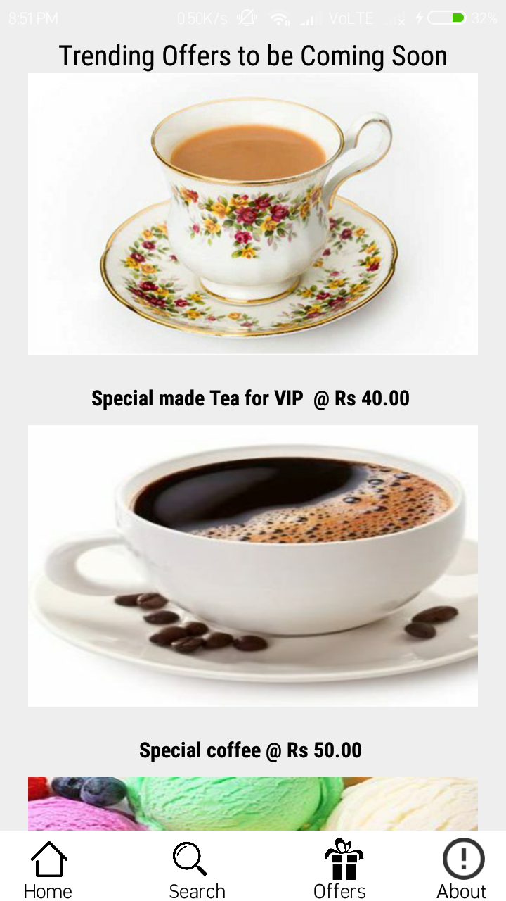

***offer_page.xml***

|  |
| --- |
| *<?xml version="1.0" encoding="utf-8"?>*  *<RelativeLayout*  *xmlns:android="http://schemas.android.com/apk/res/android" android:layout_width="match_parent"*  *android:layout_height="match_parent">*  *<RelativeLayout*  *android:layout_width="match_parent"*  *android:layout_height="wrap_content"*  *android:id="@+id/topic"*  *>*  *<TextView*  *android:layout_width="wrap_content"*  *android:layout_height="wrap_content"*  *android:text="Trending Offers to be Coming Soon"*  *android:fontFamily="sans-serif-condensed"*  *android:textSize="20dp"*  *android:textColor="#000000"*  *android:layout_centerHorizontal="true"*  */>*  *</RelativeLayout>*  *<ScrollView*  *android:layout_width="match_parent"*  *android:layout_height="match_parent"*  *android:layout_marginLeft="20dp"*  *android:layout_below="@+id/topic"*  *>*  *<RelativeLayout*  *android:layout_width="match_parent"*  *android:layout_height="match_parent">*  *<RelativeLayout*  *android:layout_width="320dp"*  *android:layout_height="250dp">*  *<ImageView*  *android:layout_width="match_parent"*  *android:layout_height="200dp"*  *android:background="@drawable/offer1"*  */>*  *<TextView*  *android:layout_width="wrap_content"*  *android:layout_height="wrap_content"*  *android:text="Special made Tea for VIP @ Rs 40.00 "*  *android:textStyle="bold"*  *android:textSize="15dp"*  *android:textColor="#000000"*  *android:fontFamily="sans-serif-condensed"*  *android:layout_marginTop="220dp"*  *android:layout_centerHorizontal="true"*  */>*  *</RelativeLayout>*  *<RelativeLayout*  *android:layout_width="320dp"*  *android:layout_height="250dp"*  *android:layout_marginTop="250dp"*  *>*  *<ImageView*  *android:layout_width="match_parent"*  *android:layout_height="200dp"*  *android:background="@drawable/offer2"*  */>*  *<TextView*  *android:layout_width="wrap_content"*  *android:layout_height="wrap_content"*  *android:text="Special coffee @ Rs 50.00 "*  *android:textStyle="bold"*  *android:textSize="15dp"*  *android:textColor="#000000"*  *android:fontFamily="sans-serif-condensed"*  *android:layout_marginTop="220dp"*  *android:layout_centerHorizontal="true"*  */>*  *</RelativeLayout>*  *<RelativeLayout*  *android:layout_width="320dp"*  *android:layout_height="250dp"*  *android:layout_marginTop="500dp"*  *>*  *<ImageView*  *android:layout_width="match_parent"*  *android:layout_height="200dp"*  *android:background="@drawable/offer3"*  */>*  *<TextView*  *android:layout_width="wrap_content"*  *android:layout_height="wrap_content"*  *android:text="Freshly made Icecream @ Rs 99.00 "*  *android:textStyle="bold"*  *android:textSize="15dp"*  *android:textColor="#000000"*  *android:fontFamily="sans-serif-condensed"*  *android:layout_marginTop="220dp"*  *android:layout_centerHorizontal="true"*  */>*  *</RelativeLayout>*  *<RelativeLayout*  *android:layout_width="320dp"*  *android:layout_height="250dp"*  *android:layout_marginTop="750dp"*  *android:layout_marginBottom="40dp"*  *>*  *<ImageView*  *android:layout_width="match_parent"*  *android:layout_height="200dp"*  *android:background="@drawable/offer5"*  */>*  *<TextView*  *android:layout_width="wrap_content"*  *android:layout_height="wrap_content"*  *android:text="Top Cookies @ Rs 199.00 "*  *android:textStyle="bold"*  *android:textSize="15dp"*  *android:textColor="#000000"*  *android:fontFamily="sans-serif-condensed"*  *android:layout_marginTop="200dp"*  *android:layout_centerHorizontal="true"*  */>*  *</RelativeLayout>*  *</RelativeLayout>*  *</ScrollView>*  *<RelativeLayout*  *android:layout_width="match_parent"*  *android:layout_height="50dp"*  *android:layout_alignParentBottom="true"*  *android:id="@+id/nav_bar"*  *android:background="#ffffff"*  *android:paddingTop="5dp"*  *android:paddingLeft="0dp"*  *android:layout_marginLeft="0dp"*  *>*  *<ImageView*  *android:id="@+id/home"*  *android:layout_marginLeft="20dp"*  *android:layout_width="30dp"*  *android:layout_height="30dp"*  *android:background="@drawable/homeicon"*  */>*  *<TextView*  *android:layout_width="wrap_content"*  *android:layout_height="wrap_content"*  *android:text="Home"*  *android:textColor="#000000"*  *android:layout_marginLeft="17dp"*  *android:layout_marginTop="28dp"*  */>*  *<ImageView*  *android:id="@+id/menu"*  *android:layout_width="30dp"*  *android:layout_height="30dp"*  *android:background="@drawable/searchicon"*  *android:layout_marginLeft="120dp"*  */>*  *<TextView*  *android:layout_width="wrap_content"*  *android:layout_height="wrap_content"*  *android:text="Search"*  *android:textColor="#000000"*  *android:layout_marginLeft="120dp"*  *android:layout_marginTop="28dp"*  */>*  *<ImageView*  *android:id="@+id/offer"*  *android:layout_width="30dp"*  *android:layout_height="30dp"*  *android:background="@drawable/offersicon"*  *android:layout_marginLeft="230dp"*  */>*  *<TextView*  *android:layout_width="wrap_content"*  *android:layout_height="wrap_content"*  *android:text="Offers"*  *android:textColor="#000000"*  *android:layout_marginLeft="223dp"*  *android:layout_marginTop="28dp"*  */>*  *<ImageView*  *android:id="@+id/account"*  *android:layout_width="30dp"*  *android:layout_height="30dp"*  *android:background="@drawable/abouticon"*  *android:layout_marginLeft="315dp"*  */>*  *<TextView*  *android:layout_width="wrap_content"*  *android:layout_height="wrap_content"*  *android:text="About"*  *android:textColor="#000000"*  *android:layout_marginLeft="310dp"*  *android:layout_marginTop="28dp"*  */>*  *</RelativeLayout>*  *</RelativeLayout>* |

*Offers.java*

|  |
| --- |
| *package com.example.mohdarif.dostea;*  *import android.content.Intent;*  *import android.media.Image;*  *import android.os.Bundle;*  *import android.support.annotation.Nullable;*  *import android.support.v7.app.AppCompatActivity;*  *import android.view.View;*  *import android.widget.ImageView;*  *import com.google.android.gms.common.api.Api;*  *public class Offers extends AppCompatActivity {*  *ImageView home,menu,offer,account;*  *@Override*  *protected void onCreate(@Nullable Bundle savedInstanceState) {*  *super.onCreate(savedInstanceState);*  *setContentView(R.layout.offer_page);*  *home = findViewById(R.id.home);*  *menu = findViewById(R.id.menu);*  *offer = findViewById(R.id.offer);*  *offer.setOnClickListener(new View.OnClickListener() {*  *@Override*  *public void onClick(View v) {*  *Intent intent = new Intent(getApplicationContext(),Offers.class);*  *startActivity(intent);*  *finish();*  *}*  *});*  *account = findViewById(R.id.account);*  *account.setOnClickListener(new View.OnClickListener() {*  *@Override*  *public void onClick(View v) {*  *Intent intent = new Intent(getApplicationContext(),ProfilePage.class);*  *startActivity(intent);*  *finish();*  *}*  *});*  *home.setOnClickListener(new View.OnClickListener() {*  *@Override*  *public void onClick(View v) {*  *Intent intent = new Intent(getApplicationContext(),HomePage.class);*  *startActivity(intent);*  *finish();*  *}*  *});*  *menu.setOnClickListener(new View.OnClickListener() {*  *@Override*  *public void onClick(View v) {*  *Intent intent = new Intent(getApplicationContext(),MenuPage.class);*  *startActivity(intent);*  *finish();*  *}*  *});*  *}*  *@Override*  *public void onBackPressed() {*  *super.onBackPressed();*  *Intent intent = new Intent(getApplicationContext(), HomePage.class);*  *startActivity(intent);*  *finish();*  *}*  *}* |

***About us Page***



***about_us.xml***

|  |
| --- |
| *<?xml version="1.0" encoding="utf-8"?>*  *<RelativeLayout*  *xmlns:android="http://schemas.android.com/apk/res/android" android:layout_width="match_parent"*  *android:layout_height="match_parent">*  *<RelativeLayout*  *android:layout_width="wrap_content"*  *android:layout_height="wrap_content"*  *android:id="@+id/about1">*  *<ImageView*  *android:layout_width="match_parent"*  *android:layout_height="400dp"*  *android:layout_centerHorizontal="true"*  *android:background="@drawable/myphoto"*  */>*  *<TextView*  *android:layout_width="wrap_content"*  *android:layout_height="wrap_content"*  *android:text="(Mohd Arif the Developer of this Application)"*  *android:textStyle="bold"*  *android:textSize="15dp"*  *android:layout_centerHorizontal="true"*  *android:textColor="#000000"*  *android:layout_marginTop="400dp"*  */>*  *</RelativeLayout>*  *<ScrollView*  *android:layout_width="wrap_content"*  *android:layout_height="wrap_content"*  *android:layout_below="@+id/about1"*  *>*  *<RelativeLayout*  *android:layout_width="match_parent"*  *android:layout_height="match_parent">*  *<TextView*  *android:layout_width="wrap_content"*  *android:layout_height="wrap_content"*  *android:text="I am developing this app for general purpose of view in order to make it easier for common people to order beverages and thier favourate items at extremely low prices the main aim of this application was to establish a well productive cafe meetng the people needs.*  *Contact info - +91 8810565494 mail - mohdaarif8299@gmail.com*  *"*  *android:layout_marginLeft="20dp"*  *android:layout_marginRight="30dp"*  *android:textColor="#000000"*  *android:textSize="20dp"*  *android:fontFamily="sans-serif-condensed"*  */>*  *</RelativeLayout>*  *</ScrollView>*  *</RelativeLayout>* |

***About.java***

|  |
| --- |
| *package com.example.mohdarif.dostea;*  *import android.content.Intent;*  *import android.os.Bundle;*  *import android.support.annotation.Nullable;*  *import android.support.v7.app.AppCompatActivity;*  *public class AboutPage extends AppCompatActivity {*  *@Override*  *protected void onCreate(@Nullable Bundle savedInstanceState) {*  *super.onCreate(savedInstanceState);*  *setContentView(R.layout.aboutpage);*  *}*  *@Override*  *public void onBackPressed() {*  *super.onBackPressed();*  *Intent intent = new Intent(getApplicationContext(),HomePage.class);*  *startActivity(intent);*  *finish();*  *}*  *}* |

***Tea Page***

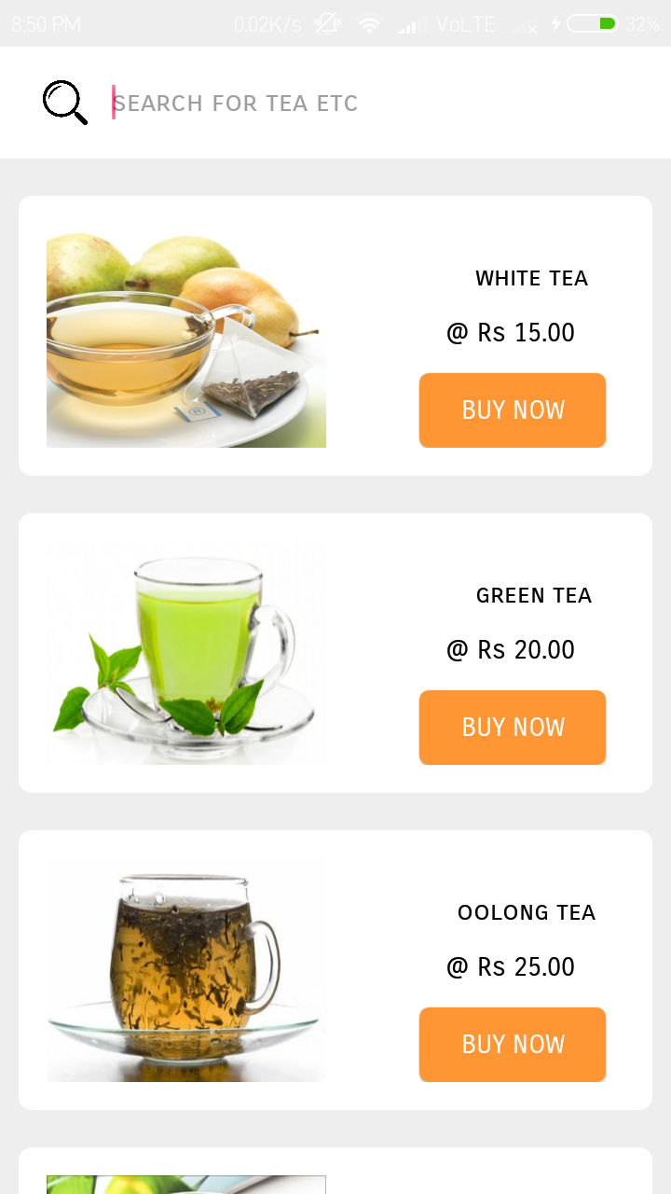

***tea.xml***

|  |
| --- |
| *<?xml version="1.0" encoding="utf-8"?>*  *<RelativeLayout*  *xmlns:android="http://schemas.android.com/apk/res/android" android:layout_width="match_parent"*  *android:layout_height="match_parent"*  *>*  *<RelativeLayout*  *android:layout_width="match_parent"*  *android:layout_height="60dp"*  *android:background="#ffffff"*  *>*  *<EditText*  *android:id="@+id/searchitem"*  *android:layout_width="290dp"*  *android:layout_marginLeft="60dp"*  *android:layout_marginTop="10dp"*  *android:layout_height="40dp"*  *android:background="@null"*  *android:hint="search for tea etc"*  *android:textColor="#000000"*  *android:fontFamily="sans-serif-smallcaps"*  *android:textSize="15dp"*  *android:layout_alignParentTop="true"*  */>*  *<ImageView*  *android:id="@+id/searchbutton"*  *android:layout_width="30dp"*  *android:layout_height="30dp"*  *android:background="@drawable/searchicon"*  *android:layout_marginLeft="20dp"*  *android:layout_marginTop="15dp"*  */>*  *</RelativeLayout>*  *<ScrollView*  *android:layout_width="match_parent"*  *android:layout_height="match_parent"*  *android:layout_marginTop="60dp"*  *>*  *<RelativeLayout*  *android:layout_width="match_parent"*  *android:layout_height="match_parent">*  *<RelativeLayout*  *android:layout_width="340dp"*  *android:layout_height="150dp"*  *android:layout_marginLeft="10dp"*  *android:layout_marginTop="20dp"*  *android:background="@drawable/homepagemenuitems"*  *android:padding="15dp"*  *>*  *<ImageView*  *android:layout_width="150dp"*  *android:layout_height="130dp"*  *android:background="@drawable/t1"*  */>*  *<TextView*  *android:layout_width="wrap_content"*  *android:layout_height="wrap_content"*  *android:text="white tea"*  *android:fontFamily="sans-serif-smallcaps"*  *android:textColor="#000000"*  *android:layout_marginLeft="230dp"*  *android:layout_marginTop="20dp"*  */>*  *<TextView*  *android:layout_width="wrap_content"*  *android:layout_height="wrap_content"*  *android:text=" @ Rs 15.00"*  *android:fontFamily="sans-serif-smallcaps"*  *android:textColor="#000000"*  *android:layout_marginTop="50dp"*  *android:layout_marginLeft="210dp"*  */>*  *<Button*  *android:id="@+id/tea1"*  *android:layout_width="100dp"*  *android:layout_height="40dp"*  *android:background="@drawable/confirm_button"*  *android:text="Buy now"*  *android:textColor="#ffffff"*  *android:fontFamily="sans-serif-smallcaps"*  *android:layout_marginLeft="200dp"*  *android:layout_marginTop="80dp"*  */>*  *</RelativeLayout>*  *<RelativeLayout*  *android:layout_width="340dp"*  *android:layout_height="150dp"*  *android:layout_marginLeft="10dp"*  *android:layout_marginTop="190dp"*  *android:background="@drawable/homepagemenuitems"*  *android:padding="15dp"*  *>*  *<ImageView*  *android:layout_width="150dp"*  *android:layout_height="130dp"*  *android:background="@drawable/t2"*  */>*  *<TextView*  *android:layout_width="wrap_content"*  *android:layout_height="wrap_content"*  *android:text="green tea"*  *android:fontFamily="sans-serif-smallcaps"*  *android:textColor="#000000"*  *android:layout_marginLeft="230dp"*  *android:layout_marginTop="20dp"*  */>*  *<TextView*  *android:layout_width="wrap_content"*  *android:layout_height="wrap_content"*  *android:text=" @ Rs 20.00"*  *android:fontFamily="sans-serif-smallcaps"*  *android:textColor="#000000"*  *android:layout_marginTop="50dp"*  *android:layout_marginLeft="210dp"*  */>*  *<Button*  *android:id="@+id/tea2"*  *android:layout_width="100dp"*  *android:layout_height="40dp"*  *android:background="@drawable/confirm_button"*  *android:text="Buy now"*  *android:textColor="#ffffff"*  *android:fontFamily="sans-serif-smallcaps"*  *android:layout_marginLeft="200dp"*  *android:layout_marginTop="80dp"*  */>*  *</RelativeLayout>*  *<RelativeLayout*  *android:layout_width="340dp"*  *android:layout_height="150dp"*  *android:layout_marginLeft="10dp"*  *android:layout_marginTop="360dp"*  *android:background="@drawable/homepagemenuitems"*  *android:padding="15dp"*  *>*  *<ImageView*  *android:layout_width="150dp"*  *android:layout_height="130dp"*  *android:background="@drawable/t3"*  */>*  *<TextView*  *android:layout_width="wrap_content"*  *android:layout_height="wrap_content"*  *android:text="oolong tea"*  *android:fontFamily="sans-serif-smallcaps"*  *android:textColor="#000000"*  *android:layout_marginLeft="220dp"*  *android:layout_marginTop="20dp"*  */>*  *<TextView*  *android:layout_width="wrap_content"*  *android:layout_height="wrap_content"*  *android:text=" @ Rs 25.00"*  *android:fontFamily="sans-serif-smallcaps"*  *android:textColor="#000000"*  *android:layout_marginTop="50dp"*  *android:layout_marginLeft="210dp"*  */>*  *<Button*  *android:id="@+id/tea3"*  *android:layout_width="100dp"*  *android:layout_height="40dp"*  *android:background="@drawable/confirm_button"*  *android:text="Buy now"*  *android:textColor="#ffffff"*  *android:fontFamily="sans-serif-smallcaps"*  *android:layout_marginLeft="200dp"*  *android:layout_marginTop="80dp"*  */>*  *</RelativeLayout>*  *<RelativeLayout*  *android:layout_width="340dp"*  *android:layout_height="150dp"*  *android:layout_marginTop="530dp"*  *android:layout_marginLeft="10dp"*  *android:background="@drawable/homepagemenuitems"*  *android:padding="15dp">*  *<ImageView*  *android:layout_width="150dp"*  *android:layout_height="130dp"*  *android:background="@drawable/t4" />*  *<TextView*  *android:layout_width="wrap_content"*  *android:layout_height="wrap_content"*  *android:layout_marginLeft="230dp"*  *android:layout_marginTop="20dp"*  *android:fontFamily="sans-serif-smallcaps"*  *android:text="black tea"*  *android:textColor="#000000" />*  *<TextView*  *android:layout_width="wrap_content"*  *android:layout_height="wrap_content"*  *android:layout_marginLeft="210dp"*  *android:layout_marginTop="50dp"*  *android:fontFamily="sans-serif-smallcaps"*  *android:text=" @ Rs 25.00"*  *android:textColor="#000000" />*  *<Button*  *android:id="@+id/tea4"*  *android:layout_width="100dp"*  *android:layout_height="40dp"*  *android:layout_marginLeft="200dp"*  *android:layout_marginTop="80dp"*  *android:background="@drawable/confirm_button"*  *android:fontFamily="sans-serif-smallcaps"*  *android:text="Buy now"*  *android:textColor="#ffffff" />*  *</RelativeLayout>*  *<RelativeLayout*  *android:layout_width="340dp"*  *android:layout_height="150dp"*  *android:layout_marginTop="700dp"*  *android:layout_marginLeft="10dp"*  *android:background="@drawable/homepagemenuitems"*  *android:padding="15dp">*  *<ImageView*  *android:layout_width="150dp"*  *android:layout_height="130dp"*  *android:background="@drawable/t5" />*  *<TextView*  *android:layout_width="wrap_content"*  *android:layout_height="wrap_content"*  *android:layout_marginLeft="220dp"*  *android:layout_marginTop="20dp"*  *android:fontFamily="sans-serif-smallcaps"*  *android:text="herbal tea"*  *android:textColor="#000000" />*  *<TextView*  *android:layout_width="wrap_content"*  *android:layout_height="wrap_content"*  *android:layout_marginLeft="220dp"*  *android:layout_marginTop="50dp"*  *android:fontFamily="sans-serif-smallcaps"*  *android:text=" @ Rs 27.00"*  *android:textColor="#000000" />*  *<Button*  *android:id="@+id/tea5"*  *android:layout_width="100dp"*  *android:layout_height="40dp"*  *android:layout_marginLeft="200dp"*  *android:layout_marginTop="80dp"*  *android:background="@drawable/confirm_button"*  *android:fontFamily="sans-serif-smallcaps"*  *android:text="Buy now"*  *android:textColor="#ffffff" />*  *</RelativeLayout>*  *<RelativeLayout*  *android:layout_width="340dp"*  *android:layout_height="150dp"*  *android:layout_marginTop="870dp"*  *android:layout_marginLeft="10dp"*  *android:background="@drawable/homepagemenuitems"*  *android:padding="15dp">*  *<ImageView*  *android:layout_width="150dp"*  *android:layout_height="match_parent"*  *android:background="@drawable/t6" />*  *<TextView*  *android:layout_width="wrap_content"*  *android:layout_height="wrap_content"*  *android:layout_marginLeft="220dp"*  *android:layout_marginTop="20dp"*  *android:fontFamily="sans-serif-smallcaps"*  *android:text="rooibos tea"*  *android:textColor="#000000" />*  *<TextView*  *android:layout_width="wrap_content"*  *android:layout_height="wrap_content"*  *android:layout_marginLeft="220dp"*  *android:layout_marginTop="50dp"*  *android:fontFamily="sans-serif-smallcaps"*  *android:text=" @ Rs 30.00"*  *android:textColor="#000000" />*  *<Button*  *android:id="@+id/tea6"*  *android:layout_width="100dp"*  *android:layout_height="40dp"*  *android:layout_marginLeft="200dp"*  *android:layout_marginTop="80dp"*  *android:background="@drawable/confirm_button"*  *android:fontFamily="sans-serif-smallcaps"*  *android:text="Buy now"*  *android:textColor="#ffffff" />*  *</RelativeLayout>*  *<RelativeLayout*  *android:layout_width="340dp"*  *android:layout_height="150dp"*  *android:layout_marginLeft="10dp"*  *android:layout_marginTop="1040dp"*  *android:background="@drawable/homepagemenuitems"*  *android:padding="15dp"*  *>*  *<ImageView*  *android:layout_width="150dp"*  *android:layout_height="130dp"*  *android:background="@drawable/t7"*  */>*  *<TextView*  *android:layout_width="wrap_content"*  *android:layout_height="wrap_content"*  *android:text="mate tea"*  *android:fontFamily="sans-serif-smallcaps"*  *android:textColor="#000000"*  *android:layout_marginLeft="230dp"*  *android:layout_marginTop="20dp"*  */>*  *<TextView*  *android:layout_width="wrap_content"*  *android:layout_height="wrap_content"*  *android:text=" @ Rs 30.00"*  *android:fontFamily="sans-serif-smallcaps"*  *android:textColor="#000000"*  *android:layout_marginTop="50dp"*  *android:layout_marginLeft="210dp"*  */>*  *<Button*  *android:id="@+id/tea7"*  *android:layout_width="100dp"*  *android:layout_height="40dp"*  *android:background="@drawable/confirm_button"*  *android:text="Buy now"*  *android:textColor="#ffffff"*  *android:fontFamily="sans-serif-smallcaps"*  *android:layout_marginLeft="200dp"*  *android:layout_marginTop="80dp"*  */>*  *</RelativeLayout>*  *<RelativeLayout*  *android:layout_width="340dp"*  *android:layout_height="150dp"*  *android:layout_marginLeft="10dp"*  *android:layout_marginTop="1210dp"*  *android:background="@drawable/homepagemenuitems"*  *android:padding="15dp"*  *android:layout_marginBottom="50dp"*  *>*  *<ImageView*  *android:layout_width="150dp"*  *android:layout_height="130dp"*  *android:background="@drawable/t8"*  */>*  *<TextView*  *android:layout_width="wrap_content"*  *android:layout_height="wrap_content"*  *android:text="bloomy tea"*  *android:fontFamily="sans-serif-smallcaps"*  *android:textColor="#000000"*  *android:layout_marginLeft="220dp"*  *android:layout_marginTop="20dp"*  */>*  *<TextView*  *android:layout_width="wrap_content"*  *android:layout_height="wrap_content"*  *android:text=" @ Rs 30.00"*  *android:fontFamily="sans-serif-smallcaps"*  *android:textColor="#000000"*  *android:layout_marginTop="50dp"*  *android:layout_marginLeft="220dp"*  */>*  *<Button*  *android:id="@+id/tea8"*  *android:layout_width="100dp"*  *android:layout_height="40dp"*  *android:background="@drawable/confirm_button"*  *android:text="Buy now"*  *android:textColor="#ffffff"*  *android:fontFamily="sans-serif-smallcaps"*  *android:layout_marginLeft="200dp"*  *android:layout_marginTop="80dp"*  */>*  *</RelativeLayout>*  *</RelativeLayout>*  *</ScrollView>*  *</RelativeLayout>* |

***Tea.java***

|  |
| --- |
| *package com.example.mohdarif.dostea;*  *import android.content.Intent;*  *import android.os.Bundle;*  *import android.support.annotation.Nullable;*  *import android.support.v7.app.AppCompatActivity;*  *import android.view.View;*  *import android.widget.Button;*  *import android.widget.EditText;*  *import android.widget.ImageView;*  *public class Tea extends AppCompatActivity {*  *Button tea1,tea2,tea3,tea4,tea5,tea6,tea7,tea8;*  *EditText searchitem;*  *ImageView searchButton;*  *String value;*  *@Override*  *protected void onCreate(@Nullable Bundle savedInstanceState) {*  *super.onCreate(savedInstanceState);*  *setContentView(R.layout.tea);*  *searchitem = findViewById(R.id.searchitem);*  *searchButton = findViewById(R.id.searchbutton);*  *searchButton.setOnClickListener(new View.OnClickListener() {*  *@Override*  *public void onClick(View v) {*  *value = searchitem.getText().toString().trim();*  *if(value.equalsIgnoreCase("white tea")) {*  *Intent intent = new Intent(getApplicationContext(),Tea1.class);*  *startActivity(intent);*  *finish();*  *}*  *else if(value.equalsIgnoreCase("green tea")) {*  *Intent intent = new Intent(getApplicationContext(),Tea2.class);*  *startActivity(intent);*  *finish();*  *}*  *else if(value.equalsIgnoreCase("oolong tea")) {*  *Intent intent = new Intent(getApplicationContext(),Tea3.class);*  *startActivity(intent);*  *finish();*  *}*  *else if(value.equalsIgnoreCase("black tea")) {*  *Intent intent = new Intent(getApplicationContext(),Tea4.class);*  *startActivity(intent);*  *finish();*  *}*  *else if(value.equalsIgnoreCase("herbal tea")) {*  *Intent intent = new Intent(getApplicationContext(),Tea5.class);*  *startActivity(intent);*  *finish();*  *}*  *else if(value.equalsIgnoreCase("rooibos tea")) {*  *Intent intent = new Intent(getApplicationContext(),Tea6.class);*  *startActivity(intent);*  *finish();*  *}*  *else if(value.equalsIgnoreCase("mate tea")) {*  *Intent intent = new Intent(getApplicationContext(),Tea7.class);*  *startActivity(intent);*  *finish();*  *}*  *else if(value.equalsIgnoreCase("bloomy tea")) {*  *Intent intent = new Intent(getApplicationContext(),Tea8.class);*  *startActivity(intent);*  *finish();*  *}*  *else {*  *Intent intent = new Intent(getApplicationContext(),NotFound.class);*  *startActivity(intent);*  *finish();*  *}*  *}*  *});*  *tea1 = findViewById(R.id.tea1);*  *tea1.setOnClickListener(new View.OnClickListener() {*  *@Override*  *public void onClick(View v) {*  *Intent intent = new Intent(getApplicationContext(),Tea1.class);*  *startActivity(intent);*  *finish();*  *}*  *});*  *tea2 = findViewById(R.id.tea2);*  *tea2.setOnClickListener(new View.OnClickListener() {*  *@Override*  *public void onClick(View v) {*  *Intent intent = new Intent(getApplicationContext(),Tea2.class);*  *startActivity(intent);*  *finish();*  *}*  *});*  *tea3 = findViewById(R.id.tea3);*  *tea3.setOnClickListener(new View.OnClickListener() {*  *@Override*  *public void onClick(View v) {*  *Intent intent = new Intent(getApplicationContext(),Tea3.class);*  *startActivity(intent);*  *finish();*  *}*  *});*  *tea4 = findViewById(R.id.tea4);*  *tea4.setOnClickListener(new View.OnClickListener() {*  *@Override*  *public void onClick(View v) {*  *Intent intent = new Intent(getApplicationContext(),Tea4.class);*  *startActivity(intent);*  *finish();*  *}*  *});*  *tea5 = findViewById(R.id.tea5);*  *tea5.setOnClickListener(new View.OnClickListener() {*  *@Override*  *public void onClick(View v) {*  *Intent intent = new Intent(getApplicationContext(),Tea5.class);*  *startActivity(intent);*  *finish();*  *}*  *});*  *tea6 = findViewById(R.id.tea6);*  *tea6.setOnClickListener(new View.OnClickListener() {*  *@Override*  *public void onClick(View v) {*  *Intent intent = new Intent(getApplicationContext(),Tea6.class);*  *startActivity(intent);*  *finish();*  *}*  *});*  *tea7 = findViewById(R.id.tea7);*  *tea7.setOnClickListener(new View.OnClickListener() {*  *@Override*  *public void onClick(View v) {*  *Intent intent = new Intent(getApplicationContext(),Tea7.class);*  *startActivity(intent);*  *finish();*  *}*  *});*  *tea8 = findViewById(R.id.tea8);*  *tea8.setOnClickListener(new View.OnClickListener() {*  *@Override*  *public void onClick(View v) {*  *Intent intent = new Intent(getApplicationContext(),Tea8.class);*  *startActivity(intent);*  *finish();*  *}*  *});*  *}*  *@Override*  *public void onBackPressed() {*  *Intent intent = new Intent(getApplicationContext(),HomePage.class);*  *startActivity(intent);*  *finish();*  *}*  *}* |

***Tea1***

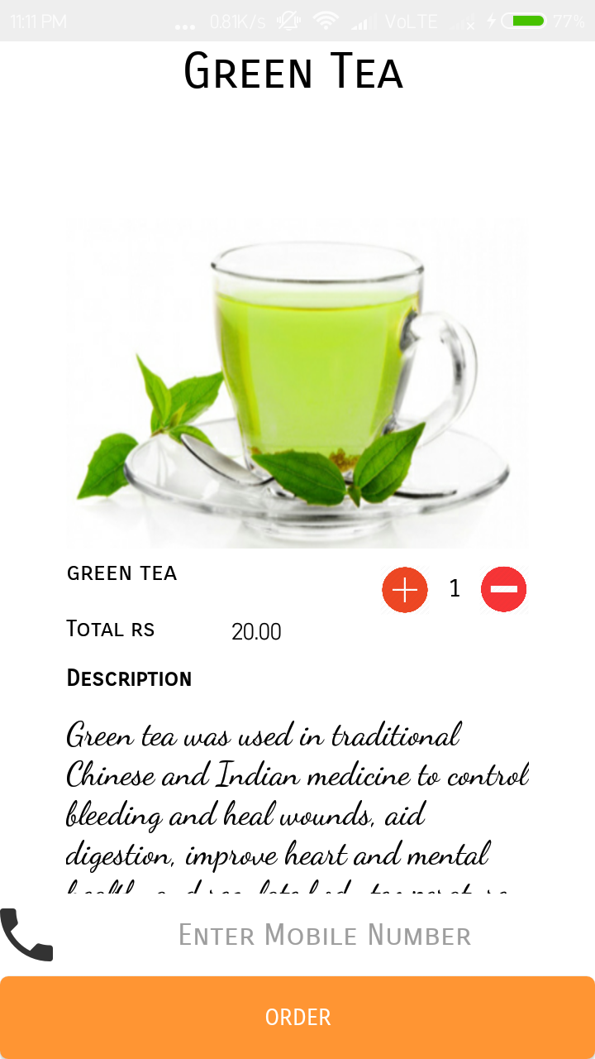

***tea1.xml***

|  |
| --- |
| *<?xml version="1.0" encoding="utf-8"?>*  *<RelativeLayout*  *xmlns:android="http://schemas.android.com/apk/res/android" android:layout_width="match_parent"*  *android:layout_height="match_parent"*  *android:background="#ffffff"*  *>*  *<RelativeLayout*  *android:layout_width="wrap_content"*  *android:layout_height="wrap_content"*  *android:id="@+id/heading"*  *>*  *<TextView*  *android:layout_width="wrap_content"*  *android:layout_height="wrap_content"*  *android:text="White Tea"*  *android:textAlignment="center"*  *android:layout_marginLeft="110dp"*  *android:textSize="30dp"*  *android:id="@+id/items"*  *android:textColor="#000000"*  *android:fontFamily="sans-serif-smallcaps"*  */>*  *</RelativeLayout>*  *<ScrollView*  *android:layout_width="match_parent"*  *android:layout_height="match_parent"*  *android:id="@+id/slide1"*  *android:layout_below="@+id/heading"*  *>*  *<RelativeLayout*  *android:layout_width="match_parent"*  *android:layout_height="700dp"*  *>*  *<RelativeLayout*  *android:id="@+id/content1"*  *android:layout_width="320dp"*  *android:layout_height="match_parent"*  *android:layout_marginTop="50dp"*  *android:layout_marginLeft="20dp"*  *android:padding="20dp"*  *>*  *<ImageView*  *android:background="@drawable/t1"*  *android:layout_width="match_parent"*  *android:layout_height="200dp"*  */>*  *<TextView*  *android:id="@+id/text1"*  *android:layout_width="wrap_content"*  *android:layout_height="wrap_content"*  *android:layout_marginLeft="0dp"*  *android:layout_marginTop="205dp"*  *android:textColor="#000000"*  *android:text="white tea"*  *android:fontFamily="sans-serif-smallcaps"*  *android:textSize="15dp"*  */>*  *<Button*  *android:layout_width="30dp"*  *android:id="@+id/plusicon"*  *android:layout_height="30dp"*  *android:background="@drawable/plus1"*  *android:layout_marginTop="210dp"*  *android:layout_marginLeft="190dp"*  */>*  *<TextView*  *android:id="@+id/value"*  *android:layout_width="30dp"*  *android:layout_height="30dp"*  *android:textSize="15dp"*  *android:textColor="#000000"*  *android:textAlignment="center"*  *android:fontFamily="sans-serif-smallcaps"*  *android:layout_marginTop="210dp"*  *android:padding="5dp"*  *android:text="1"*  *android:layout_marginLeft="220dp"*  */>*  *<Button*  *android:id="@+id/minus"*  *android:layout_width="30dp"*  *android:layout_height="30dp"*  *android:layout_marginLeft="250dp"*  *android:layout_marginTop="210dp"*  *android:background="@drawable/minus1"*  */>*  *<TextView*  *android:layout_width="wrap_content"*  *android:layout_height="wrap_content"*  *android:text="Total rs "*  *android:textColor="#000000"*  *android:fontFamily="sans-serif-smallcaps"*  *android:layout_marginTop="240dp"*  */>*  *<TextView*  *android:id="@+id/amount"*  *android:layout_width="60dp"*  *android:layout_height="20dp"*  *android:text="15.00"*  *android:textColor="#000000"*  *android:layout_marginTop="240dp"*  *android:layout_marginLeft="100dp"*  */>*  *<TextView*  *android:layout_width="wrap_content"*  *android:layout_height="wrap_content"*  *android:text="Description"*  *android:textColor="#000000"*  *android:fontFamily="sans-serif-smallcaps"*  *android:layout_marginTop="270dp"*  *android:textStyle="bold"*  */>*  *<TextView*  *android:layout_width="wrap_content"*  *android:layout_height="wrap_content"*  *android:textColor="#000000"*  *android:fontFamily="cursive"*  *android:textSize="20dp"*  *android:text="White tea is made from the leaves of the Camellia sinensis plant. This is the same plant that is used to make other kinds of tea, such as green or black tea.*  *It is harvested mainly in China but is also produced in other regions, such as Thailand, India, Taiwan and Nepal."*  *android:layout_marginTop="300dp"*  */>*  *</RelativeLayout>*  *</RelativeLayout>*  *</ScrollView>*  *<EditText*  *android:id="@+id/getMobile"*  *android:layout_width="match_parent"*  *android:layout_height="50dp"*  *android:layout_alignParentBottom="true"*  *android:layout_marginBottom="50dp"*  *android:layout_marginLeft="0dp"*  *android:inputType="number"*  *android:background="#ffffff"*  *android:drawableLeft="@drawable/phoneicon"*  *android:hint="Enter Mobile Number"*  *android:fontFamily="sans-serif-smallcaps"*  *android:textAlignment="center"*  */>*  *<Button*  *android:id="@+id/orderButton"*  *android:layout_width="match_parent"*  *android:layout_height="50dp"*  *android:text="Order"*  *android:textColor="#ffffff"*  *android:fontFamily="sans-serif-smallcaps"*  *android:layout_marginLeft="0dp"*  *android:layout_alignParentBottom="true"*  *android:background="@drawable/confirm_button"*  *android:layout_marginBottom="0dp"*  */>*  *</RelativeLayout>* |

***Tea1.java***

|  |
| --- |
| *package com.example.mohdarif.dostea;*  *import android.app.NotificationManager;*  *import android.app.PendingIntent;*  *import android.content.Context;*  *import android.content.Intent;*  *import android.os.Bundle;*  *import android.support.v4.app.NotificationCompat;*  *import android.support.v7.app.AppCompatActivity;*  *import android.telephony.SmsManager;*  *import android.view.View;*  *import android.widget.Button;*  *import android.widget.EditText;*  *import android.widget.TextView;*  *import android.widget.Toast;*  *public class Tea1 extends AppCompatActivity {*  *Button confirm,add,sub;*  *EditText getMobile;*  *TextView value,amount;*  *int countOrderId=1,countOrderNumber=1,countOrder=0;*  *final float initailAmount = (float) 15.00;*  *@Override*  *protected void onCreate(Bundle savedInstanceState) {*  *super.onCreate(savedInstanceState);*  *setContentView(R.layout.tea1);*  *value = findViewById(R.id.value);*  *amount = findViewById(R.id.amount);*  *add = findViewById(R.id.plusicon);*  *add.setOnClickListener(new View.OnClickListener() {*  *@Override*  *public void onClick(View v) {*  *countOrderNumber++;*  *if (countOrderNumber>10) {*  *Toast.makeText(getApplicationContext(),"maximum quantity only 10 at a time",Toast.LENGTH_LONG).show();*  *}*  *else{*  *value.setText(""+countOrderNumber);*  *amount.setText(""+initailAmount*countOrderNumber);*  *}*  *}*  *});*  *sub = findViewById(R.id.minus);*  *sub.setOnClickListener(new View.OnClickListener() {*  *@Override*  *public void onClick(View v) {*  *countOrderNumber--;*  *if (countOrderNumber<1) {*  *Toast.makeText(getApplicationContext(),"only 1 selected",Toast.LENGTH_LONG).show();*  *}*  *else {*  *value.setText(""+countOrderNumber);*  *amount.setText(""+initailAmount*countOrderNumber);*  *}*  *}*  *});*  *getMobile = findViewById(R.id.getMobile);*  *confirm = findViewById(R.id.orderButton);*  *confirm.setOnClickListener(new View.OnClickListener() {*  *@Override*  *public void onClick(View v) {*  *countOrderId++;*  *String number = getMobile.getText().toString().trim();*  *if (number.isEmpty()||number.length()<10) {*  *Toast.makeText(getApplicationContext(),"Enter a valid number",Toast.LENGTH_LONG).show();*  *getMobile.requestFocus();*  *}*  *else {*  *addNotification();*  *SmsManager sms= SmsManager.getDefault();*  *sms.sendTextMessage(number, null, "Your Order for "+countOrderNumber+ " White Tea has been confirmed Kindly Par Rs "+amount.getText(),null,null);*  *Toast.makeText(getApplicationContext(), "Order recieved successfully!",*  *Toast.LENGTH_LONG).show();*  *Intent intent1 = new Intent(getApplicationContext(),ConfirmOrder.class);*  *startActivity(intent1);*  *}*  *}*  *});*  *}*  *private void addNotification() {*  *NotificationCompat.Builder builder =*  *new NotificationCompat.Builder(this)*  *.setSmallIcon(R.drawable.notificationicon)*  *.setContentTitle("Dostea")*  *.setContentText(IceCream1.notification);*  *Intent notificationIntent = new Intent(this, MainActivity.class);*  *PendingIntent contentIntent = PendingIntent.getActivity(this, 0, notificationIntent,*  *PendingIntent.FLAG_UPDATE_CURRENT);*  *builder.setContentIntent(contentIntent);*  *// Add as notification*  *NotificationManager manager = (NotificationManager) getSystemService(Context.NOTIFICATION_SERVICE);*  *manager.notify(0, builder.build());*  *}*  *@Override*  *public void onBackPressed() {*  *Intent intent = new Intent(getApplicationContext(),Tea.class);*  *startActivity(intent);*  *finish();*  *}*  *}* |

***Tea 2***

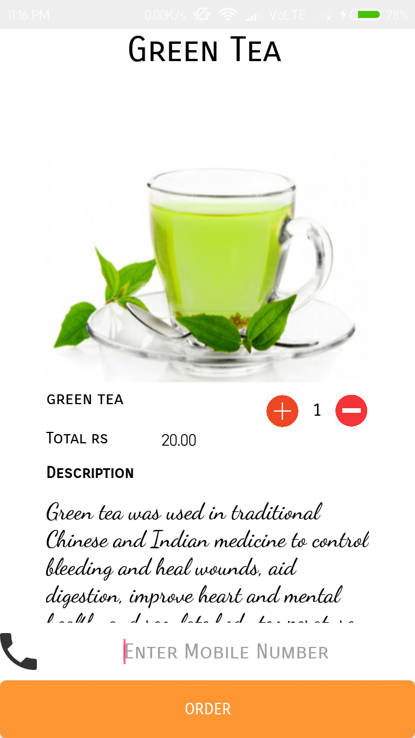

***tea2.xml***

|  |
| --- |
| *<?xml version="1.0" encoding="utf-8"?>*  *<RelativeLayout*  *xmlns:android="http://schemas.android.com/apk/res/android" android:layout_width="match_parent"*  *android:layout_height="match_parent"*  *android:background="#ffffff"*  *>*  *<RelativeLayout*  *android:layout_width="wrap_content"*  *android:layout_height="wrap_content"*  *android:id="@+id/heading"*  *>*  *<TextView*  *android:layout_width="wrap_content"*  *android:layout_height="wrap_content"*  *android:text="Green Tea"*  *android:textAlignment="center"*  *android:layout_marginLeft="110dp"*  *android:textSize="30dp"*  *android:id="@+id/items"*  *android:textColor="#000000"*  *android:fontFamily="sans-serif-smallcaps"*  */>*  *</RelativeLayout>*  *<ScrollView*  *android:layout_width="match_parent"*  *android:layout_height="match_parent"*  *android:id="@+id/slide1"*  *android:layout_below="@+id/heading"*  *>*  *<RelativeLayout*  *android:layout_width="match_parent"*  *android:layout_height="750dp"*  *>*  *<RelativeLayout*  *android:id="@+id/content1"*  *android:layout_width="320dp"*  *android:layout_height="match_parent"*  *android:layout_marginTop="50dp"*  *android:layout_marginLeft="20dp"*  *android:padding="20dp"*  *>*  *<ImageView*  *android:background="@drawable/t2"*  *android:layout_width="match_parent"*  *android:layout_height="200dp"*  */>*  *<TextView*  *android:id="@+id/text1"*  *android:layout_width="wrap_content"*  *android:layout_height="wrap_content"*  *android:layout_marginLeft="0dp"*  *android:layout_marginTop="205dp"*  *android:textColor="#000000"*  *android:text="green tea"*  *android:fontFamily="sans-serif-smallcaps"*  *android:textSize="15dp"*  */>*  *<Button*  *android:layout_width="30dp"*  *android:id="@+id/plusicon"*  *android:layout_height="30dp"*  *android:background="@drawable/plus1"*  *android:layout_marginTop="210dp"*  *android:layout_marginLeft="190dp"*  */>*  *<TextView*  *android:id="@+id/value"*  *android:layout_width="30dp"*  *android:layout_height="30dp"*  *android:textSize="15dp"*  *android:textColor="#000000"*  *android:textAlignment="center"*  *android:fontFamily="sans-serif-smallcaps"*  *android:layout_marginTop="210dp"*  *android:padding="5dp"*  *android:text="1"*  *android:layout_marginLeft="220dp"*  */>*  *<Button*  *android:id="@+id/minus"*  *android:layout_width="30dp"*  *android:layout_height="30dp"*  *android:layout_marginLeft="250dp"*  *android:layout_marginTop="210dp"*  *android:background="@drawable/minus1"*  */>*  *<TextView*  *android:layout_width="wrap_content"*  *android:layout_height="wrap_content"*  *android:text="Total rs "*  *android:textColor="#000000"*  *android:fontFamily="sans-serif-smallcaps"*  *android:layout_marginTop="240dp"*  */>*  *<TextView*  *android:id="@+id/amount"*  *android:layout_width="60dp"*  *android:layout_height="20dp"*  *android:text="20.00"*  *android:textColor="#000000"*  *android:layout_marginTop="240dp"*  *android:layout_marginLeft="100dp"*  */>*  *<TextView*  *android:layout_width="wrap_content"*  *android:layout_height="wrap_content"*  *android:text="Description"*  *android:textColor="#000000"*  *android:fontFamily="sans-serif-smallcaps"*  *android:layout_marginTop="270dp"*  *android:textStyle="bold"*  */>*  *<TextView*  *android:layout_width="wrap_content"*  *android:layout_height="wrap_content"*  *android:textColor="#000000"*  *android:fontFamily="cursive"*  *android:textSize="20dp"*  *android:text="Green tea was used in traditional Chinese and Indian medicine to control bleeding and heal wounds, aid digestion, improve heart and mental health, and regulate body temperature.*  *Recent studies have shown green tea can potentially have positive effects on everything from weight loss to liver disorders, type 2 diabetes, and Alzheimer's disease."*  *android:layout_marginTop="300dp"*  */>*  *</RelativeLayout>*  *</RelativeLayout>*  *</ScrollView>*  *<EditText*  *android:id="@+id/getMobile"*  *android:layout_width="match_parent"*  *android:layout_height="50dp"*  *android:layout_alignParentBottom="true"*  *android:layout_marginBottom="50dp"*  *android:layout_marginLeft="0dp"*  *android:inputType="number"*  *android:background="#ffffff"*  *android:drawableLeft="@drawable/phoneicon"*  *android:hint="Enter Mobile Number"*  *android:fontFamily="sans-serif-smallcaps"*  *android:textAlignment="center"*  */>*  *<Button*  *android:id="@+id/orderButton"*  *android:layout_width="match_parent"*  *android:layout_height="50dp"*  *android:text="Order"*  *android:textColor="#ffffff"*  *android:fontFamily="sans-serif-smallcaps"*  *android:layout_marginLeft="0dp"*  *android:layout_alignParentBottom="true"*  *android:background="@drawable/confirm_button"*  *android:layout_marginBottom="0dp"*  */>*  *</RelativeLayout>* |

***Tea2.java***

|  |
| --- |
| *package com.example.mohdarif.dostea;*  *import android.app.NotificationManager;*  *import android.app.PendingIntent;*  *import android.content.Context;*  *import android.content.Intent;*  *import android.os.Bundle;*  *import android.support.v4.app.NotificationCompat;*  *import android.support.v7.app.AppCompatActivity;*  *import android.telephony.SmsManager;*  *import android.view.View;*  *import android.widget.Button;*  *import android.widget.EditText;*  *import android.widget.TextView;*  *import android.widget.Toast;*  *public class Tea2 extends AppCompatActivity {*  *Button confirm,add,sub;*  *EditText getMobile;*  *TextView value,amount;*  *int countOrderId=1,countOrderNumber=1;*  *final float initailAmount = (float) 20.00;*  *@Override*  *protected void onCreate(Bundle savedInstanceState) {*  *super.onCreate(savedInstanceState);*  *setContentView(R.layout.tea2);*  *value = findViewById(R.id.value);*  *amount = findViewById(R.id.amount);*  *add = findViewById(R.id.plusicon);*  *add.setOnClickListener(new View.OnClickListener() {*  *@Override*  *public void onClick(View v) {*  *countOrderNumber++;*  *if (countOrderNumber>10) {*  *Toast.makeText(getApplicationContext(),"maximum quantity only 10 at a time",Toast.LENGTH_LONG).show();*  *}*  *else{*  *value.setText(""+countOrderNumber);*  *amount.setText(""+initailAmount*countOrderNumber);*  *}*  *}*  *});*  *sub = findViewById(R.id.minus);*  *sub.setOnClickListener(new View.OnClickListener() {*  *@Override*  *public void onClick(View v) {*  *countOrderNumber--;*  *if (countOrderNumber<1) {*  *Toast.makeText(getApplicationContext(),"only 1 selected",Toast.LENGTH_LONG).show();*  *}*  *else {*  *value.setText(""+countOrderNumber);*  *amount.setText(""+initailAmount*countOrderNumber);*  *}*  *}*  *});*  *getMobile = findViewById(R.id.getMobile);*  *confirm = findViewById(R.id.orderButton);*  *confirm.setOnClickListener(new View.OnClickListener() {*  *@Override*  *public void onClick(View v) {*  *countOrderId++;*  *String number = getMobile.getText().toString().trim();*  *if (number.isEmpty()||number.length()<10) {*  *Toast.makeText(getApplicationContext(),"Enter a valid number",Toast.LENGTH_LONG).show();*  *getMobile.requestFocus();*  *}*  *else {*  *addNotification();*  *SmsManager sms= SmsManager.getDefault();*  *sms.sendTextMessage(number, null, "Your Order for "+countOrderNumber+ " Green Tea has been confirmed Kindly Par Rs "+amount.getText(),null,null);*  *Toast.makeText(getApplicationContext(), "Order recieved successfully!",*  *Toast.LENGTH_LONG).show();*  *Intent intent1 = new Intent(getApplicationContext(),ConfirmOrder.class);*  *startActivity(intent1);*  *}*  *}*  *});*  *}*  *private void addNotification() {*  *NotificationCompat.Builder builder =*  *new NotificationCompat.Builder(this)*  *.setSmallIcon(R.drawable.notificationicon)*  *.setContentTitle("Dostea")*  *.setContentText(IceCream1.notification);*  *Intent notificationIntent = new Intent(this, MainActivity.class);*  *PendingIntent contentIntent = PendingIntent.getActivity(this, 0, notificationIntent,*  *PendingIntent.FLAG_UPDATE_CURRENT);*  *builder.setContentIntent(contentIntent);*  *// Add as notification*  *NotificationManager manager = (NotificationManager) getSystemService(Context.NOTIFICATION_SERVICE);*  *manager.notify(0, builder.build());*  *}*  *@Override*  *public void onBackPressed() {*  *Intent intent = new Intent(getApplicationContext(),Tea.class);*  *startActivity(intent);*  *finish();*  *}*  *}* |

***Coffee***

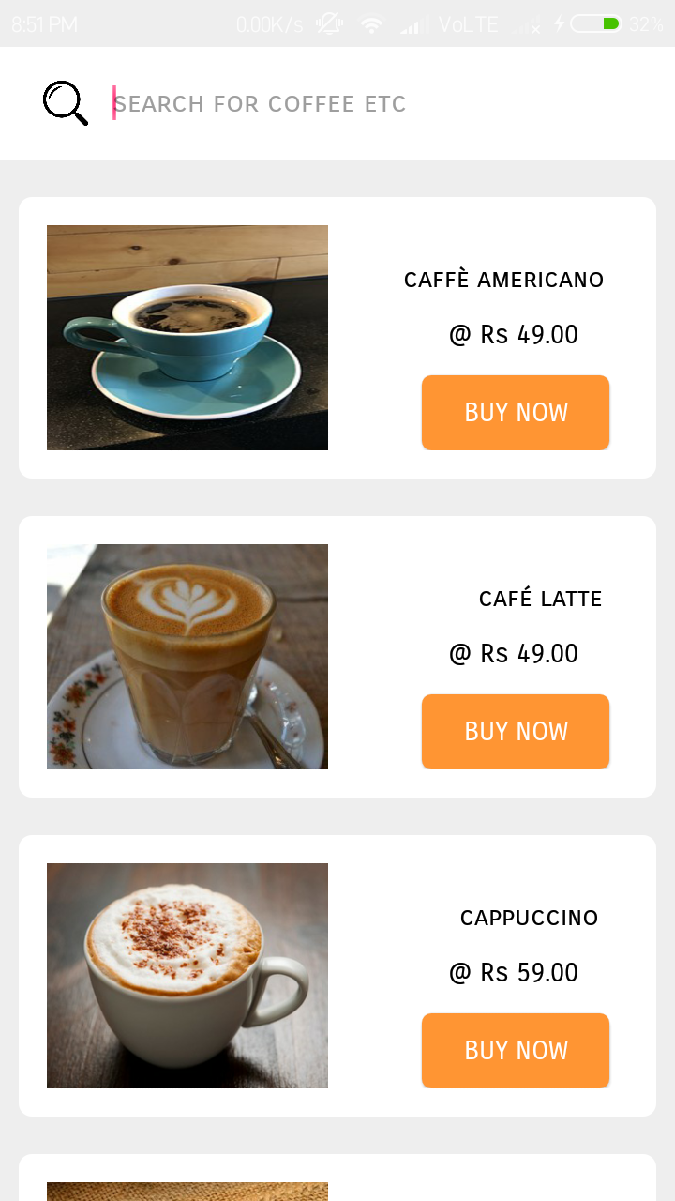

***coffee.xml***

|  |
| --- |
| *<?xml version="1.0" encoding="utf-8"?>*  *<RelativeLayout*  *xmlns:android="http://schemas.android.com/apk/res/android" android:layout_width="match_parent"*  *android:layout_height="match_parent"*  *>*  *<RelativeLayout*  *android:layout_width="match_parent"*  *android:layout_height="60dp"*  *android:background="#ffffff"*  *>*  *<EditText*  *android:id="@+id/searchitem"*  *android:layout_width="290dp"*  *android:layout_marginLeft="60dp"*  *android:layout_marginTop="10dp"*  *android:layout_height="40dp"*  *android:background="@null"*  *android:hint="search for coffee etc"*  *android:textColor="#000000"*  *android:fontFamily="sans-serif-smallcaps"*  *android:textSize="15dp"*  *android:layout_alignParentTop="true"*  */>*  *<ImageView*  *android:id="@+id/searchbutton"*  *android:layout_width="30dp"*  *android:layout_height="30dp"*  *android:background="@drawable/searchicon"*  *android:layout_marginLeft="20dp"*  *android:layout_marginTop="15dp"*  */>*  *</RelativeLayout>*  *<ScrollView*  *android:layout_width="match_parent"*  *android:layout_height="match_parent"*  *android:layout_marginTop="60dp"*  *>*  *<RelativeLayout*  *android:layout_width="match_parent"*  *android:layout_height="match_parent">*  *<RelativeLayout*  *android:layout_width="340dp"*  *android:layout_height="150dp"*  *android:layout_marginLeft="10dp"*  *android:layout_marginTop="20dp"*  *android:background="@drawable/homepagemenuitems"*  *android:padding="15dp"*  *>*  *<ImageView*  *android:layout_width="150dp"*  *android:layout_height="130dp"*  *android:background="@drawable/c1"*  */>*  *<TextView*  *android:layout_width="wrap_content"*  *android:layout_height="wrap_content"*  *android:text="caffè americano"*  *android:fontFamily="sans-serif-smallcaps"*  *android:textColor="#000000"*  *android:layout_marginLeft="190dp"*  *android:layout_marginTop="20dp"*  */>*  *<TextView*  *android:layout_width="wrap_content"*  *android:layout_height="wrap_content"*  *android:text=" @ Rs 49.00"*  *android:fontFamily="sans-serif-smallcaps"*  *android:textColor="#000000"*  *android:layout_marginTop="50dp"*  *android:layout_marginLeft="210dp"*  */>*  *<Button*  *android:id="@+id/coffe1"*  *android:layout_width="100dp"*  *android:layout_height="40dp"*  *android:background="@drawable/confirm_button"*  *android:text="Buy now"*  *android:textColor="#ffffff"*  *android:fontFamily="sans-serif-smallcaps"*  *android:layout_marginLeft="200dp"*  *android:layout_marginTop="80dp"*  */>*  *</RelativeLayout>*  *<RelativeLayout*  *android:layout_width="340dp"*  *android:layout_height="150dp"*  *android:layout_marginLeft="10dp"*  *android:layout_marginTop="190dp"*  *android:background="@drawable/homepagemenuitems"*  *android:padding="15dp"*  *>*  *<ImageView*  *android:layout_width="150dp"*  *android:layout_height="130dp"*  *android:background="@drawable/c2"*  */>*  *<TextView*  *android:layout_width="wrap_content"*  *android:layout_height="wrap_content"*  *android:text="café latte"*  *android:fontFamily="sans-serif-smallcaps"*  *android:textColor="#000000"*  *android:layout_marginLeft="230dp"*  *android:layout_marginTop="20dp"*  */>*  *<TextView*  *android:layout_width="wrap_content"*  *android:layout_height="wrap_content"*  *android:text=" @ Rs 49.00"*  *android:fontFamily="sans-serif-smallcaps"*  *android:textColor="#000000"*  *android:layout_marginTop="50dp"*  *android:layout_marginLeft="210dp"*  */>*  *<Button*  *android:id="@+id/coffee2"*  *android:layout_width="100dp"*  *android:layout_height="40dp"*  *android:background="@drawable/confirm_button"*  *android:text="Buy now"*  *android:textColor="#ffffff"*  *android:fontFamily="sans-serif-smallcaps"*  *android:layout_marginLeft="200dp"*  *android:layout_marginTop="80dp"*  */>*  *</RelativeLayout>*  *<RelativeLayout*  *android:layout_width="340dp"*  *android:layout_height="150dp"*  *android:layout_marginLeft="10dp"*  *android:layout_marginTop="360dp"*  *android:background="@drawable/homepagemenuitems"*  *android:padding="15dp"*  *>*  *<ImageView*  *android:layout_width="150dp"*  *android:layout_height="130dp"*  *android:background="@drawable/c3"*  */>*  *<TextView*  *android:layout_width="wrap_content"*  *android:layout_height="wrap_content"*  *android:text="cappuccino"*  *android:fontFamily="sans-serif-smallcaps"*  *android:textColor="#000000"*  *android:layout_marginLeft="220dp"*  *android:layout_marginTop="20dp"*  */>*  *<TextView*  *android:layout_width="wrap_content"*  *android:layout_height="wrap_content"*  *android:text=" @ Rs 59.00"*  *android:fontFamily="sans-serif-smallcaps"*  *android:textColor="#000000"*  *android:layout_marginTop="50dp"*  *android:layout_marginLeft="210dp"*  */>*  *<Button*  *android:id="@+id/coffee3"*  *android:layout_width="100dp"*  *android:layout_height="40dp"*  *android:background="@drawable/confirm_button"*  *android:text="Buy now"*  *android:textColor="#ffffff"*  *android:fontFamily="sans-serif-smallcaps"*  *android:layout_marginLeft="200dp"*  *android:layout_marginTop="80dp"*  */>*  *</RelativeLayout>*  *<RelativeLayout*  *android:layout_width="340dp"*  *android:layout_height="150dp"*  *android:layout_marginTop="530dp"*  *android:layout_marginLeft="10dp"*  *android:background="@drawable/homepagemenuitems"*  *android:padding="15dp">*  *<ImageView*  *android:layout_width="150dp"*  *android:layout_height="130dp"*  *android:background="@drawable/c4" />*  *<TextView*  *android:layout_width="wrap_content"*  *android:layout_height="wrap_content"*  *android:layout_marginLeft="230dp"*  *android:layout_marginTop="20dp"*  *android:fontFamily="sans-serif-smallcaps"*  *android:text="espresso"*  *android:textColor="#000000" />*  *<TextView*  *android:layout_width="wrap_content"*  *android:layout_height="wrap_content"*  *android:layout_marginLeft="210dp"*  *android:layout_marginTop="50dp"*  *android:fontFamily="sans-serif-smallcaps"*  *android:text=" @ Rs 79.00"*  *android:textColor="#000000" />*  *<Button*  *android:id="@+id/coffee4"*  *android:layout_width="100dp"*  *android:layout_height="40dp"*  *android:layout_marginLeft="200dp"*  *android:layout_marginTop="80dp"*  *android:background="@drawable/confirm_button"*  *android:fontFamily="sans-serif-smallcaps"*  *android:text="Buy now"*  *android:textColor="#ffffff" />*  *</RelativeLayout>*  *<RelativeLayout*  *android:layout_width="340dp"*  *android:layout_height="150dp"*  *android:layout_marginTop="700dp"*  *android:layout_marginLeft="10dp"*  *android:background="@drawable/homepagemenuitems"*  *android:padding="15dp">*  *<ImageView*  *android:layout_width="150dp"*  *android:layout_height="130dp"*  *android:background="@drawable/c5" />*  *<TextView*  *android:layout_width="wrap_content"*  *android:layout_height="wrap_content"*  *android:layout_marginLeft="220dp"*  *android:layout_marginTop="20dp"*  *android:fontFamily="sans-serif-smallcaps"*  *android:text="flat white"*  *android:textColor="#000000" />*  *<TextView*  *android:layout_width="wrap_content"*  *android:layout_height="wrap_content"*  *android:layout_marginLeft="220dp"*  *android:layout_marginTop="50dp"*  *android:fontFamily="sans-serif-smallcaps"*  *android:text=" @ Rs 79.00"*  *android:textColor="#000000" />*  *<Button*  *android:id="@+id/coffee5"*  *android:layout_width="100dp"*  *android:layout_height="40dp"*  *android:layout_marginLeft="200dp"*  *android:layout_marginTop="80dp"*  *android:background="@drawable/confirm_button"*  *android:fontFamily="sans-serif-smallcaps"*  *android:text="Buy now"*  *android:textColor="#ffffff" />*  *</RelativeLayout>*  *<RelativeLayout*  *android:layout_width="340dp"*  *android:layout_height="150dp"*  *android:layout_marginTop="870dp"*  *android:layout_marginLeft="10dp"*  *android:background="@drawable/homepagemenuitems"*  *android:padding="15dp">*  *<ImageView*  *android:layout_width="150dp"*  *android:layout_height="match_parent"*  *android:background="@drawable/c6" />*  *<TextView*  *android:layout_width="wrap_content"*  *android:layout_height="wrap_content"*  *android:layout_marginLeft="220dp"*  *android:layout_marginTop="20dp"*  *android:fontFamily="sans-serif-smallcaps"*  *android:text="long black"*  *android:textColor="#000000" />*  *<TextView*  *android:layout_width="wrap_content"*  *android:layout_height="wrap_content"*  *android:layout_marginLeft="220dp"*  *android:layout_marginTop="50dp"*  *android:fontFamily="sans-serif-smallcaps"*  *android:text=" @ Rs 80.00"*  *android:textColor="#000000" />*  *<Button*  *android:id="@+id/coffee6"*  *android:layout_width="100dp"*  *android:layout_height="40dp"*  *android:layout_marginLeft="200dp"*  *android:layout_marginTop="80dp"*  *android:background="@drawable/confirm_button"*  *android:fontFamily="sans-serif-smallcaps"*  *android:text="Buy now"*  *android:textColor="#ffffff" />*  *</RelativeLayout>*  *<RelativeLayout*  *android:layout_width="340dp"*  *android:layout_height="150dp"*  *android:layout_marginLeft="10dp"*  *android:layout_marginTop="1040dp"*  *android:background="@drawable/homepagemenuitems"*  *android:padding="15dp"*  *>*  *<ImageView*  *android:layout_width="150dp"*  *android:layout_height="130dp"*  *android:background="@drawable/c7"*  */>*  *<TextView*  *android:layout_width="wrap_content"*  *android:layout_height="wrap_content"*  *android:text="irish coffee"*  *android:fontFamily="sans-serif-smallcaps"*  *android:textColor="#000000"*  *android:layout_marginLeft="230dp"*  *android:layout_marginTop="20dp"*  */>*  *<TextView*  *android:layout_width="wrap_content"*  *android:layout_height="wrap_content"*  *android:text=" @ Rs 89.00"*  *android:fontFamily="sans-serif-smallcaps"*  *android:textColor="#000000"*  *android:layout_marginTop="50dp"*  *android:layout_marginLeft="210dp"*  */>*  *<Button*  *android:id="@+id/coffee7"*  *android:layout_width="100dp"*  *android:layout_height="40dp"*  *android:background="@drawable/confirm_button"*  *android:text="Buy now"*  *android:textColor="#ffffff"*  *android:fontFamily="sans-serif-smallcaps"*  *android:layout_marginLeft="200dp"*  *android:layout_marginTop="80dp"*  */>*  *</RelativeLayout>*  *<RelativeLayout*  *android:layout_width="340dp"*  *android:layout_height="150dp"*  *android:layout_marginLeft="10dp"*  *android:layout_marginTop="1210dp"*  *android:background="@drawable/homepagemenuitems"*  *android:padding="15dp"*  *android:layout_marginBottom="50dp"*  *>*  *<ImageView*  *android:layout_width="150dp"*  *android:layout_height="130dp"*  *android:background="@drawable/c8"*  */>*  *<TextView*  *android:layout_width="wrap_content"*  *android:layout_height="wrap_content"*  *android:text="macchiato"*  *android:fontFamily="sans-serif-smallcaps"*  *android:textColor="#000000"*  *android:layout_marginLeft="220dp"*  *android:layout_marginTop="20dp"*  */>*  *<TextView*  *android:layout_width="wrap_content"*  *android:layout_height="wrap_content"*  *android:text=" @ Rs 99.00"*  *android:fontFamily="sans-serif-smallcaps"*  *android:textColor="#000000"*  *android:layout_marginTop="50dp"*  *android:layout_marginLeft="220dp"*  */>*  *<Button*  *android:id="@+id/coffee8"*  *android:layout_width="100dp"*  *android:layout_height="40dp"*  *android:background="@drawable/confirm_button"*  *android:text="Buy now"*  *android:textColor="#ffffff"*  *android:fontFamily="sans-serif-smallcaps"*  *android:layout_marginLeft="200dp"*  *android:layout_marginTop="80dp"*  */>*  *</RelativeLayout>*  *</RelativeLayout>*  *</ScrollView>*  *</RelativeLayout>* |

***Coffee.java***

|  |
| --- |
| *package com.example.mohdarif.dostea;*  *import android.content.Intent;*  *import android.os.Bundle;*  *import android.support.annotation.Nullable;*  *import android.support.v7.app.AppCompatActivity;*  *import android.view.View;*  *import android.widget.Button;*  *import android.widget.EditText;*  *import android.widget.ImageView;*  *public class Coffee extends AppCompatActivity {*  *Button coffee1,coffee2,coffee3,coffee4,coffee5,coffee6,coffee7,coffee8;*  *EditText searchitem;*  *ImageView searchButton;*  *String value;*  *@Override*  *protected void onCreate(@Nullable Bundle savedInstanceState) {*  *super.onCreate(savedInstanceState);*  *setContentView(R.layout.coffee);*  *searchitem = findViewById(R.id.searchitem);*  *searchButton = findViewById(R.id.searchbutton);*  *searchButton.setOnClickListener(new View.OnClickListener() {*  *@Override*  *public void onClick(View v) {*  *value = searchitem.getText().toString().trim();*  *if(value.equalsIgnoreCase("coffee americano")) {*  *Intent intent = new Intent(getApplicationContext(),Coffee1.class);*  *startActivity(intent);*  *finish();*  *}*  *else if(value.equalsIgnoreCase("coffee latte")) {*  *Intent intent = new Intent(getApplicationContext(),Coffee2.class);*  *startActivity(intent);*  *finish();*  *}*  *else if(value.equalsIgnoreCase("cappuccino")) {*  *Intent intent = new Intent(getApplicationContext(),Coffee3.class);*  *startActivity(intent);*  *finish();*  *}*  *else if(value.equalsIgnoreCase("espresso")) {*  *Intent intent = new Intent(getApplicationContext(),Coffee4.class);*  *startActivity(intent);*  *finish();*  *}*  *else if(value.equalsIgnoreCase("flat white")) {*  *Intent intent = new Intent(getApplicationContext(),Coffee5.class);*  *startActivity(intent);*  *finish();*  *}*  *else if(value.equalsIgnoreCase("long black")) {*  *Intent intent = new Intent(getApplicationContext(),Coffee6.class);*  *startActivity(intent);*  *finish();*  *}*  *else if(value.equalsIgnoreCase("irish coffee")) {*  *Intent intent = new Intent(getApplicationContext(),Coffee7.class);*  *startActivity(intent);*  *finish();*  *}*  *else if(value.equalsIgnoreCase("macchiato")) {*  *Intent intent = new Intent(getApplicationContext(),Coffee8.class);*  *startActivity(intent);*  *finish();*  *}*  *else {*  *Intent intent = new Intent(getApplicationContext(),NotFound.class);*  *startActivity(intent);*  *finish();*  *}*  *}*  *});*  *String searchValue = searchitem.getText().toString().trim();*  *if (searchValue.equals("Coffee Americano")) {*  *Intent intent = new Intent(getApplicationContext(),Coffee1.class);*  *startActivity(intent);*  *finish();*  *}*  *coffee1 = findViewById(R.id.coffe1);*  *coffee1.setOnClickListener(new View.OnClickListener() {*  *@Override*  *public void onClick(View v) {*  *Intent intent = new Intent(getApplicationContext(),Coffee1.class);*  *startActivity(intent);*  *finish();*  *}*  *});*  *coffee2 = findViewById(R.id.coffee2);*  *coffee2.setOnClickListener(new View.OnClickListener() {*  *@Override*  *public void onClick(View v) {*  *Intent intent = new Intent(getApplicationContext(),Coffee2.class);*  *startActivity(intent);*  *finish();*  *}*  *});*  *coffee3 = findViewById(R.id.coffee3);*  *coffee3.setOnClickListener(new View.OnClickListener() {*  *@Override*  *public void onClick(View v) {*  *Intent intent = new Intent(getApplicationContext(),Coffee3.class);*  *startActivity(intent);*  *finish();*  *}*  *});*  *coffee4 = findViewById(R.id.coffee4);*  *coffee4.setOnClickListener(new View.OnClickListener() {*  *@Override*  *public void onClick(View v) {*  *Intent intent = new Intent(getApplicationContext(),Coffee4.class);*  *startActivity(intent);*  *finish();*  *}*  *});*  *coffee5 = findViewById(R.id.coffee5);*  *coffee5.setOnClickListener(new View.OnClickListener() {*  *@Override*  *public void onClick(View v) {*  *Intent intent = new Intent(getApplicationContext(),Coffee5.class);*  *startActivity(intent);*  *finish();*  *}*  *});*  *coffee6 = findViewById(R.id.coffee6);*  *coffee6.setOnClickListener(new View.OnClickListener() {*  *@Override*  *public void onClick(View v) {*  *Intent intent = new Intent(getApplicationContext(),Coffee6.class);*  *startActivity(intent);*  *finish();*  *}*  *});*  *coffee7 = findViewById(R.id.coffee7);*  *coffee7.setOnClickListener(new View.OnClickListener() {*  *@Override*  *public void onClick(View v) {*  *Intent intent = new Intent(getApplicationContext(),Coffee7.class);*  *startActivity(intent);*  *finish();*  *}*  *});*  *coffee8 = findViewById(R.id.coffee8);*  *coffee8.setOnClickListener(new View.OnClickListener() {*  *@Override*  *public void onClick(View v) {*  *Intent intent = new Intent(getApplicationContext(),Coffee8.class);*  *startActivity(intent);*  *finish();*  *}*  *});*  *}*  *@Override*  *public void onBackPressed() {*  *Intent intent = new Intent(getApplicationContext(),HomePage.class);*  *startActivity(intent);*  *finish();*  *}*  *}* |

***Coffee1***

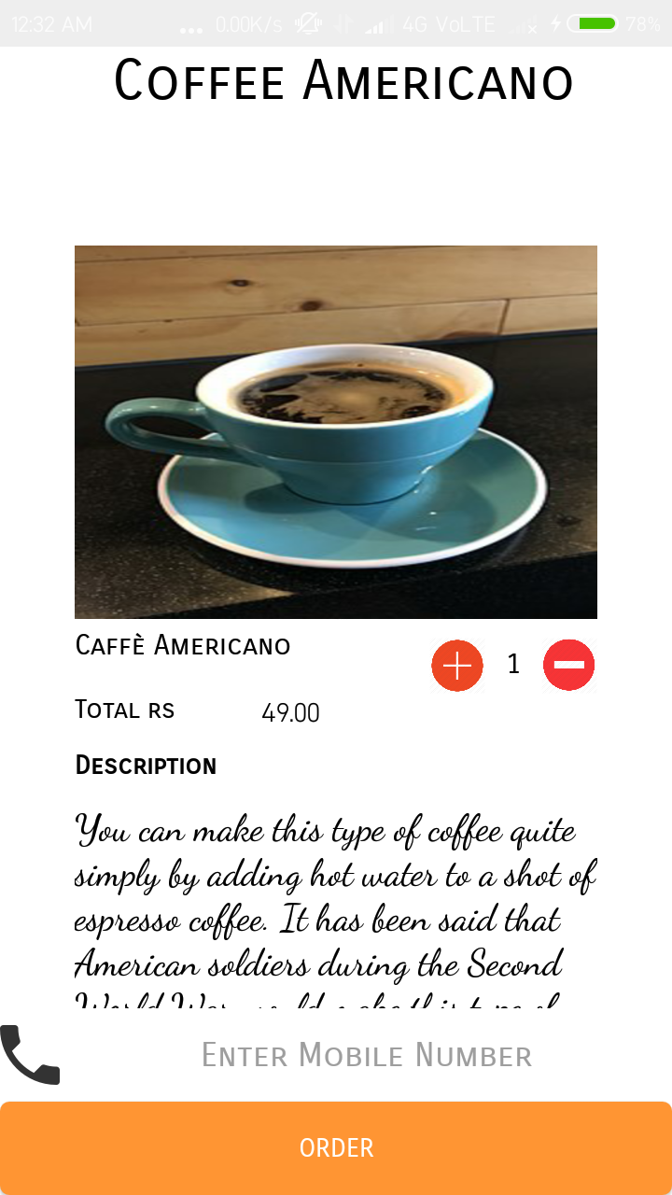

***coffee1.xml***

|  |
| --- |
| *<?xml version="1.0" encoding="utf-8"?>*  *<RelativeLayout*  *xmlns:android="http://schemas.android.com/apk/res/android" android:layout_width="match_parent"*  *android:layout_height="match_parent"*  *android:background="#ffffff"*  *>*  *<RelativeLayout*  *android:layout_width="wrap_content"*  *android:layout_height="wrap_content"*  *android:id="@+id/heading"*  *>*  *<TextView*  *android:layout_width="wrap_content"*  *android:layout_height="wrap_content"*  *android:text="Coffee Americano"*  *android:textAlignment="center"*  *android:layout_marginLeft="60dp"*  *android:textSize="30dp"*  *android:id="@+id/items"*  *android:textColor="#000000"*  *android:fontFamily="sans-serif-smallcaps"*  */>*  *</RelativeLayout>*  *<ScrollView*  *android:layout_width="match_parent"*  *android:layout_height="match_parent"*  *android:id="@+id/slide1"*  *android:layout_below="@+id/heading"*  *>*  *<RelativeLayout*  *android:layout_width="match_parent"*  *android:layout_height="700dp"*  *>*  *<RelativeLayout*  *android:id="@+id/content1"*  *android:layout_width="320dp"*  *android:layout_height="match_parent"*  *android:layout_marginTop="50dp"*  *android:layout_marginLeft="20dp"*  *android:padding="20dp"*  *>*  *<ImageView*  *android:background="@drawable/c1"*  *android:layout_width="match_parent"*  *android:layout_height="200dp"*  */>*  *<TextView*  *android:id="@+id/text1"*  *android:layout_width="wrap_content"*  *android:layout_height="wrap_content"*  *android:layout_marginLeft="0dp"*  *android:layout_marginTop="205dp"*  *android:textColor="#000000"*  *android:text="Caffè Americano"*  *android:fontFamily="sans-serif-smallcaps"*  *android:textSize="15dp"*  */>*  *<Button*  *android:layout_width="30dp"*  *android:id="@+id/plusicon"*  *android:layout_height="30dp"*  *android:background="@drawable/plus1"*  *android:layout_marginTop="210dp"*  *android:layout_marginLeft="190dp"*  */>*  *<TextView*  *android:id="@+id/value"*  *android:layout_width="30dp"*  *android:layout_height="30dp"*  *android:textSize="15dp"*  *android:textColor="#000000"*  *android:textAlignment="center"*  *android:fontFamily="sans-serif-smallcaps"*  *android:layout_marginTop="210dp"*  *android:padding="5dp"*  *android:text="1"*  *android:layout_marginLeft="220dp"*  */>*  *<Button*  *android:id="@+id/minus"*  *android:layout_width="30dp"*  *android:layout_height="30dp"*  *android:layout_marginLeft="250dp"*  *android:layout_marginTop="210dp"*  *android:background="@drawable/minus1"*  */>*  *<TextView*  *android:layout_width="wrap_content"*  *android:layout_height="wrap_content"*  *android:text="Total rs "*  *android:textColor="#000000"*  *android:fontFamily="sans-serif-smallcaps"*  *android:layout_marginTop="240dp"*  */>*  *<TextView*  *android:id="@+id/amount"*  *android:layout_width="60dp"*  *android:layout_height="20dp"*  *android:text="49.00"*  *android:textColor="#000000"*  *android:layout_marginTop="240dp"*  *android:layout_marginLeft="100dp"*  */>*  *<TextView*  *android:layout_width="wrap_content"*  *android:layout_height="wrap_content"*  *android:text="Description"*  *android:textColor="#000000"*  *android:fontFamily="sans-serif-smallcaps"*  *android:layout_marginTop="270dp"*  *android:textStyle="bold"*  */>*  *<TextView*  *android:layout_width="wrap_content"*  *android:layout_height="wrap_content"*  *android:textColor="#000000"*  *android:fontFamily="cursive"*  *android:textSize="20dp"*  *android:text="You can make this type of coffee quite simply by adding hot water to a shot of espresso coffee. It has been said that American soldiers during the Second World War would make this type of coffee to make their beverages last longer. It was then (apparently) adopted by American baristas after the war."*  *android:layout_marginTop="300dp"*  */>*  *</RelativeLayout>*  *</RelativeLayout>*  *</ScrollView>*  *<EditText*  *android:id="@+id/getMobile"*  *android:layout_width="match_parent"*  *android:layout_height="50dp"*  *android:layout_alignParentBottom="true"*  *android:layout_marginBottom="50dp"*  *android:layout_marginLeft="0dp"*  *android:inputType="number"*  *android:background="#ffffff"*  *android:drawableLeft="@drawable/phoneicon"*  *android:hint="Enter Mobile Number"*  *android:fontFamily="sans-serif-smallcaps"*  *android:textAlignment="center"*  */>*  *<Button*  *android:id="@+id/orderButton"*  *android:layout_width="match_parent"*  *android:layout_height="50dp"*  *android:text="Order"*  *android:textColor="#ffffff"*  *android:fontFamily="sans-serif-smallcaps"*  *android:layout_marginLeft="0dp"*  *android:layout_alignParentBottom="true"*  *android:background="@drawable/confirm_button"*  *android:layout_marginBottom="0dp"*  */>*  *</RelativeLayout>* |

***Coffee1.java***

|  |
| --- |
| *package com.example.mohdarif.dostea;*  *import android.app.NotificationManager;*  *import android.app.PendingIntent;*  *import android.content.Context;*  *import android.content.Intent;*  *import android.os.Bundle;*  *import android.support.v4.app.NotificationCompat;*  *import android.support.v7.app.AppCompatActivity;*  *import android.telephony.SmsManager;*  *import android.view.View;*  *import android.widget.Button;*  *import android.widget.EditText;*  *import android.widget.TextView;*  *import android.widget.Toast;*  *public class Coffee1 extends AppCompatActivity {*  *Button confirm,add,sub;*  *TextView value,amount;*  *EditText getMobile;*  *int countOrderId=101,countOrderNumber=1;*  *final float initailAmount = (float) 49.00;*  *@Override*  *protected void onCreate(Bundle savedInstanceState) {*  *super.onCreate(savedInstanceState);*  *setContentView(R.layout.coffee1);*  *value = findViewById(R.id.value);*  *amount = findViewById(R.id.amount);*  *add = findViewById(R.id.plusicon);*  *add.setOnClickListener(new View.OnClickListener() {*  *@Override*  *public void onClick(View v) {*  *countOrderNumber++;*  *if (countOrderNumber>10) {*  *Toast.makeText(getApplicationContext(),"maximum quantity only 10 at a time",Toast.LENGTH_LONG).show();*  *}*  *else{*  *value.setText(""+countOrderNumber);*  *amount.setText(""+initailAmount*countOrderNumber);*  *}*  *}*  *});*  *sub = findViewById(R.id.minus);*  *sub.setOnClickListener(new View.OnClickListener() {*  *@Override*  *public void onClick(View v) {*  *countOrderNumber--;*  *if (countOrderNumber<1) {*  *Toast.makeText(getApplicationContext(),"only 1 selected",Toast.LENGTH_LONG).show();*  *}*  *else {*  *value.setText(""+countOrderNumber);*  *amount.setText(""+initailAmount*countOrderNumber);*  *}*  *}*  *});*  *confirm = findViewById(R.id.orderButton);*  *getMobile = findViewById(R.id.getMobile);*  *confirm.setOnClickListener(new View.OnClickListener() {*  *@Override*  *public void onClick(View v) {*  *countOrderId++;*  *String number = getMobile.getText().toString().trim();*  *if (number.isEmpty()||number.length()<10) {*  *Toast.makeText(getApplicationContext(),"Enter a valid number",Toast.LENGTH_LONG).show();*  *getMobile.requestFocus();*  *}*  *else {*  *addNotification();*  *SmsManager sms= SmsManager.getDefault();*  *sms.sendTextMessage(number, null, "Your Order for "+countOrderNumber+ " Coffee Americano has been confirmed Kindly Par Rs "+amount.getText(),null,null);*  *Toast.makeText(getApplicationContext(), "Order recieved successfully!",*  *Toast.LENGTH_LONG).show();*  *Intent intent1 = new Intent(getApplicationContext(),ConfirmOrder.class);*  *startActivity(intent1);*  *}*  *}*  *});*  *}*  *private void addNotification() {*  *NotificationCompat.Builder builder =*  *new NotificationCompat.Builder(this)*  *.setSmallIcon(R.drawable.notificationicon)*  *.setContentTitle("Dostea")*  *.setContentText(IceCream1.notification);*  *Intent notificationIntent = new Intent(this, MainActivity.class);*  *PendingIntent contentIntent = PendingIntent.getActivity(this, 0, notificationIntent,*  *PendingIntent.FLAG_UPDATE_CURRENT);*  *builder.setContentIntent(contentIntent);*  *// Add as notification*  *NotificationManager manager = (NotificationManager) getSystemService(Context.NOTIFICATION_SERVICE);*  *manager.notify(0, builder.build());*  *}*  *@Override*  *public void onBackPressed() {*  *Intent intent = new Intent(getApplicationContext(),Coffee.class);*  *startActivity(intent);*  *finish();*  *}*  *}* |

***Coffee2***

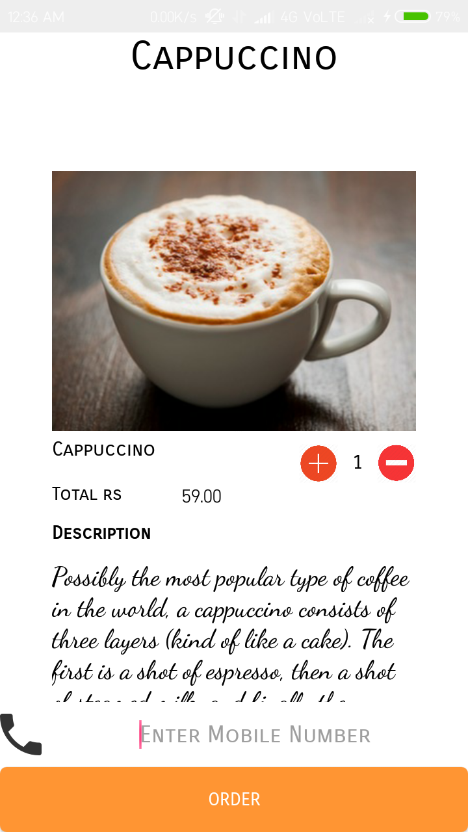

***coffee2.xml***

|  |
| --- |
| *<?xml version="1.0" encoding="utf-8"?>*  *<RelativeLayout*  *xmlns:android="http://schemas.android.com/apk/res/android" android:layout_width="match_parent"*  *android:layout_height="match_parent"*  *android:background="#ffffff"*  *>*  *<RelativeLayout*  *android:layout_width="wrap_content"*  *android:layout_height="wrap_content"*  *android:id="@+id/heading"*  *>*  *<TextView*  *android:layout_width="wrap_content"*  *android:layout_height="wrap_content"*  *android:text="Coffee Latte"*  *android:textAlignment="center"*  *android:layout_marginLeft="100dp"*  *android:textSize="30dp"*  *android:id="@+id/items"*  *android:textColor="#000000"*  *android:fontFamily="sans-serif-smallcaps"*  */>*  *</RelativeLayout>*  *<ScrollView*  *android:layout_width="match_parent"*  *android:layout_height="match_parent"*  *android:id="@+id/slide1"*  *android:layout_below="@+id/heading"*  *>*  *<RelativeLayout*  *android:layout_width="match_parent"*  *android:layout_height="700dp"*  *>*  *<RelativeLayout*  *android:id="@+id/content1"*  *android:layout_width="320dp"*  *android:layout_height="match_parent"*  *android:layout_marginTop="50dp"*  *android:layout_marginLeft="20dp"*  *android:padding="20dp"*  *>*  *<ImageView*  *android:background="@drawable/c2"*  *android:layout_width="match_parent"*  *android:layout_height="200dp"*  */>*  *<TextView*  *android:id="@+id/text1"*  *android:layout_width="wrap_content"*  *android:layout_height="wrap_content"*  *android:layout_marginLeft="0dp"*  *android:layout_marginTop="205dp"*  *android:textColor="#000000"*  *android:text="Café Latte"*  *android:fontFamily="sans-serif-smallcaps"*  *android:textSize="15dp"*  */>*  *<Button*  *android:layout_width="30dp"*  *android:id="@+id/plusicon"*  *android:layout_height="30dp"*  *android:background="@drawable/plus1"*  *android:layout_marginTop="210dp"*  *android:layout_marginLeft="190dp"*  */>*  *<TextView*  *android:id="@+id/value"*  *android:layout_width="30dp"*  *android:layout_height="30dp"*  *android:textSize="15dp"*  *android:textColor="#000000"*  *android:textAlignment="center"*  *android:fontFamily="sans-serif-smallcaps"*  *android:layout_marginTop="210dp"*  *android:padding="5dp"*  *android:text="1"*  *android:layout_marginLeft="220dp"*  */>*  *<Button*  *android:id="@+id/minus"*  *android:layout_width="30dp"*  *android:layout_height="30dp"*  *android:layout_marginLeft="250dp"*  *android:layout_marginTop="210dp"*  *android:background="@drawable/minus1"*  */>*  *<TextView*  *android:layout_width="wrap_content"*  *android:layout_height="wrap_content"*  *android:text="Total rs "*  *android:textColor="#000000"*  *android:fontFamily="sans-serif-smallcaps"*  *android:layout_marginTop="240dp"*  */>*  *<TextView*  *android:id="@+id/amount"*  *android:layout_width="60dp"*  *android:layout_height="20dp"*  *android:text="49.00"*  *android:textColor="#000000"*  *android:layout_marginTop="240dp"*  *android:layout_marginLeft="100dp"*  */>*  *<TextView*  *android:layout_width="wrap_content"*  *android:layout_height="wrap_content"*  *android:text="Description"*  *android:textColor="#000000"*  *android:fontFamily="sans-serif-smallcaps"*  *android:layout_marginTop="270dp"*  *android:textStyle="bold"*  */>*  *<TextView*  *android:layout_width="wrap_content"*  *android:layout_height="wrap_content"*  *android:textColor="#000000"*  *android:fontFamily="cursive"*  *android:textSize="20dp"*  *android:text="A fairly popular option for coffee drinkers, a latte consists steamed (or scolded) milk and a single shot of coffee. It is usually quite frothy, and you’ll occasionally encounter cafes that don’t understand the difference between this and a flat white."*  *android:layout_marginTop="300dp"*  */>*  *</RelativeLayout>*  *</RelativeLayout>*  *</ScrollView>*  *<EditText*  *android:id="@+id/getMobile"*  *android:layout_width="match_parent"*  *android:layout_height="50dp"*  *android:layout_alignParentBottom="true"*  *android:layout_marginBottom="50dp"*  *android:layout_marginLeft="0dp"*  *android:inputType="number"*  *android:background="#ffffff"*  *android:drawableLeft="@drawable/phoneicon"*  *android:hint="Enter Mobile Number"*  *android:fontFamily="sans-serif-smallcaps"*  *android:textAlignment="center"*  */>*  *<Button*  *android:id="@+id/orderButton"*  *android:layout_width="match_parent"*  *android:layout_height="50dp"*  *android:text="Order"*  *android:textColor="#ffffff"*  *android:fontFamily="sans-serif-smallcaps"*  *android:layout_marginLeft="0dp"*  *android:layout_alignParentBottom="true"*  *android:background="@drawable/confirm_button"*  *android:layout_marginBottom="0dp"*  */>*  *</RelativeLayout>* |

***Coffee2,java***

|  |
| --- |
| *package com.example.mohdarif.dostea;*  *import android.app.NotificationManager;*  *import android.app.PendingIntent;*  *import android.content.Context;*  *import android.content.Intent;*  *import android.os.Bundle;*  *import android.support.v4.app.NotificationCompat;*  *import android.support.v7.app.AppCompatActivity;*  *import android.telephony.SmsManager;*  *import android.view.View;*  *import android.widget.Button;*  *import android.widget.EditText;*  *import android.widget.TextView;*  *import android.widget.Toast;*  *public class Coffee2 extends AppCompatActivity {*  *Button confirm,add,sub;*  *TextView value,amount;*  *EditText getMobile;*  *int countOrderId=101,countOrderNumber=1;*  *final float initailAmount = (float) 49.00;*  *@Override*  *protected void onCreate(Bundle savedInstanceState) {*  *super.onCreate(savedInstanceState);*  *setContentView(R.layout.coffee2);*  *value = findViewById(R.id.value);*  *amount = findViewById(R.id.amount);*  *add = findViewById(R.id.plusicon);*  *add.setOnClickListener(new View.OnClickListener() {*  *@Override*  *public void onClick(View v) {*  *countOrderNumber++;*  *if (countOrderNumber>10) {*  *Toast.makeText(getApplicationContext(),"maximum quantity only 10 at a time",Toast.LENGTH_LONG).show();*  *}*  *else{*  *value.setText(""+countOrderNumber);*  *amount.setText(""+initailAmount*countOrderNumber);*  *}*  *}*  *});*  *sub = findViewById(R.id.minus);*  *sub.setOnClickListener(new View.OnClickListener() {*  *@Override*  *public void onClick(View v) {*  *countOrderNumber--;*  *if (countOrderNumber<1) {*  *Toast.makeText(getApplicationContext(),"only 1 selected",Toast.LENGTH_LONG).show();*  *}*  *else {*  *value.setText(""+countOrderNumber);*  *amount.setText(""+initailAmount*countOrderNumber);*  *}*  *}*  *});*  *confirm = findViewById(R.id.orderButton);*  *getMobile = findViewById(R.id.getMobile);*  *confirm.setOnClickListener(new View.OnClickListener() {*  *@Override*  *public void onClick(View v) {*  *countOrderId++;*  *String number = getMobile.getText().toString().trim();*  *if (number.isEmpty()||number.length()<10) {*  *Toast.makeText(getApplicationContext(),"Enter a valid number",Toast.LENGTH_LONG).show();*  *getMobile.requestFocus();*  *}*  *else {*  *addNotification();*  *Intent intent=new Intent(getApplicationContext(),MainActivity.class);*  *PendingIntent pi=PendingIntent.getActivity(getApplicationContext(), 0, intent,0);*  *//Get the SmsManager instance and call the sendTextMessage method to send message*  *SmsManager sms= SmsManager.getDefault();*  *sms.sendTextMessage(number, null, "Your Order for "+countOrderNumber+ " Coffee Latte has been confirmed Kindly Par Rs "+amount.getText(),null,null);*  *Toast.makeText(getApplicationContext(), "Order recieved successfully!",*  *Toast.LENGTH_LONG).show();*  *Intent intent1 = new Intent(getApplicationContext(),ConfirmOrder.class);*  *startActivity(intent1);*  *}*  *}*  *});*  *}*  *private void addNotification() {*  *NotificationCompat.Builder builder =*  *new NotificationCompat.Builder(this)*  *.setSmallIcon(R.drawable.notificationicon)*  *.setContentTitle("Dostea")*  *.setContentText(IceCream1.notification);*  *Intent notificationIntent = new Intent(this, MainActivity.class);*  *PendingIntent contentIntent = PendingIntent.getActivity(this, 0, notificationIntent,*  *PendingIntent.FLAG_UPDATE_CURRENT);*  *builder.setContentIntent(contentIntent);*  *// Add as notification*  *NotificationManager manager = (NotificationManager) getSystemService(Context.NOTIFICATION_SERVICE);*  *manager.notify(0, builder.build());*  *}*  *@Override*  *public void onBackPressed() {*  *Intent intent = new Intent(getApplicationContext(),Coffee.class);*  *startActivity(intent);*  *finish();*  *}*  *}* |

***Cookies***

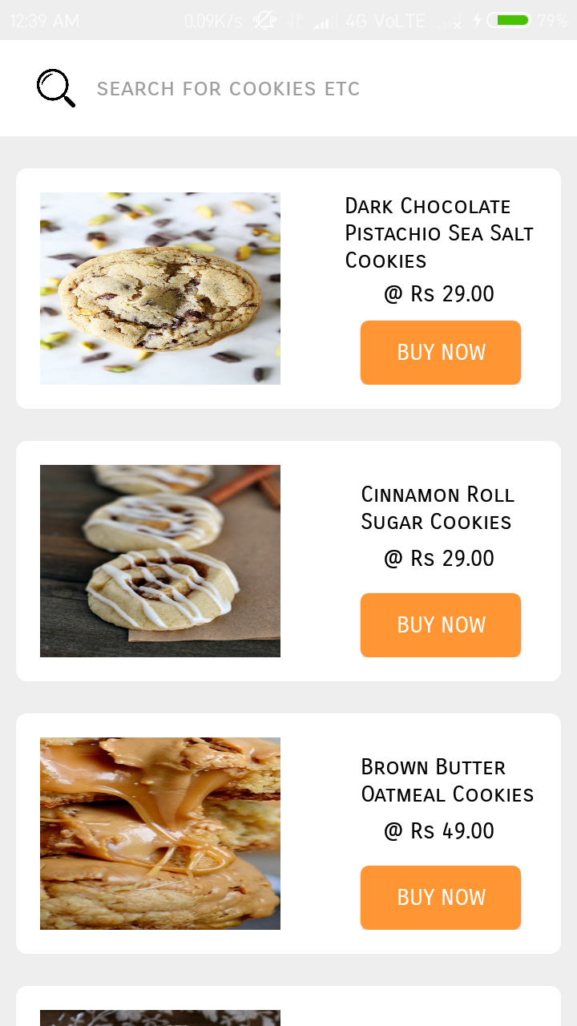

***cookies.xml***

|  |
| --- |
| *<?xml version="1.0" encoding="utf-8"?>*  *<RelativeLayout*  *xmlns:android="http://schemas.android.com/apk/res/android" android:layout_width="match_parent"*  *android:layout_height="match_parent"*  *>*  *<RelativeLayout*  *android:layout_width="match_parent"*  *android:layout_height="60dp"*  *android:background="#ffffff"*  *>*  *<EditText*  *android:id="@+id/searchitem"*  *android:layout_width="290dp"*  *android:layout_marginLeft="60dp"*  *android:layout_marginTop="10dp"*  *android:layout_height="40dp"*  *android:background="@null"*  *android:hint="search for cookies etc"*  *android:textColor="#000000"*  *android:fontFamily="sans-serif-smallcaps"*  *android:textSize="15dp"*  *android:layout_alignParentTop="true"*  */>*  *<ImageView*  *android:id="@+id/searchbutton"*  *android:layout_width="30dp"*  *android:layout_height="30dp"*  *android:background="@drawable/searchicon"*  *android:layout_marginLeft="20dp"*  *android:layout_marginTop="15dp"*  */>*  *</RelativeLayout>*  *<ScrollView*  *android:layout_width="match_parent"*  *android:layout_height="match_parent"*  *android:layout_marginTop="60dp"*  *>*  *<RelativeLayout*  *android:layout_width="match_parent"*  *android:layout_height="match_parent">*  *<RelativeLayout*  *android:layout_width="340dp"*  *android:layout_height="150dp"*  *android:layout_marginLeft="10dp"*  *android:layout_marginTop="20dp"*  *android:background="@drawable/homepagemenuitems"*  *android:padding="15dp"*  *>*  *<ImageView*  *android:layout_width="150dp"*  *android:layout_height="130dp"*  *android:background="@drawable/bis1"*  */>*  *<TextView*  *android:layout_width="wrap_content"*  *android:layout_height="wrap_content"*  *android:text="Dark Chocolate Pistachio Sea Salt Cookies"*  *android:fontFamily="sans-serif-smallcaps"*  *android:textColor="#000000"*  *android:layout_marginLeft="190dp"*  *android:layout_marginTop="0dp"*  */>*  *<TextView*  *android:layout_width="wrap_content"*  *android:layout_height="wrap_content"*  *android:text=" @ Rs 29.00"*  *android:fontFamily="sans-serif-smallcaps"*  *android:textColor="#000000"*  *android:layout_marginTop="55dp"*  *android:layout_marginLeft="210dp"*  */>*  *<Button*  *android:id="@+id/cookie1"*  *android:layout_width="100dp"*  *android:layout_height="40dp"*  *android:background="@drawable/confirm_button"*  *android:text="Buy now"*  *android:textColor="#ffffff"*  *android:fontFamily="sans-serif-smallcaps"*  *android:layout_marginLeft="200dp"*  *android:layout_marginTop="80dp"*  */>*  *</RelativeLayout>*  *<RelativeLayout*  *android:layout_width="340dp"*  *android:layout_height="150dp"*  *android:layout_marginLeft="10dp"*  *android:layout_marginTop="190dp"*  *android:background="@drawable/homepagemenuitems"*  *android:padding="15dp"*  *>*  *<ImageView*  *android:layout_width="150dp"*  *android:layout_height="130dp"*  *android:background="@drawable/bis2"*  */>*  *<TextView*  *android:layout_width="wrap_content"*  *android:layout_height="wrap_content"*  *android:text="Cinnamon Roll Sugar Cookies"*  *android:fontFamily="sans-serif-smallcaps"*  *android:textColor="#000000"*  *android:layout_marginLeft="200dp"*  *android:layout_marginTop="10dp"*  */>*  *<TextView*  *android:layout_width="wrap_content"*  *android:layout_height="wrap_content"*  *android:text=" @ Rs 29.00"*  *android:fontFamily="sans-serif-smallcaps"*  *android:textColor="#000000"*  *android:layout_marginTop="50dp"*  *android:layout_marginLeft="210dp"*  */>*  *<Button*  *android:id="@+id/cookie2"*  *android:layout_width="100dp"*  *android:layout_height="40dp"*  *android:background="@drawable/confirm_button"*  *android:text="Buy now"*  *android:textColor="#ffffff"*  *android:fontFamily="sans-serif-smallcaps"*  *android:layout_marginLeft="200dp"*  *android:layout_marginTop="80dp"*  */>*  *</RelativeLayout>*  *<RelativeLayout*  *android:layout_width="340dp"*  *android:layout_height="150dp"*  *android:layout_marginLeft="10dp"*  *android:layout_marginTop="360dp"*  *android:background="@drawable/homepagemenuitems"*  *android:padding="15dp"*  *>*  *<ImageView*  *android:layout_width="150dp"*  *android:layout_height="130dp"*  *android:background="@drawable/bis3"*  */>*  *<TextView*  *android:layout_width="wrap_content"*  *android:layout_height="wrap_content"*  *android:text="Brown Butter Oatmeal Cookies"*  *android:fontFamily="sans-serif-smallcaps"*  *android:textColor="#000000"*  *android:layout_marginLeft="200dp"*  *android:layout_marginTop="10dp"*  */>*  *<TextView*  *android:layout_width="wrap_content"*  *android:layout_height="wrap_content"*  *android:text=" @ Rs 49.00"*  *android:fontFamily="sans-serif-smallcaps"*  *android:textColor="#000000"*  *android:layout_marginTop="50dp"*  *android:layout_marginLeft="210dp"*  */>*  *<Button*  *android:id="@+id/cookie3"*  *android:layout_width="100dp"*  *android:layout_height="40dp"*  *android:background="@drawable/confirm_button"*  *android:text="Buy now"*  *android:textColor="#ffffff"*  *android:fontFamily="sans-serif-smallcaps"*  *android:layout_marginLeft="200dp"*  *android:layout_marginTop="80dp"*  */>*  *</RelativeLayout>*  *<RelativeLayout*  *android:layout_width="340dp"*  *android:layout_height="150dp"*  *android:layout_marginTop="530dp"*  *android:layout_marginLeft="10dp"*  *android:background="@drawable/homepagemenuitems"*  *android:padding="15dp">*  *<ImageView*  *android:layout_width="150dp"*  *android:layout_height="130dp"*  *android:background="@drawable/bis4" />*  *<TextView*  *android:layout_width="wrap_content"*  *android:layout_height="wrap_content"*  *android:layout_marginLeft="210dp"*  *android:layout_marginTop="10dp"*  *android:fontFamily="sans-serif-smallcaps"*  *android:text="Kitsilano Cookies"*  *android:textColor="#000000" />*  *<TextView*  *android:layout_width="wrap_content"*  *android:layout_height="wrap_content"*  *android:layout_marginLeft="210dp"*  *android:layout_marginTop="50dp"*  *android:fontFamily="sans-serif-smallcaps"*  *android:text=" @ Rs 49.00"*  *android:textColor="#000000" />*  *<Button*  *android:id="@+id/cookie4"*  *android:layout_width="100dp"*  *android:layout_height="40dp"*  *android:layout_marginLeft="200dp"*  *android:layout_marginTop="80dp"*  *android:background="@drawable/confirm_button"*  *android:fontFamily="sans-serif-smallcaps"*  *android:text="Buy now"*  *android:textColor="#ffffff" />*  *</RelativeLayout>*  *<RelativeLayout*  *android:layout_width="340dp"*  *android:layout_height="150dp"*  *android:layout_marginTop="700dp"*  *android:layout_marginLeft="10dp"*  *android:background="@drawable/homepagemenuitems"*  *android:padding="15dp">*  *<ImageView*  *android:layout_width="150dp"*  *android:layout_height="130dp"*  *android:background="@drawable/bis5" />*  *<TextView*  *android:layout_width="wrap_content"*  *android:layout_height="wrap_content"*  *android:layout_marginLeft="190dp"*  *android:layout_marginTop="0dp"*  *android:fontFamily="sans-serif-smallcaps"*  *android:text="Brown Butter Bourbon Spice Cookies"*  *android:textColor="#000000" />*  *<TextView*  *android:layout_width="wrap_content"*  *android:layout_height="wrap_content"*  *android:layout_marginLeft="220dp"*  *android:layout_marginTop="55dp"*  *android:fontFamily="sans-serif-smallcaps"*  *android:text=" @ Rs 79.00"*  *android:textColor="#000000" />*  *<Button*  *android:id="@+id/cookie5"*  *android:layout_width="100dp"*  *android:layout_height="40dp"*  *android:layout_marginLeft="200dp"*  *android:layout_marginTop="80dp"*  *android:background="@drawable/confirm_button"*  *android:fontFamily="sans-serif-smallcaps"*  *android:text="Buy now"*  *android:textColor="#ffffff" />*  *</RelativeLayout>*  *<RelativeLayout*  *android:layout_width="340dp"*  *android:layout_height="150dp"*  *android:layout_marginTop="870dp"*  *android:layout_marginLeft="10dp"*  *android:background="@drawable/homepagemenuitems"*  *android:padding="15dp">*  *<ImageView*  *android:layout_width="150dp"*  *android:layout_height="match_parent"*  *android:background="@drawable/bis6" />*  *<TextView*  *android:layout_width="wrap_content"*  *android:layout_height="wrap_content"*  *android:layout_marginLeft="200dp"*  *android:layout_marginTop="10dp"*  *android:fontFamily="sans-serif-smallcaps"*  *android:text="Jelly Sandwich Cookies"*  *android:textColor="#000000" />*  *<TextView*  *android:layout_width="wrap_content"*  *android:layout_height="wrap_content"*  *android:layout_marginLeft="220dp"*  *android:layout_marginTop="50dp"*  *android:fontFamily="sans-serif-smallcaps"*  *android:text=" @ Rs 80.00"*  *android:textColor="#000000" />*  *<Button*  *android:id="@+id/cookie6"*  *android:layout_width="100dp"*  *android:layout_height="40dp"*  *android:layout_marginLeft="200dp"*  *android:layout_marginTop="80dp"*  *android:background="@drawable/confirm_button"*  *android:fontFamily="sans-serif-smallcaps"*  *android:text="Buy now"*  *android:textColor="#ffffff" />*  *</RelativeLayout>*  *<RelativeLayout*  *android:layout_width="340dp"*  *android:layout_height="150dp"*  *android:layout_marginLeft="10dp"*  *android:layout_marginTop="1040dp"*  *android:background="@drawable/homepagemenuitems"*  *android:padding="15dp"*  *>*  *<ImageView*  *android:layout_width="150dp"*  *android:layout_height="130dp"*  *android:background="@drawable/bis7"*  */>*  *<TextView*  *android:layout_width="wrap_content"*  *android:layout_height="wrap_content"*  *android:text="Caramel Pecan Snickerdoodle Cookies"*  *android:fontFamily="sans-serif-smallcaps"*  *android:textColor="#000000"*  *android:layout_marginLeft="190dp"*  *android:layout_marginTop="0dp"*  */>*  *<TextView*  *android:layout_width="wrap_content"*  *android:layout_height="wrap_content"*  *android:text=" @ Rs 89.00"*  *android:fontFamily="sans-serif-smallcaps"*  *android:textColor="#000000"*  *android:layout_marginTop="55dp"*  *android:layout_marginLeft="210dp"*  */>*  *<Button*  *android:id="@+id/cookie7"*  *android:layout_width="100dp"*  *android:layout_height="40dp"*  *android:background="@drawable/confirm_button"*  *android:text="Buy now"*  *android:textColor="#ffffff"*  *android:fontFamily="sans-serif-smallcaps"*  *android:layout_marginLeft="200dp"*  *android:layout_marginTop="80dp"*  */>*  *</RelativeLayout>*  *<RelativeLayout*  *android:layout_width="340dp"*  *android:layout_height="150dp"*  *android:layout_marginLeft="10dp"*  *android:layout_marginTop="1210dp"*  *android:background="@drawable/homepagemenuitems"*  *android:padding="15dp"*  *android:layout_marginBottom="50dp"*  *>*  *<ImageView*  *android:layout_width="150dp"*  *android:layout_height="130dp"*  *android:background="@drawable/bis8"*  */>*  *<TextView*  *android:layout_width="wrap_content"*  *android:layout_height="wrap_content"*  *android:text="Apricot Pistachio Oatmeal Cookies"*  *android:fontFamily="sans-serif-smallcaps"*  *android:textColor="#000000"*  *android:layout_marginLeft="190dp"*  *android:layout_marginTop="10dp"*  */>*  *<TextView*  *android:layout_width="wrap_content"*  *android:layout_height="wrap_content"*  *android:text=" @ Rs 99.00"*  *android:fontFamily="sans-serif-smallcaps"*  *android:textColor="#000000"*  *android:layout_marginTop="50dp"*  *android:layout_marginLeft="220dp"*  */>*  *<Button*  *android:id="@+id/cookie8"*  *android:layout_width="100dp"*  *android:layout_height="40dp"*  *android:background="@drawable/confirm_button"*  *android:text="Buy now"*  *android:textColor="#ffffff"*  *android:fontFamily="sans-serif-smallcaps"*  *android:layout_marginLeft="200dp"*  *android:layout_marginTop="80dp"*  */>*  *</RelativeLayout>*  *</RelativeLayout>*  *</ScrollView>*  *</RelativeLayout>* |

***Cookie.java***

|  |
| --- |
| *package com.example.mohdarif.dostea;*  *import android.content.Intent;*  *import android.os.Bundle;*  *import android.support.annotation.Nullable;*  *import android.support.v7.app.AppCompatActivity;*  *import android.view.View;*  *import android.widget.Button;*  *import android.widget.EditText;*  *import android.widget.ImageView;*  *public class Cookie extends AppCompatActivity {*  *Button cookie1,cookie2,cookie3,cookie4,cookie5,cookie6,cookie7,cookie8;*  *EditText searchitem;*  *ImageView searchButton;*  *String value;*  *@Override*  *protected void onCreate(@Nullable Bundle savedInstanceState) {*  *super.onCreate(savedInstanceState);*  *setContentView(R.layout.cookie);*  *searchitem = findViewById(R.id.searchitem);*  *searchButton = findViewById(R.id.searchbutton);*  *searchButton.setOnClickListener(new View.OnClickListener() {*  *@Override*  *public void onClick(View v) {*  *value = searchitem.getText().toString().trim();*  *if(value.equalsIgnoreCase("Dark Chocolate Pistachio Sea Salt Cookies")) {*  *Intent intent = new Intent(getApplicationContext(),Cookie1.class);*  *startActivity(intent);*  *finish();*  *}*  *else if(value.equalsIgnoreCase("Cinnamon Roll Sugar Cookies")) {*  *Intent intent = new Intent(getApplicationContext(),Cookie2.class);*  *startActivity(intent);*  *finish();*  *}*  *else if(value.equalsIgnoreCase("Brown Butter Oatmeal Cookies")) {*  *Intent intent = new Intent(getApplicationContext(),Cookie3.class);*  *startActivity(intent);*  *finish();*  *}*  *else if(value.equalsIgnoreCase("Kitsilano Cookies")) {*  *Intent intent = new Intent(getApplicationContext(),Cookie4.class);*  *startActivity(intent);*  *finish();*  *}*  *else if(value.equalsIgnoreCase("Brown Butter Bourbon Spice Cookies")) {*  *Intent intent = new Intent(getApplicationContext(),Cookie5.class);*  *startActivity(intent);*  *finish();*  *}*  *else if(value.equalsIgnoreCase("Jelly Sandwich Cookies")) {*  *Intent intent = new Intent(getApplicationContext(),Cookie6.class);*  *startActivity(intent);*  *finish();*  *}*  *else if(value.equalsIgnoreCase("Caramel Pecan Snickerdoodle Cookies")) {*  *Intent intent = new Intent(getApplicationContext(),Cookie7.class);*  *startActivity(intent);*  *finish();*  *}*  *else if(value.equalsIgnoreCase("Apricot Pistachio Oatmeal Cookies")) {*  *Intent intent = new Intent(getApplicationContext(),Cookie8.class);*  *startActivity(intent);*  *finish();*  *}*  *else {*  *Intent intent = new Intent(getApplicationContext(),NotFound.class);*  *startActivity(intent);*  *finish();*  *}*  *}*  *});*  *cookie1 = findViewById(R.id.cookie1);*  *cookie1.setOnClickListener(new View.OnClickListener() {*  *@Override*  *public void onClick(View v) {*  *Intent intent = new Intent(getApplicationContext(),Cookie1.class);*  *startActivity(intent);*  *finish();*  *}*  *});*  *cookie2 = findViewById(R.id.cookie2);*  *cookie2.setOnClickListener(new View.OnClickListener() {*  *@Override*  *public void onClick(View v) {*  *Intent intent = new Intent(getApplicationContext(),Cookie2.class);*  *startActivity(intent);*  *finish();*  *}*  *});*  *cookie3 = findViewById(R.id.cookie3);*  *cookie3.setOnClickListener(new View.OnClickListener() {*  *@Override*  *public void onClick(View v) {*  *Intent intent = new Intent(getApplicationContext(),Cookie3.class);*  *startActivity(intent);*  *finish();*  *}*  *});*  *cookie4 = findViewById(R.id.cookie4);*  *cookie4.setOnClickListener(new View.OnClickListener() {*  *@Override*  *public void onClick(View v) {*  *Intent intent = new Intent(getApplicationContext(),Cookie4.class);*  *startActivity(intent);*  *finish();*  *}*  *});*  *cookie5 = findViewById(R.id.cookie5);*  *cookie5.setOnClickListener(new View.OnClickListener() {*  *@Override*  *public void onClick(View v) {*  *Intent intent = new Intent(getApplicationContext(),Cookie5.class);*  *startActivity(intent);*  *finish();*  *}*  *});*  *cookie6 = findViewById(R.id.cookie6);*  *cookie6.setOnClickListener(new View.OnClickListener() {*  *@Override*  *public void onClick(View v) {*  *Intent intent = new Intent(getApplicationContext(),Cookie6.class);*  *startActivity(intent);*  *finish();*  *}*  *});*  *cookie7 = findViewById(R.id.cookie7);*  *cookie7.setOnClickListener(new View.OnClickListener() {*  *@Override*  *public void onClick(View v) {*  *Intent intent = new Intent(getApplicationContext(),Cookie7.class);*  *startActivity(intent);*  *finish();*  *}*  *});*  *cookie8 = findViewById(R.id.cookie8);*  *cookie8.setOnClickListener(new View.OnClickListener() {*  *@Override*  *public void onClick(View v) {*  *Intent intent = new Intent(getApplicationContext(),Cookie8.class);*  *startActivity(intent);*  *finish();*  *}*  *});*  *}*  *@Override*  *public void onBackPressed() {*  *Intent intent = new Intent(getApplicationContext(),HomePage.class);*  *startActivity(intent);*  *finish();*  *}*  *}* |

***Cookie 1***

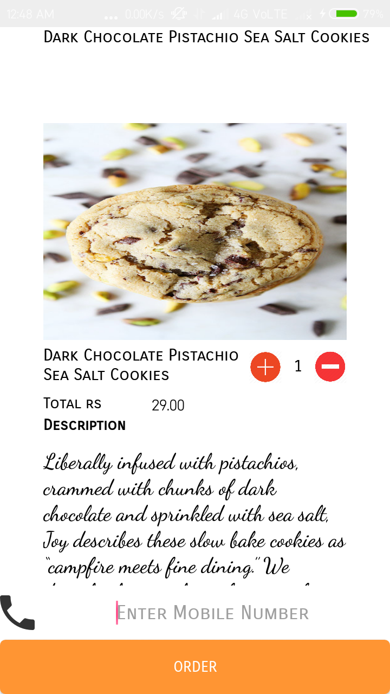

***cookie1.xml***

|  |
| --- |
| *<?xml version="1.0" encoding="utf-8"?>*  *<RelativeLayout*  *xmlns:android="http://schemas.android.com/apk/res/android" android:layout_width="match_parent"*  *android:layout_height="match_parent"*  *android:background="#ffffff"*  *>*  *<RelativeLayout*  *android:layout_width="wrap_content"*  *android:layout_height="wrap_content"*  *android:id="@+id/heading"*  *>*  *<TextView*  *android:layout_width="wrap_content"*  *android:layout_height="wrap_content"*  *android:text="Dark Chocolate Pistachio Sea Salt Cookies"*  *android:textAlignment="center"*  *android:layout_marginLeft="40dp"*  *android:textSize="15dp"*  *android:id="@+id/items"*  *android:textColor="#000000"*  *android:fontFamily="sans-serif-smallcaps"*  */>*  *</RelativeLayout>*  *<ScrollView*  *android:layout_width="match_parent"*  *android:layout_height="match_parent"*  *android:id="@+id/slide1"*  *android:layout_below="@+id/heading"*  *>*  *<RelativeLayout*  *android:layout_width="match_parent"*  *android:layout_height="700dp"*  *>*  *<RelativeLayout*  *android:id="@+id/content1"*  *android:layout_width="320dp"*  *android:layout_height="match_parent"*  *android:layout_marginTop="50dp"*  *android:layout_marginLeft="20dp"*  *android:padding="20dp"*  *>*  *<ImageView*  *android:background="@drawable/bis1"*  *android:layout_width="match_parent"*  *android:layout_height="200dp"*  */>*  *<TextView*  *android:id="@+id/text1"*  *android:layout_width="200dp"*  *android:layout_height="wrap_content"*  *android:layout_marginLeft="0dp"*  *android:layout_marginTop="205dp"*  *android:textColor="#000000"*  *android:text="Dark Chocolate Pistachio Sea Salt Cookies"*  *android:fontFamily="sans-serif-smallcaps"*  *android:textSize="15dp"*  */>*  *<Button*  *android:layout_width="30dp"*  *android:id="@+id/plusicon"*  *android:layout_height="30dp"*  *android:background="@drawable/plus1"*  *android:layout_marginTop="210dp"*  *android:layout_marginLeft="190dp"*  */>*  *<TextView*  *android:id="@+id/value"*  *android:layout_width="30dp"*  *android:layout_height="30dp"*  *android:textSize="15dp"*  *android:textColor="#000000"*  *android:textAlignment="center"*  *android:fontFamily="sans-serif-smallcaps"*  *android:layout_marginTop="210dp"*  *android:padding="5dp"*  *android:text="1"*  *android:layout_marginLeft="220dp"*  */>*  *<Button*  *android:id="@+id/minus"*  *android:layout_width="30dp"*  *android:layout_height="30dp"*  *android:layout_marginLeft="250dp"*  *android:layout_marginTop="210dp"*  *android:background="@drawable/minus1"*  */>*  *<TextView*  *android:layout_width="wrap_content"*  *android:layout_height="wrap_content"*  *android:text="Total rs "*  *android:textColor="#000000"*  *android:fontFamily="sans-serif-smallcaps"*  *android:layout_marginTop="250dp"*  */>*  *<TextView*  *android:id="@+id/amount"*  *android:layout_width="60dp"*  *android:layout_height="20dp"*  *android:text="29.00"*  *android:textColor="#000000"*  *android:layout_marginTop="250dp"*  *android:layout_marginLeft="100dp"*  */>*  *<TextView*  *android:layout_width="wrap_content"*  *android:layout_height="wrap_content"*  *android:text="Description"*  *android:textColor="#000000"*  *android:fontFamily="sans-serif-smallcaps"*  *android:layout_marginTop="270dp"*  *android:textStyle="bold"*  */>*  *<TextView*  *android:layout_width="wrap_content"*  *android:layout_height="wrap_content"*  *android:textColor="#000000"*  *android:fontFamily="cursive"*  *android:textSize="20dp"*  *android:text="Liberally infused with pistachios, crammed with chunks of dark chocolate and sprinkled with sea salt, Joy describes these slow bake cookies as “campfire meets fine dining.” We describe them as the perfect mix of sweet and salty."*  *android:layout_marginTop="300dp"*  */>*  *</RelativeLayout>*  *</RelativeLayout>*  *</ScrollView>*  *<EditText*  *android:id="@+id/getMobile"*  *android:layout_width="match_parent"*  *android:layout_height="50dp"*  *android:layout_alignParentBottom="true"*  *android:layout_marginBottom="50dp"*  *android:layout_marginLeft="0dp"*  *android:inputType="number"*  *android:background="#ffffff"*  *android:drawableLeft="@drawable/phoneicon"*  *android:hint="Enter Mobile Number"*  *android:fontFamily="sans-serif-smallcaps"*  *android:textAlignment="center"*  */>*  *<Button*  *android:id="@+id/orderButton"*  *android:layout_width="match_parent"*  *android:layout_height="50dp"*  *android:text="Order"*  *android:textColor="#ffffff"*  *android:fontFamily="sans-serif-smallcaps"*  *android:layout_marginLeft="0dp"*  *android:layout_alignParentBottom="true"*  *android:background="@drawable/confirm_button"*  *android:layout_marginBottom="0dp"*  */>*  *</RelativeLayout>* |

***Cookie1.java***

|  |
| --- |
| *package com.example.mohdarif.dostea;*  *import android.app.NotificationManager;*  *import android.app.PendingIntent;*  *import android.content.Context;*  *import android.content.Intent;*  *import android.os.Bundle;*  *import android.support.v4.app.NotificationCompat;*  *import android.support.v7.app.AppCompatActivity;*  *import android.telephony.SmsManager;*  *import android.view.View;*  *import android.widget.Button;*  *import android.widget.EditText;*  *import android.widget.TextView;*  *import android.widget.Toast;*  *public class Cookie1 extends AppCompatActivity {*  *Button confirm,add,sub;*  *TextView value,amount;*  *EditText getMobile;*  *int countOrderId=101,countOrderNumber=1;*  *final float initailAmount = (float) 29.00;*  *@Override*  *protected void onCreate(Bundle savedInstanceState) {*  *super.onCreate(savedInstanceState);*  *setContentView(R.layout.cookie1);*  *value = findViewById(R.id.value);*  *amount = findViewById(R.id.amount);*  *add = findViewById(R.id.plusicon);*  *add.setOnClickListener(new View.OnClickListener() {*  *@Override*  *public void onClick(View v) {*  *countOrderNumber++;*  *if (countOrderNumber>10) {*  *Toast.makeText(getApplicationContext(),"maximum quantity only 10 at a time",Toast.LENGTH_LONG).show();*  *}*  *else{*  *value.setText(""+countOrderNumber);*  *amount.setText(""+initailAmount*countOrderNumber);*  *}*  *}*  *});*  *sub = findViewById(R.id.minus);*  *sub.setOnClickListener(new View.OnClickListener() {*  *@Override*  *public void onClick(View v) {*  *countOrderNumber--;*  *if (countOrderNumber<1) {*  *Toast.makeText(getApplicationContext(),"only 1 selected",Toast.LENGTH_LONG).show();*  *}*  *else {*  *value.setText(""+countOrderNumber);*  *amount.setText(""+initailAmount*countOrderNumber);*  *}*  *}*  *});*  *confirm = findViewById(R.id.orderButton);*  *getMobile = findViewById(R.id.getMobile);*  *confirm.setOnClickListener(new View.OnClickListener() {*  *@Override*  *public void onClick(View v) {*  *countOrderId++;*  *String number = getMobile.getText().toString().trim();*  *if (number.isEmpty()||number.length()<10) {*  *Toast.makeText(getApplicationContext(),"Enter a valid number",Toast.LENGTH_LONG).show();*  *getMobile.requestFocus();*  *}*  *else {*  *addNotification();*  *Intent intent=new Intent(getApplicationContext(),MainActivity.class);*  *PendingIntent pi=PendingIntent.getActivity(getApplicationContext(), 0, intent,0);*  *//Get the SmsManager instance and call the sendTextMessage method to send message*  *SmsManager sms= SmsManager.getDefault();*  *sms.sendTextMessage(number, null, "Your Order for "+countOrderNumber+ " Dark Chocolate Pistachio Sea Salt Cookies has been confirmed Kindly Par Rs "+amount.getText(),null,null);*  *Toast.makeText(getApplicationContext(), "Order recieved successfully!",*  *Toast.LENGTH_LONG).show();*  *Intent intent1 = new Intent(getApplicationContext(),ConfirmOrder.class);*  *startActivity(intent1);*  *}*  *}*  *});*  *}*  *private void addNotification() {*  *NotificationCompat.Builder builder =*  *new NotificationCompat.Builder(this)*  *.setSmallIcon(R.drawable.notificationicon)*  *.setContentTitle("Dostea")*  *.setContentText(IceCream1.notification);*  *Intent notificationIntent = new Intent(this, MainActivity.class);*  *PendingIntent contentIntent = PendingIntent.getActivity(this, 0, notificationIntent,*  *PendingIntent.FLAG_UPDATE_CURRENT);*  *builder.setContentIntent(contentIntent);*  *// Add as notification*  *NotificationManager manager = (NotificationManager) getSystemService(Context.NOTIFICATION_SERVICE);*  *manager.notify(0, builder.build());*  *}*  *@Override*  *public void onBackPressed() {*  *Intent intent = new Intent(getApplicationContext(),Cookie.class);*  *startActivity(intent);*  *finish();*  *}*  *}* |

***Cookie 2***

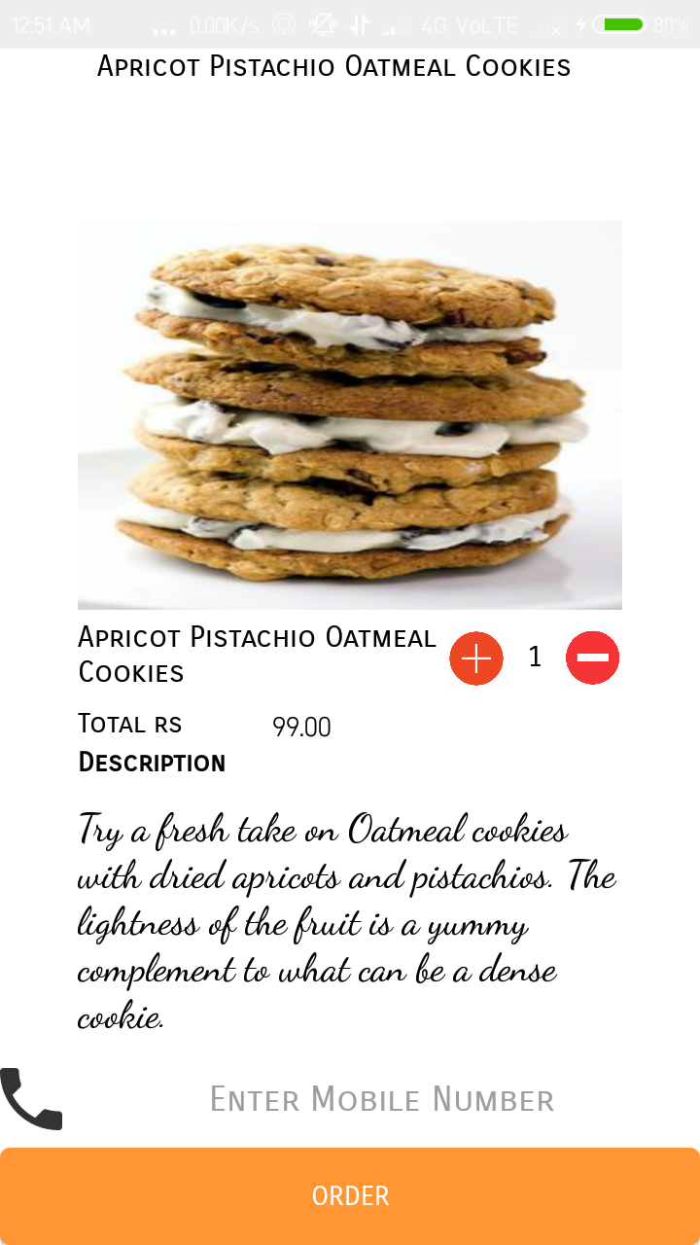

***cookie2.xml***

|  |
| --- |
| *<?xml version="1.0" encoding="utf-8"?>*  *<RelativeLayout*  *xmlns:android="http://schemas.android.com/apk/res/android" android:layout_width="match_parent"*  *android:layout_height="match_parent"*  *android:background="#ffffff"*  *>*  *<RelativeLayout*  *android:layout_width="wrap_content"*  *android:layout_height="wrap_content"*  *android:id="@+id/heading"*  *>*  *<TextView*  *android:layout_width="wrap_content"*  *android:layout_height="wrap_content"*  *android:text="Cinnamon Roll Sugar Cookies"*  *android:textAlignment="center"*  *android:layout_marginLeft="60dp"*  *android:textSize="15dp"*  *android:id="@+id/items"*  *android:textColor="#000000"*  *android:fontFamily="sans-serif-smallcaps"*  */>*  *</RelativeLayout>*  *<ScrollView*  *android:layout_width="match_parent"*  *android:layout_height="match_parent"*  *android:id="@+id/slide1"*  *android:layout_below="@+id/heading"*  *>*  *<RelativeLayout*  *android:layout_width="match_parent"*  *android:layout_height="700dp"*  *>*  *<RelativeLayout*  *android:id="@+id/content1"*  *android:layout_width="320dp"*  *android:layout_height="match_parent"*  *android:layout_marginTop="50dp"*  *android:layout_marginLeft="20dp"*  *android:padding="20dp"*  *>*  *<ImageView*  *android:background="@drawable/bis2"*  *android:layout_width="match_parent"*  *android:layout_height="200dp"*  */>*  *<TextView*  *android:id="@+id/text1"*  *android:layout_width="200dp"*  *android:layout_height="wrap_content"*  *android:layout_marginLeft="0dp"*  *android:layout_marginTop="205dp"*  *android:textColor="#000000"*  *android:text="Cinnamon Roll Sugar Cookies"*  *android:fontFamily="sans-serif-smallcaps"*  *android:textSize="15dp"*  */>*  *<Button*  *android:layout_width="30dp"*  *android:id="@+id/plusicon"*  *android:layout_height="30dp"*  *android:background="@drawable/plus1"*  *android:layout_marginTop="210dp"*  *android:layout_marginLeft="190dp"*  */>*  *<TextView*  *android:id="@+id/value"*  *android:layout_width="30dp"*  *android:layout_height="30dp"*  *android:textSize="15dp"*  *android:textColor="#000000"*  *android:textAlignment="center"*  *android:fontFamily="sans-serif-smallcaps"*  *android:layout_marginTop="210dp"*  *android:padding="5dp"*  *android:text="1"*  *android:layout_marginLeft="220dp"*  */>*  *<Button*  *android:id="@+id/minus"*  *android:layout_width="30dp"*  *android:layout_height="30dp"*  *android:layout_marginLeft="250dp"*  *android:layout_marginTop="210dp"*  *android:background="@drawable/minus1"*  */>*  *<TextView*  *android:layout_width="wrap_content"*  *android:layout_height="wrap_content"*  *android:text="Total rs "*  *android:textColor="#000000"*  *android:fontFamily="sans-serif-smallcaps"*  *android:layout_marginTop="250dp"*  */>*  *<TextView*  *android:id="@+id/amount"*  *android:layout_width="60dp"*  *android:layout_height="20dp"*  *android:text="29.00"*  *android:textColor="#000000"*  *android:layout_marginTop="250dp"*  *android:layout_marginLeft="100dp"*  */>*  *<TextView*  *android:layout_width="wrap_content"*  *android:layout_height="wrap_content"*  *android:text="Description"*  *android:textColor="#000000"*  *android:fontFamily="sans-serif-smallcaps"*  *android:layout_marginTop="270dp"*  *android:textStyle="bold"*  */>*  *<TextView*  *android:layout_width="wrap_content"*  *android:layout_height="wrap_content"*  *android:textColor="#000000"*  *android:fontFamily="cursive"*  *android:textSize="20dp"*  *android:text="They may have started as sugar cookies, but a sprinkle of cinnamon and brown sugar turns this treat into heavenly little cinnamon rolls. Topped with cream cheese frosting, these cookies are better than the real deal."*  *android:layout_marginTop="300dp"*  */>*  *</RelativeLayout>*  *</RelativeLayout>*  *</ScrollView>*  *<EditText*  *android:id="@+id/getMobile"*  *android:layout_width="match_parent"*  *android:layout_height="50dp"*  *android:layout_alignParentBottom="true"*  *android:layout_marginBottom="50dp"*  *android:layout_marginLeft="0dp"*  *android:inputType="number"*  *android:background="#ffffff"*  *android:drawableLeft="@drawable/phoneicon"*  *android:hint="Enter Mobile Number"*  *android:fontFamily="sans-serif-smallcaps"*  *android:textAlignment="center"*  */>*  *<Button*  *android:id="@+id/orderButton"*  *android:layout_width="match_parent"*  *android:layout_height="50dp"*  *android:text="Order"*  *android:textColor="#ffffff"*  *android:fontFamily="sans-serif-smallcaps"*  *android:layout_marginLeft="0dp"*  *android:layout_alignParentBottom="true"*  *android:background="@drawable/confirm_button"*  *android:layout_marginBottom="0dp"*  */>*  *</RelativeLayout>* |

***Cookie2.java***

|  |
| --- |
| *package com.example.mohdarif.dostea;*  *import android.app.NotificationManager;*  *import android.app.PendingIntent;*  *import android.content.Context;*  *import android.content.Intent;*  *import android.os.Bundle;*  *import android.support.v4.app.NotificationCompat;*  *import android.support.v7.app.AppCompatActivity;*  *import android.telephony.SmsManager;*  *import android.view.View;*  *import android.widget.Button;*  *import android.widget.EditText;*  *import android.widget.TextView;*  *import android.widget.Toast;*  *public class Cookie2 extends AppCompatActivity {*  *Button confirm,add,sub;*  *TextView value,amount;*  *EditText getMobile;*  *int countOrderId=101,countOrderNumber=1;*  *final float initailAmount = (float) 29.00;*  *@Override*  *protected void onCreate(Bundle savedInstanceState) {*  *super.onCreate(savedInstanceState);*  *setContentView(R.layout.cookie2);*  *value = findViewById(R.id.value);*  *amount = findViewById(R.id.amount);*  *add = findViewById(R.id.plusicon);*  *add.setOnClickListener(new View.OnClickListener() {*  *@Override*  *public void onClick(View v) {*  *countOrderNumber++;*  *if (countOrderNumber>10) {*  *Toast.makeText(getApplicationContext(),"maximum quantity only 10 at a time",Toast.LENGTH_LONG).show();*  *}*  *else{*  *value.setText(""+countOrderNumber);*  *amount.setText(""+initailAmount*countOrderNumber);*  *}*  *}*  *});*  *sub = findViewById(R.id.minus);*  *sub.setOnClickListener(new View.OnClickListener() {*  *@Override*  *public void onClick(View v) {*  *countOrderNumber--;*  *if (countOrderNumber<1) {*  *Toast.makeText(getApplicationContext(),"only 1 selected",Toast.LENGTH_LONG).show();*  *}*  *else {*  *value.setText(""+countOrderNumber);*  *amount.setText(""+initailAmount*countOrderNumber);*  *}*  *}*  *});*  *confirm = findViewById(R.id.orderButton);*  *getMobile = findViewById(R.id.getMobile);*  *confirm.setOnClickListener(new View.OnClickListener() {*  *@Override*  *public void onClick(View v) {*  *countOrderId++;*  *String number = getMobile.getText().toString().trim();*  *if (number.isEmpty()||number.length()<10) {*  *Toast.makeText(getApplicationContext(),"Enter a valid number",Toast.LENGTH_LONG).show();*  *getMobile.requestFocus();*  *}*  *else {*  *addNotification();*  *Intent intent=new Intent(getApplicationContext(),MainActivity.class);*  *PendingIntent pi=PendingIntent.getActivity(getApplicationContext(), 0, intent,0);*  *//Get the SmsManager instance and call the sendTextMessage method to send message*  *SmsManager sms= SmsManager.getDefault();*  *sms.sendTextMessage(number, null, "Your Order for "+countOrderNumber+ " Cinnamon Roll Sugar Cookies has been confirmed Kindly Par Rs "+amount.getText(),null,null);*  *Toast.makeText(getApplicationContext(), "Order recieved successfully!",*  *Toast.LENGTH_LONG).show();*  *Intent intent1 = new Intent(getApplicationContext(),ConfirmOrder.class);*  *startActivity(intent1);*  *}*  *}*  *});*  *}*  *private void addNotification() {*  *NotificationCompat.Builder builder =*  *new NotificationCompat.Builder(this)*  *.setSmallIcon(R.drawable.notificationicon)*  *.setContentTitle("Dostea")*  *.setContentText(IceCream1.notification);*  *Intent notificationIntent = new Intent(this, MainActivity.class);*  *PendingIntent contentIntent = PendingIntent.getActivity(this, 0, notificationIntent,*  *PendingIntent.FLAG_UPDATE_CURRENT);*  *builder.setContentIntent(contentIntent);*  *// Add as notification*  *NotificationManager manager = (NotificationManager) getSystemService(Context.NOTIFICATION_SERVICE);*  *manager.notify(0, builder.build());*  *}*  *@Override*  *public void onBackPressed() {*  *Intent intent = new Intent(getApplicationContext(),Cookie.class);*  *startActivity(intent);*  *finish();*  *}*  *}* |

***Ice Cream***

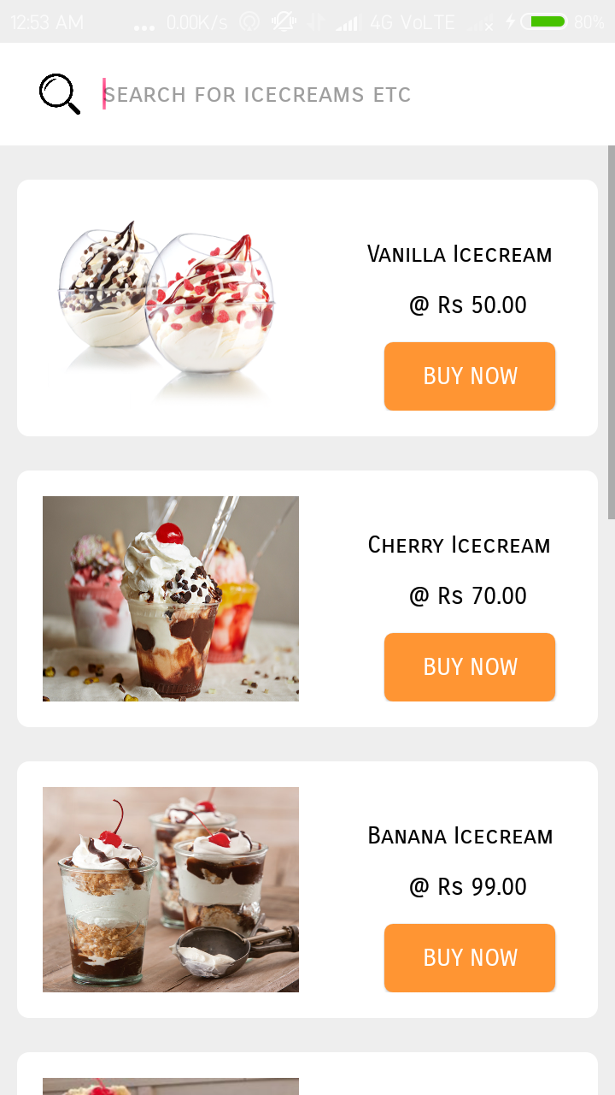

***icecream.xml***

|  |
| --- |
| *<?xml version="1.0" encoding="utf-8"?>*  *<RelativeLayout*  *xmlns:android="http://schemas.android.com/apk/res/android" android:layout_width="match_parent"*  *android:layout_height="match_parent"*  *>*  *<RelativeLayout*  *android:layout_width="match_parent"*  *android:layout_height="60dp"*  *android:background="#ffffff"*  *>*  *<EditText*  *android:id="@+id/searchitem"*  *android:layout_width="290dp"*  *android:layout_marginLeft="60dp"*  *android:layout_marginTop="10dp"*  *android:layout_height="40dp"*  *android:background="@null"*  *android:hint="search for icecreams etc"*  *android:textColor="#000000"*  *android:fontFamily="sans-serif-smallcaps"*  *android:textSize="15dp"*  *android:layout_alignParentTop="true"*  */>*  *<ImageView*  *android:id="@+id/searchbutton"*  *android:layout_width="30dp"*  *android:layout_height="30dp"*  *android:background="@drawable/searchicon"*  *android:layout_marginLeft="20dp"*  *android:layout_marginTop="15dp"*  */>*  *</RelativeLayout>*  *<ScrollView*  *android:layout_width="match_parent"*  *android:layout_height="match_parent"*  *android:layout_marginTop="60dp"*  *>*  *<RelativeLayout*  *android:layout_width="match_parent"*  *android:layout_height="match_parent">*  *<RelativeLayout*  *android:layout_width="340dp"*  *android:layout_height="150dp"*  *android:layout_marginLeft="10dp"*  *android:layout_marginTop="20dp"*  *android:background="@drawable/homepagemenuitems"*  *android:padding="15dp"*  *>*  *<ImageView*  *android:layout_width="150dp"*  *android:layout_height="130dp"*  *android:background="@drawable/i1"*  */>*  *<TextView*  *android:layout_width="wrap_content"*  *android:layout_height="wrap_content"*  *android:text="Vanilla Icecream"*  *android:fontFamily="sans-serif-smallcaps"*  *android:textColor="#000000"*  *android:layout_marginLeft="190dp"*  *android:layout_marginTop="20dp"*  */>*  *<TextView*  *android:layout_width="wrap_content"*  *android:layout_height="wrap_content"*  *android:text=" @ Rs 50.00"*  *android:fontFamily="sans-serif-smallcaps"*  *android:textColor="#000000"*  *android:layout_marginTop="50dp"*  *android:layout_marginLeft="210dp"*  */>*  *<Button*  *android:id="@+id/ice1"*  *android:layout_width="100dp"*  *android:layout_height="40dp"*  *android:background="@drawable/confirm_button"*  *android:text="Buy now"*  *android:textColor="#ffffff"*  *android:fontFamily="sans-serif-smallcaps"*  *android:layout_marginLeft="200dp"*  *android:layout_marginTop="80dp"*  */>*  *</RelativeLayout>*  *<RelativeLayout*  *android:layout_width="340dp"*  *android:layout_height="150dp"*  *android:layout_marginLeft="10dp"*  *android:layout_marginTop="190dp"*  *android:background="@drawable/homepagemenuitems"*  *android:padding="15dp"*  *>*  *<ImageView*  *android:layout_width="150dp"*  *android:layout_height="130dp"*  *android:background="@drawable/i2"*  */>*  *<TextView*  *android:layout_width="wrap_content"*  *android:layout_height="wrap_content"*  *android:text="Cherry Icecream"*  *android:fontFamily="sans-serif-smallcaps"*  *android:textColor="#000000"*  *android:layout_marginLeft="190dp"*  *android:layout_marginTop="20dp"*  */>*  *<TextView*  *android:layout_width="wrap_content"*  *android:layout_height="wrap_content"*  *android:text=" @ Rs 70.00"*  *android:fontFamily="sans-serif-smallcaps"*  *android:textColor="#000000"*  *android:layout_marginTop="50dp"*  *android:layout_marginLeft="210dp"*  */>*  *<Button*  *android:id="@+id/ice2"*  *android:layout_width="100dp"*  *android:layout_height="40dp"*  *android:background="@drawable/confirm_button"*  *android:text="Buy now"*  *android:textColor="#ffffff"*  *android:fontFamily="sans-serif-smallcaps"*  *android:layout_marginLeft="200dp"*  *android:layout_marginTop="80dp"*  */>*  *</RelativeLayout>*  *<RelativeLayout*  *android:layout_width="340dp"*  *android:layout_height="150dp"*  *android:layout_marginLeft="10dp"*  *android:layout_marginTop="360dp"*  *android:background="@drawable/homepagemenuitems"*  *android:padding="15dp"*  *>*  *<ImageView*  *android:layout_width="150dp"*  *android:layout_height="130dp"*  *android:background="@drawable/i3"*  */>*  *<TextView*  *android:layout_width="wrap_content"*  *android:layout_height="wrap_content"*  *android:text="Banana Icecream"*  *android:fontFamily="sans-serif-smallcaps"*  *android:textColor="#000000"*  *android:layout_marginLeft="190dp"*  *android:layout_marginTop="20dp"*  */>*  *<TextView*  *android:layout_width="wrap_content"*  *android:layout_height="wrap_content"*  *android:text=" @ Rs 99.00"*  *android:fontFamily="sans-serif-smallcaps"*  *android:textColor="#000000"*  *android:layout_marginTop="50dp"*  *android:layout_marginLeft="210dp"*  */>*  *<Button*  *android:id="@+id/ice3"*  *android:layout_width="100dp"*  *android:layout_height="40dp"*  *android:background="@drawable/confirm_button"*  *android:text="Buy now"*  *android:textColor="#ffffff"*  *android:fontFamily="sans-serif-smallcaps"*  *android:layout_marginLeft="200dp"*  *android:layout_marginTop="80dp"*  */>*  *</RelativeLayout>*  *<RelativeLayout*  *android:layout_width="340dp"*  *android:layout_height="150dp"*  *android:layout_marginTop="530dp"*  *android:layout_marginLeft="10dp"*  *android:background="@drawable/homepagemenuitems"*  *android:padding="15dp">*  *<ImageView*  *android:layout_width="150dp"*  *android:layout_height="130dp"*  *android:background="@drawable/i4" />*  *<TextView*  *android:layout_width="wrap_content"*  *android:layout_height="wrap_content"*  *android:layout_marginLeft="190dp"*  *android:layout_marginTop="20dp"*  *android:fontFamily="sans-serif-smallcaps"*  *android:text="Chocolate Cherry"*  *android:textColor="#000000" />*  *<TextView*  *android:layout_width="wrap_content"*  *android:layout_height="wrap_content"*  *android:layout_marginLeft="210dp"*  *android:layout_marginTop="50dp"*  *android:fontFamily="sans-serif-smallcaps"*  *android:text=" @ Rs 99.00"*  *android:textColor="#000000" />*  *<Button*  *android:id="@+id/ice4"*  *android:layout_width="100dp"*  *android:layout_height="40dp"*  *android:layout_marginLeft="200dp"*  *android:layout_marginTop="80dp"*  *android:background="@drawable/confirm_button"*  *android:fontFamily="sans-serif-smallcaps"*  *android:text="Buy now"*  *android:textColor="#ffffff" />*  *</RelativeLayout>*  *<RelativeLayout*  *android:layout_width="340dp"*  *android:layout_height="150dp"*  *android:layout_marginTop="700dp"*  *android:layout_marginLeft="10dp"*  *android:background="@drawable/homepagemenuitems"*  *android:padding="15dp">*  *<ImageView*  *android:layout_width="150dp"*  *android:layout_height="130dp"*  *android:background="@drawable/i5" />*  *<TextView*  *android:layout_width="wrap_content"*  *android:layout_height="wrap_content"*  *android:layout_marginLeft="190dp"*  *android:layout_marginTop="20dp"*  *android:fontFamily="sans-serif-smallcaps"*  *android:text="Butter Scotch"*  *android:textColor="#000000" />*  *<TextView*  *android:layout_width="wrap_content"*  *android:layout_height="wrap_content"*  *android:layout_marginLeft="210dp"*  *android:layout_marginTop="50dp"*  *android:fontFamily="sans-serif-smallcaps"*  *android:text=" @ Rs 109.00"*  *android:textColor="#000000" />*  *<Button*  *android:id="@+id/ice5"*  *android:layout_width="100dp"*  *android:layout_height="40dp"*  *android:layout_marginLeft="200dp"*  *android:layout_marginTop="80dp"*  *android:background="@drawable/confirm_button"*  *android:fontFamily="sans-serif-smallcaps"*  *android:text="Buy now"*  *android:textColor="#ffffff" />*  *</RelativeLayout>*  *<RelativeLayout*  *android:layout_width="340dp"*  *android:layout_height="150dp"*  *android:layout_marginTop="870dp"*  *android:layout_marginLeft="10dp"*  *android:background="@drawable/homepagemenuitems"*  *android:padding="15dp">*  *<ImageView*  *android:layout_width="150dp"*  *android:layout_height="match_parent"*  *android:background="@drawable/i6" />*  *<TextView*  *android:layout_width="wrap_content"*  *android:layout_height="wrap_content"*  *android:layout_marginLeft="210dp"*  *android:layout_marginTop="20dp"*  *android:fontFamily="sans-serif-smallcaps"*  *android:text="Choco Milk"*  *android:textColor="#000000" />*  *<TextView*  *android:layout_width="wrap_content"*  *android:layout_height="wrap_content"*  *android:layout_marginLeft="210dp"*  *android:layout_marginTop="50dp"*  *android:fontFamily="sans-serif-smallcaps"*  *android:text=" @ Rs 100.00"*  *android:textColor="#000000" />*  *<Button*  *android:id="@+id/ice6"*  *android:layout_width="100dp"*  *android:layout_height="40dp"*  *android:layout_marginLeft="200dp"*  *android:layout_marginTop="80dp"*  *android:background="@drawable/confirm_button"*  *android:fontFamily="sans-serif-smallcaps"*  *android:text="Buy now"*  *android:textColor="#ffffff" />*  *</RelativeLayout>*  *<RelativeLayout*  *android:layout_width="340dp"*  *android:layout_height="150dp"*  *android:layout_marginLeft="10dp"*  *android:layout_marginTop="1040dp"*  *android:background="@drawable/homepagemenuitems"*  *android:padding="15dp"*  *>*  *<ImageView*  *android:layout_width="150dp"*  *android:layout_height="130dp"*  *android:background="@drawable/i7"*  */>*  *<TextView*  *android:layout_width="wrap_content"*  *android:layout_height="wrap_content"*  *android:text="Butter Cream"*  *android:fontFamily="sans-serif-smallcaps"*  *android:textColor="#000000"*  *android:layout_marginLeft="200dp"*  *android:layout_marginTop="20dp"*  */>*  *<TextView*  *android:layout_width="wrap_content"*  *android:layout_height="wrap_content"*  *android:text=" @ Rs 50.00"*  *android:fontFamily="sans-serif-smallcaps"*  *android:textColor="#000000"*  *android:layout_marginTop="50dp"*  *android:layout_marginLeft="210dp"*  */>*  *<Button*  *android:id="@+id/ice7"*  *android:layout_width="100dp"*  *android:layout_height="40dp"*  *android:background="@drawable/confirm_button"*  *android:text="Buy now"*  *android:textColor="#ffffff"*  *android:fontFamily="sans-serif-smallcaps"*  *android:layout_marginLeft="200dp"*  *android:layout_marginTop="80dp"*  */>*  *</RelativeLayout>*  *<RelativeLayout*  *android:layout_width="340dp"*  *android:layout_height="150dp"*  *android:layout_marginLeft="10dp"*  *android:layout_marginTop="1210dp"*  *android:background="@drawable/homepagemenuitems"*  *android:padding="15dp"*  *android:layout_marginBottom="50dp"*  *>*  *<ImageView*  *android:layout_width="150dp"*  *android:layout_height="130dp"*  *android:background="@drawable/i8"*  */>*  *<TextView*  *android:layout_width="wrap_content"*  *android:layout_height="wrap_content"*  *android:text="Choco Cream"*  *android:fontFamily="sans-serif-smallcaps"*  *android:textColor="#000000"*  *android:layout_marginLeft="200dp"*  *android:layout_marginTop="20dp"*  */>*  *<TextView*  *android:layout_width="wrap_content"*  *android:layout_height="wrap_content"*  *android:text=" @ Rs 79.00"*  *android:fontFamily="sans-serif-smallcaps"*  *android:textColor="#000000"*  *android:layout_marginTop="50dp"*  *android:layout_marginLeft="210dp"*  */>*  *<Button*  *android:id="@+id/ice8"*  *android:layout_width="100dp"*  *android:layout_height="40dp"*  *android:background="@drawable/confirm_button"*  *android:text="Buy now"*  *android:textColor="#ffffff"*  *android:fontFamily="sans-serif-smallcaps"*  *android:layout_marginLeft="200dp"*  *android:layout_marginTop="80dp"*  */>*  *</RelativeLayout>*  *</RelativeLayout>*  *</ScrollView>*  *</RelativeLayout>* |

***IceCream.java***

|  |
| --- |
| *package com.example.mohdarif.dostea;*  *import android.content.Intent;*  *import android.os.Bundle;*  *import android.support.annotation.Nullable;*  *import android.support.v7.app.AppCompatActivity;*  *import android.view.View;*  *import android.widget.Button;*  *import android.widget.EditText;*  *import android.widget.ImageView;*  *public class IceCream extends AppCompatActivity {*  *Button ice1,ice2,ice3,ice4,ice5,ice6,ice7,ice8;*  *EditText searchitem;*  *ImageView searchButton;*  *String value;*  *@Override*  *protected void onCreate(@Nullable Bundle savedInstanceState) {*  *super.onCreate(savedInstanceState);*  *setContentView(R.layout.ice_cream);*  *searchitem = findViewById(R.id.searchitem);*  *searchButton = findViewById(R.id.searchbutton);*  *searchButton.setOnClickListener(new View.OnClickListener() {*  *@Override*  *public void onClick(View v) {*  *value = searchitem.getText().toString().trim();*  *if(value.equalsIgnoreCase("vanilla icecream")) {*  *Intent intent = new Intent(getApplicationContext(),IceCream1.class);*  *startActivity(intent);*  *finish();*  *}*  *else if(value.equalsIgnoreCase("cherry icecream")) {*  *Intent intent = new Intent(getApplicationContext(),IceCream2.class);*  *startActivity(intent);*  *finish();*  *}*  *else if(value.equalsIgnoreCase("Banana icecream")) {*  *Intent intent = new Intent(getApplicationContext(),IceCream3.class);*  *startActivity(intent);*  *finish();*  *}*  *else if(value.equalsIgnoreCase("chocolate cherry")) {*  *Intent intent = new Intent(getApplicationContext(),IceCream4.class);*  *startActivity(intent);*  *finish();*  *}*  *else if(value.equalsIgnoreCase("butter scotch")) {*  *Intent intent = new Intent(getApplicationContext(),IceCream5.class);*  *startActivity(intent);*  *finish();*  *}*  *else if(value.equalsIgnoreCase("choco milk")) {*  *Intent intent = new Intent(getApplicationContext(),IceCream6.class);*  *startActivity(intent);*  *finish();*  *}*  *else if(value.equalsIgnoreCase("butter cream")) {*  *Intent intent = new Intent(getApplicationContext(),IceCream7.class);*  *startActivity(intent);*  *finish();*  *}*  *else if(value.equalsIgnoreCase("choco cream")) {*  *Intent intent = new Intent(getApplicationContext(),IceCream8.class);*  *startActivity(intent);*  *finish();*  *}*  *else {*  *Intent intent = new Intent(getApplicationContext(),NotFound.class);*  *startActivity(intent);*  *finish();*  *}*  *}*  *});*  *ice1 = findViewById(R.id.ice1);*  *ice1.setOnClickListener(new View.OnClickListener() {*  *@Override*  *public void onClick(View v) {*  *Intent intent = new Intent(getApplicationContext(),IceCream1.class);*  *startActivity(intent);*  *finish();*  *}*  *});*  *ice2 = findViewById(R.id.ice2);*  *ice2.setOnClickListener(new View.OnClickListener() {*  *@Override*  *public void onClick(View v) {*  *Intent intent = new Intent(getApplicationContext(),IceCream2.class);*  *startActivity(intent);*  *finish();*  *}*  *});*  *ice3 = findViewById(R.id.ice3);*  *ice3.setOnClickListener(new View.OnClickListener() {*  *@Override*  *public void onClick(View v) {*  *Intent intent = new Intent(getApplicationContext(),IceCream3.class);*  *startActivity(intent);*  *finish();*  *}*  *});*  *ice4 = findViewById(R.id.ice4);*  *ice4.setOnClickListener(new View.OnClickListener() {*  *@Override*  *public void onClick(View v) {*  *Intent intent = new Intent(getApplicationContext(),IceCream4.class);*  *startActivity(intent);*  *finish();*  *}*  *});*  *ice5 = findViewById(R.id.ice5);*  *ice5.setOnClickListener(new View.OnClickListener() {*  *@Override*  *public void onClick(View v) {*  *Intent intent = new Intent(getApplicationContext(),IceCream5.class);*  *startActivity(intent);*  *finish();*  *}*  *});*  *ice6 = findViewById(R.id.ice6);*  *ice6.setOnClickListener(new View.OnClickListener() {*  *@Override*  *public void onClick(View v) {*  *Intent intent = new Intent(getApplicationContext(),IceCream6.class);*  *startActivity(intent);*  *finish();*  *}*  *});*  *ice7 = findViewById(R.id.ice7);*  *ice7.setOnClickListener(new View.OnClickListener() {*  *@Override*  *public void onClick(View v) {*  *Intent intent = new Intent(getApplicationContext(),IceCream7.class);*  *startActivity(intent);*  *finish();*  *}*  *});*  *ice8 = findViewById(R.id.ice8);*  *ice8.setOnClickListener(new View.OnClickListener() {*  *@Override*  *public void onClick(View v) {*  *Intent intent = new Intent(getApplicationContext(),IceCream8.class);*  *startActivity(intent);*  *finish();*  *}*  *});*  *}*  *@Override*  *public void onBackPressed() {*  *Intent intent = new Intent(getApplicationContext(),HomePage.class);*  *startActivity(intent);*  *finish();*  *}*  *}* |

***Ice Cream1***

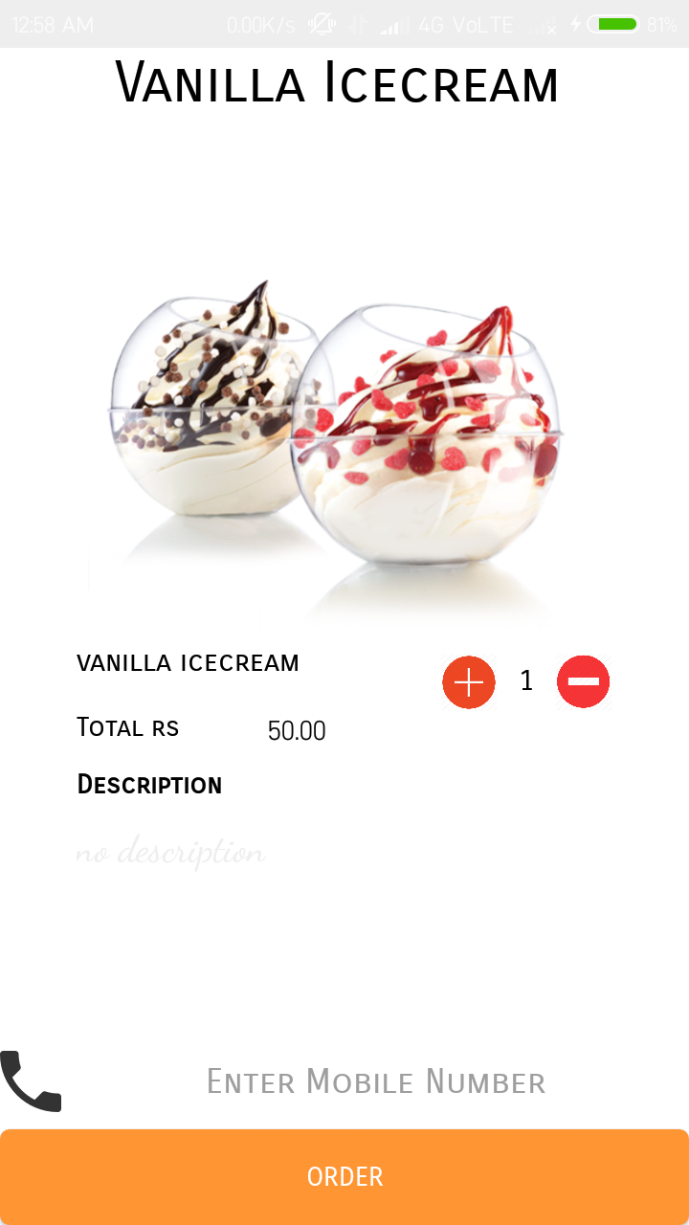

***icecream1.xml***

|  |
| --- |
| *<?xml version="1.0" encoding="utf-8"?>*  *<RelativeLayout*  *xmlns:android="http://schemas.android.com/apk/res/android" android:layout_width="match_parent"*  *android:layout_height="match_parent"*  *android:background="#ffffff"*  *>*  *<RelativeLayout*  *android:layout_width="wrap_content"*  *android:layout_alignParentTop="true"*  *android:id="@+id/heading"*  *android:layout_height="wrap_content">*  *<TextView*  *android:layout_width="wrap_content"*  *android:layout_height="wrap_content"*  *android:text="Vanilla Icecream"*  *android:layout_marginLeft="60dp"*  *android:textSize="30dp"*  *android:id="@+id/items"*  *android:textColor="#000000"*  *android:fontFamily="sans-serif-smallcaps"*  */>*  *</RelativeLayout>*  *<ScrollView*  *android:layout_width="match_parent"*  *android:layout_height="match_parent"*  *android:id="@+id/slide1"*  *android:layout_below="@id/heading"*  *>*  *<RelativeLayout*  *android:layout_width="match_parent"*  *android:layout_height="700dp"*  *>*  *<RelativeLayout*  *android:id="@+id/content1"*  *android:layout_width="320dp"*  *android:layout_height="match_parent"*  *android:layout_marginTop="50dp"*  *android:layout_marginLeft="20dp"*  *android:padding="20dp"*  *>*  *<ImageView*  *android:background="@drawable/i1"*  *android:layout_width="match_parent"*  *android:layout_height="200dp"*  */>*  *<TextView*  *android:id="@+id/text1"*  *android:layout_width="wrap_content"*  *android:layout_height="wrap_content"*  *android:layout_marginLeft="0dp"*  *android:layout_marginTop="205dp"*  *android:textColor="#000000"*  *android:text="vanilla icecream"*  *android:fontFamily="sans-serif-smallcaps"*  *android:textSize="15dp"*  */>*  *<Button*  *android:layout_width="30dp"*  *android:id="@+id/plusicon"*  *android:layout_height="30dp"*  *android:background="@drawable/plus1"*  *android:layout_marginTop="210dp"*  *android:layout_marginLeft="190dp"*  */>*  *<TextView*  *android:id="@+id/value"*  *android:layout_width="30dp"*  *android:layout_height="30dp"*  *android:textSize="15dp"*  *android:textColor="#000000"*  *android:textAlignment="center"*  *android:fontFamily="sans-serif-smallcaps"*  *android:layout_marginTop="210dp"*  *android:padding="5dp"*  *android:text="1"*  *android:layout_marginLeft="220dp"*  */>*  *<Button*  *android:id="@+id/minus"*  *android:layout_width="30dp"*  *android:layout_height="30dp"*  *android:layout_marginLeft="250dp"*  *android:layout_marginTop="210dp"*  *android:background="@drawable/minus1"*  */>*  *<TextView*  *android:layout_width="wrap_content"*  *android:layout_height="wrap_content"*  *android:text="Total rs "*  *android:textColor="#000000"*  *android:fontFamily="sans-serif-smallcaps"*  *android:layout_marginTop="240dp"*  */>*  *<TextView*  *android:id="@+id/amount"*  *android:layout_width="60dp"*  *android:layout_height="20dp"*  *android:text="50.00"*  *android:textColor="#000000"*  *android:layout_marginTop="240dp"*  *android:layout_marginLeft="100dp"*  */>*  *<TextView*  *android:layout_width="wrap_content"*  *android:layout_height="wrap_content"*  *android:text="Description"*  *android:textColor="#000000"*  *android:fontFamily="sans-serif-smallcaps"*  *android:layout_marginTop="270dp"*  *android:textStyle="bold"*  */>*  *<TextView*  *android:layout_width="wrap_content"*  *android:layout_height="wrap_content"*  *android:textColor="#eeeeee"*  *android:fontFamily="cursive"*  *android:textSize="20dp"*  *android:text="no description"*  *android:layout_marginTop="300dp"*  */>*  *</RelativeLayout>*  *</RelativeLayout>*  *</ScrollView>*  *<EditText*  *android:id="@+id/getMobile"*  *android:layout_width="match_parent"*  *android:layout_height="50dp"*  *android:layout_alignParentBottom="true"*  *android:layout_marginBottom="50dp"*  *android:layout_marginLeft="0dp"*  *android:inputType="number"*  *android:background="#ffffff"*  *android:drawableLeft="@drawable/phoneicon"*  *android:hint="Enter Mobile Number"*  *android:fontFamily="sans-serif-smallcaps"*  *android:textAlignment="center"*  */>*  *<Button*  *android:id="@+id/orderButton"*  *android:layout_width="match_parent"*  *android:layout_height="50dp"*  *android:text="Order"*  *android:textColor="#ffffff"*  *android:fontFamily="sans-serif-smallcaps"*  *android:layout_marginLeft="0dp"*  *android:layout_alignParentBottom="true"*  *android:background="@drawable/confirm_button"*  *android:layout_marginBottom="0dp"*  */>*  *</RelativeLayout>* |

***IceCream1.java***

|  |
| --- |
| *package com.example.mohdarif.dostea;*  *import android.app.NotificationManager;*  *import android.app.PendingIntent;*  *import android.content.Context;*  *import android.content.Intent;*  *import android.os.Bundle;*  *import android.support.v4.app.NotificationCompat;*  *import android.support.v7.app.AppCompatActivity;*  *import android.telephony.SmsManager;*  *import android.view.View;*  *import android.widget.Button;*  *import android.widget.EditText;*  *import android.widget.TextView;*  *import android.widget.Toast;*  *public class IceCream1 extends AppCompatActivity {*  *Button confirm,add,sub;*  *EditText getMobile;*  *TextView value,amount;*  *static final String notification = "Thanks for Ordering with us !!";*  *int countOrderId=1,countOrderNumber=1,countOrder=0;*  *final float initailAmount = (float) 50.00;*  *@Override*  *protected void onCreate(Bundle savedInstanceState) {*  *super.onCreate(savedInstanceState);*  *setContentView(R.layout.icecream1);*  *value = findViewById(R.id.value);*  *amount = findViewById(R.id.amount);*  *add = findViewById(R.id.plusicon);*  *add.setOnClickListener(new View.OnClickListener() {*  *@Override*  *public void onClick(View v) {*  *countOrderNumber++;*  *if (countOrderNumber>10) {*  *Toast.makeText(getApplicationContext(),"maximum quantity only 10 at a time",Toast.LENGTH_LONG).show();*  *}*  *else{*  *value.setText(""+countOrderNumber);*  *amount.setText(""+initailAmount*countOrderNumber);*  *}*  *}*  *});*  *sub = findViewById(R.id.minus);*  *sub.setOnClickListener(new View.OnClickListener() {*  *@Override*  *public void onClick(View v) {*  *countOrderNumber--;*  *if (countOrderNumber<1) {*  *Toast.makeText(getApplicationContext(),"only 1 selected",Toast.LENGTH_LONG).show();*  *}*  *else {*  *value.setText(""+countOrderNumber);*  *amount.setText(""+initailAmount*countOrderNumber);*  *}*  *}*  *});*  *confirm = findViewById(R.id.orderButton);*  *getMobile = findViewById(R.id.getMobile);*  *confirm.setOnClickListener(new View.OnClickListener() {*  *@Override*  *public void onClick(View v) {*  *countOrderId++;*  *countOrder++;*  *String number = getMobile.getText().toString().trim();*  *if (number.isEmpty()||number.length()<10) {*  *Toast.makeText(getApplicationContext(),"Enter a valid number",Toast.LENGTH_LONG).show();*  *getMobile.requestFocus();*  *}*  *else {*  *addNotification();*  *Intent intent=new Intent(getApplicationContext(),MainActivity.class);*  *PendingIntent pi=PendingIntent.getActivity(getApplicationContext(), 0, intent,0);*  *//Get the SmsManager instance and call the sendTextMessage method to send message*  *SmsManager sms= SmsManager.getDefault();*  *sms.sendTextMessage(number, null, "Your Order for "+countOrderNumber+ " Vanilla Ice Cream has been confirmed Kindly Par Rs "+amount.getText(),null,null);*  *Toast.makeText(getApplicationContext(), "Order recieved successfully!",*  *Toast.LENGTH_LONG).show();*  *Intent intent1 = new Intent(getApplicationContext(),ConfirmOrder.class);*  *startActivity(intent1);*  *}*  *}*  *});*  *}*  *private void addNotification() {*  *NotificationCompat.Builder builder =*  *new NotificationCompat.Builder(this)*  *.setSmallIcon(R.drawable.notificationicon)*  *.setContentTitle("Dostea")*  *.setContentText("Thanks for Ordering with us !!");*  *Intent notificationIntent = new Intent(this, MainActivity.class);*  *PendingIntent contentIntent = PendingIntent.getActivity(this, 0, notificationIntent,*  *PendingIntent.FLAG_UPDATE_CURRENT);*  *builder.setContentIntent(contentIntent);*  *// Add as notification*  *NotificationManager manager = (NotificationManager) getSystemService(Context.NOTIFICATION_SERVICE);*  *manager.notify(0, builder.build());*  *}*  *@Override*  *public void onBackPressed() {*  *Intent intent = new Intent(getApplicationContext(),IceCream.class);*  *startActivity(intent);*  *finish();*  *}*  *}* |

***Ice Cream2***

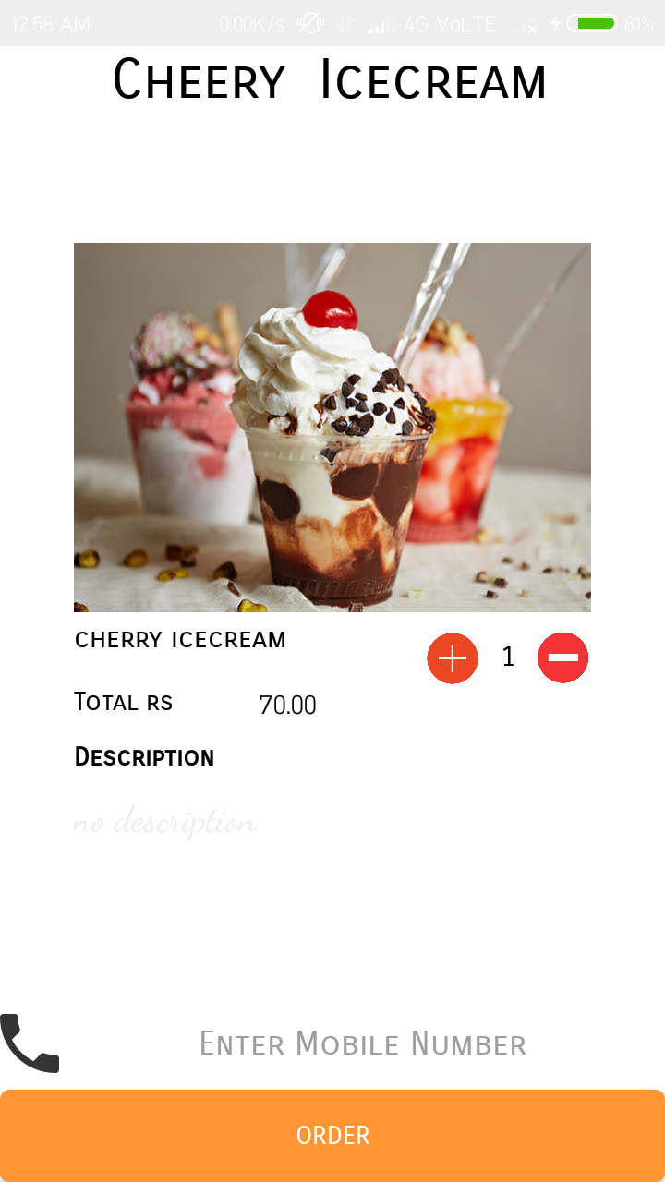

***icecream2.xml***

|  |
| --- |
| *<?xml version="1.0" encoding="utf-8"?>*  *<RelativeLayout*  *xmlns:android="http://schemas.android.com/apk/res/android" android:layout_width="match_parent"*  *android:layout_height="match_parent"*  *android:background="#ffffff"*  *>*  *<RelativeLayout*  *android:layout_width="wrap_content"*  *android:layout_height="wrap_content"*  *android:id="@+id/heading"*  *>*  *<TextView*  *android:layout_width="wrap_content"*  *android:layout_height="wrap_content"*  *android:text="Cheery Icecream"*  *android:textAlignment="center"*  *android:layout_marginLeft="60dp"*  *android:textSize="30dp"*  *android:id="@+id/items"*  *android:textColor="#000000"*  *android:fontFamily="sans-serif-smallcaps"*  */>*  *</RelativeLayout>*  *<ScrollView*  *android:layout_width="match_parent"*  *android:layout_height="match_parent"*  *android:id="@+id/slide1"*  *android:layout_below="@+id/heading"*  *>*  *<RelativeLayout*  *android:layout_width="match_parent"*  *android:layout_height="700dp"*  *>*  *<RelativeLayout*  *android:id="@+id/content1"*  *android:layout_width="320dp"*  *android:layout_height="match_parent"*  *android:layout_marginTop="50dp"*  *android:layout_marginLeft="20dp"*  *android:padding="20dp"*  *>*  *<ImageView*  *android:background="@drawable/i2"*  *android:layout_width="match_parent"*  *android:layout_height="200dp"*  */>*  *<TextView*  *android:id="@+id/text1"*  *android:layout_width="wrap_content"*  *android:layout_height="wrap_content"*  *android:layout_marginLeft="0dp"*  *android:layout_marginTop="205dp"*  *android:textColor="#000000"*  *android:text="cherry icecream"*  *android:fontFamily="sans-serif-smallcaps"*  *android:textSize="15dp"*  */>*  *<Button*  *android:layout_width="30dp"*  *android:id="@+id/plusicon"*  *android:layout_height="30dp"*  *android:background="@drawable/plus1"*  *android:layout_marginTop="210dp"*  *android:layout_marginLeft="190dp"*  */>*  *<TextView*  *android:id="@+id/value"*  *android:layout_width="30dp"*  *android:layout_height="30dp"*  *android:textSize="15dp"*  *android:textColor="#000000"*  *android:textAlignment="center"*  *android:fontFamily="sans-serif-smallcaps"*  *android:layout_marginTop="210dp"*  *android:padding="5dp"*  *android:text="1"*  *android:layout_marginLeft="220dp"*  */>*  *<Button*  *android:id="@+id/minus"*  *android:layout_width="30dp"*  *android:layout_height="30dp"*  *android:layout_marginLeft="250dp"*  *android:layout_marginTop="210dp"*  *android:background="@drawable/minus1"*  */>*  *<TextView*  *android:layout_width="wrap_content"*  *android:layout_height="wrap_content"*  *android:text="Total rs "*  *android:textColor="#000000"*  *android:fontFamily="sans-serif-smallcaps"*  *android:layout_marginTop="240dp"*  */>*  *<TextView*  *android:id="@+id/amount"*  *android:layout_width="60dp"*  *android:layout_height="20dp"*  *android:text="70.00"*  *android:textColor="#000000"*  *android:layout_marginTop="240dp"*  *android:layout_marginLeft="100dp"*  */>*  *<TextView*  *android:layout_width="wrap_content"*  *android:layout_height="wrap_content"*  *android:text="Description"*  *android:textColor="#000000"*  *android:fontFamily="sans-serif-smallcaps"*  *android:layout_marginTop="270dp"*  *android:textStyle="bold"*  */>*  *<TextView*  *android:layout_width="wrap_content"*  *android:layout_height="wrap_content"*  *android:textColor="#eeeeee"*  *android:fontFamily="cursive"*  *android:textSize="20dp"*  *android:text="no description"*  *android:layout_marginTop="300dp"*  */>*  *</RelativeLayout>*  *</RelativeLayout>*  *</ScrollView>*  *<EditText*  *android:id="@+id/getMobile"*  *android:layout_width="match_parent"*  *android:layout_height="50dp"*  *android:layout_alignParentBottom="true"*  *android:layout_marginBottom="50dp"*  *android:layout_marginLeft="0dp"*  *android:inputType="number"*  *android:background="#ffffff"*  *android:drawableLeft="@drawable/phoneicon"*  *android:hint="Enter Mobile Number"*  *android:fontFamily="sans-serif-smallcaps"*  *android:textAlignment="center"*  */>*  *<Button*  *android:id="@+id/orderButton"*  *android:layout_width="match_parent"*  *android:layout_height="50dp"*  *android:text="Order"*  *android:textColor="#ffffff"*  *android:fontFamily="sans-serif-smallcaps"*  *android:layout_marginLeft="0dp"*  *android:layout_alignParentBottom="true"*  *android:background="@drawable/confirm_button"*  *android:layout_marginBottom="0dp"*  */>*  *</RelativeLayout>* |

***IceCream2.java***

|  |
| --- |
| *package com.example.mohdarif.dostea;*  *import android.app.NotificationManager;*  *import android.app.PendingIntent;*  *import android.content.Context;*  *import android.content.Intent;*  *import android.os.Bundle;*  *import android.support.v4.app.NotificationCompat;*  *import android.support.v7.app.AppCompatActivity;*  *import android.telephony.SmsManager;*  *import android.view.View;*  *import android.widget.Button;*  *import android.widget.EditText;*  *import android.widget.TextView;*  *import android.widget.Toast;*  *public class IceCream2 extends AppCompatActivity {*  *Button confirm,add,sub;*  *EditText getMobile;*  *TextView value,amount;*  *int countOrderId=1,countOrderNumber=1,countOrder=0;*  *final float initailAmount = (float) 70.00;*  *@Override*  *protected void onCreate(Bundle savedInstanceState) {*  *super.onCreate(savedInstanceState);*  *setContentView(R.layout.icecream2);*  *value = findViewById(R.id.value);*  *amount = findViewById(R.id.amount);*  *add = findViewById(R.id.plusicon);*  *add.setOnClickListener(new View.OnClickListener() {*  *@Override*  *public void onClick(View v) {*  *countOrderNumber++;*  *if (countOrderNumber>10) {*  *Toast.makeText(getApplicationContext(),"maximum quantity only 10 at a time",Toast.LENGTH_LONG).show();*  *}*  *else{*  *value.setText(""+countOrderNumber);*  *amount.setText(""+initailAmount*countOrderNumber);*  *}*  *}*  *});*  *sub = findViewById(R.id.minus);*  *sub.setOnClickListener(new View.OnClickListener() {*  *@Override*  *public void onClick(View v) {*  *countOrderNumber--;*  *if (countOrderNumber<1) {*  *Toast.makeText(getApplicationContext(),"only 1 selected",Toast.LENGTH_LONG).show();*  *}*  *else {*  *value.setText(""+countOrderNumber);*  *amount.setText(""+initailAmount*countOrderNumber);*  *}*  *}*  *});*  *confirm = findViewById(R.id.orderButton);*  *getMobile = findViewById(R.id.getMobile);*  *confirm.setOnClickListener(new View.OnClickListener() {*  *@Override*  *public void onClick(View v) {*  *countOrderId++;*  *countOrder++;*  *String number = getMobile.getText().toString().trim();*  *if (number.isEmpty()||number.length()<10) {*  *Toast.makeText(getApplicationContext(),"Enter a valid number",Toast.LENGTH_LONG).show();*  *getMobile.requestFocus();*  *}*  *else {*  *addNotification();*  *Intent intent=new Intent(getApplicationContext(),MainActivity.class);*  *PendingIntent pi=PendingIntent.getActivity(getApplicationContext(), 0, intent,0);*  *//Get the SmsManager instance and call the sendTextMessage method to send message*  *SmsManager sms= SmsManager.getDefault();*  *sms.sendTextMessage(number, null, "Your Order for "+countOrderNumber+ " Cherry Ice Cream has been confirmed Kindly Pay Rs "+amount.getText(), null,null);*  *Toast.makeText(getApplicationContext(), "Order recieved successfully!",*  *Toast.LENGTH_LONG).show();*  *Intent intent1 = new Intent(getApplicationContext(),ConfirmOrder.class);*  *startActivity(intent1);*  *}*  *}*  *});*  *}*  *private void addNotification() {*  *NotificationCompat.Builder builder =*  *new NotificationCompat.Builder(this)*  *.setSmallIcon(R.drawable.notificationicon)*  *.setContentTitle("Dostea")*  *.setContentText("Thanks for Ordering with us !!");*  *Intent notificationIntent = new Intent(this, MainActivity.class);*  *PendingIntent contentIntent = PendingIntent.getActivity(this, 0, notificationIntent,*  *PendingIntent.FLAG_UPDATE_CURRENT);*  *builder.setContentIntent(contentIntent);*  *// Add as notification*  *NotificationManager manager = (NotificationManager) getSystemService(Context.NOTIFICATION_SERVICE);*  *manager.notify(0, builder.build());*  *}*  *@Override*  *public void onBackPressed() {*  *Intent intent = new Intent(getApplicationContext(),IceCream.class);*  *startActivity(intent);*  *finish();*  *}*  *}* |

***About us***

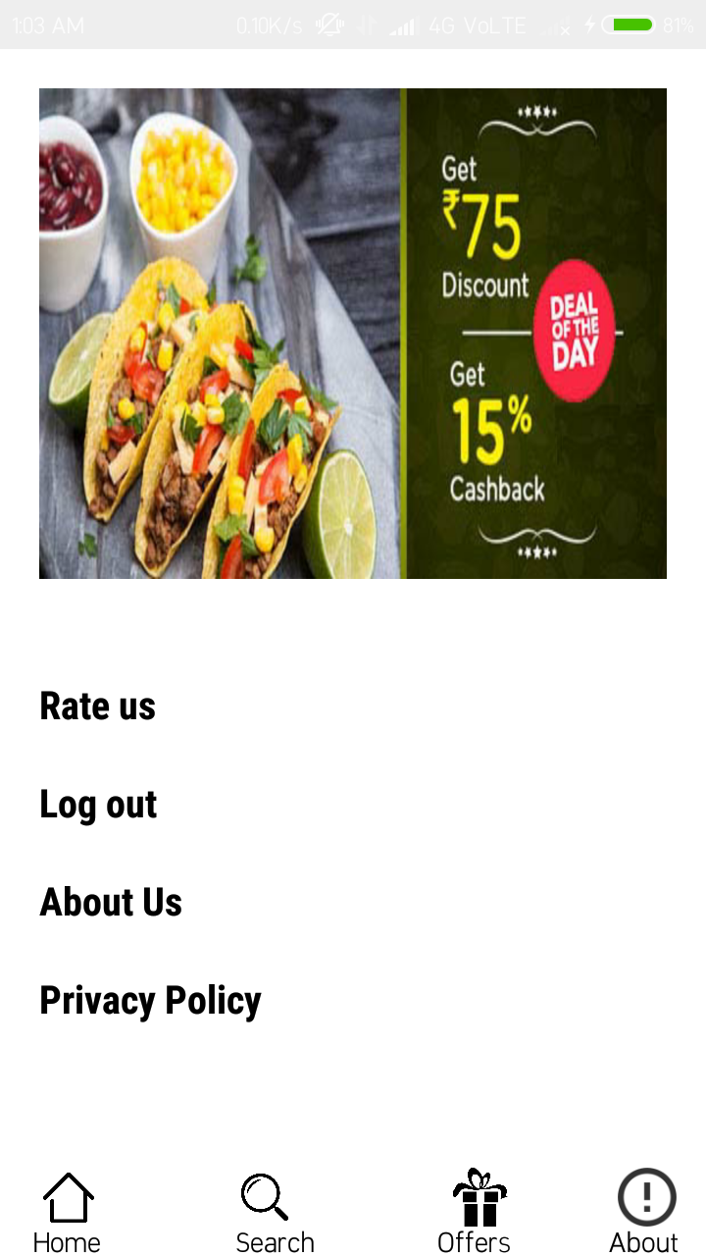

***aboutpage.xml***

|  |
| --- |
| *<?xml version="1.0" encoding="utf-8"?>*  *<RelativeLayout*  *xmlns:android="http://schemas.android.com/apk/res/android" android:layout_width="match_parent"*  *android:layout_height="match_parent">*  *<RelativeLayout*  *android:layout_width="wrap_content"*  *android:layout_height="wrap_content"*  *android:id="@+id/about1">*  *<ImageView*  *android:layout_width="match_parent"*  *android:layout_height="400dp"*  *android:layout_centerHorizontal="true"*  *android:background="@drawable/myphoto"*  */>*  *<TextView*  *android:layout_width="wrap_content"*  *android:layout_height="wrap_content"*  *android:text="(Mohd Arif the Developer of this Application)"*  *android:textStyle="bold"*  *android:textSize="15dp"*  *android:layout_centerHorizontal="true"*  *android:textColor="#000000"*  *android:layout_marginTop="400dp"*  */>*  *</RelativeLayout>*  *<ScrollView*  *android:layout_width="wrap_content"*  *android:layout_height="wrap_content"*  *android:layout_below="@+id/about1"*  *>*  *<RelativeLayout*  *android:layout_width="match_parent"*  *android:layout_height="match_parent">*  *<TextView*  *android:layout_width="wrap_content"*  *android:layout_height="wrap_content"*  *android:text="I am developing this app for general purpose of view in order to make it easier for common people to order beverages and thier favourate items at extremely low prices the main aim of this application was to establish a well productive cafe meetng the people needs.*  *Contact info - +91 8810565494 mail - mohdaarif8299@gmail.com*  *"*  *android:layout_marginLeft="20dp"*  *android:layout_marginRight="30dp"*  *android:textColor="#000000"*  *android:textSize="20dp"*  *android:fontFamily="sans-serif-condensed"*  */>*  *</RelativeLayout>*  *</ScrollView>*  *</RelativeLayout>* |

***AboutPage.java***

|  |
| --- |
| *package com.example.mohdarif.dostea;*  *import android.content.Intent;*  *import android.os.Bundle;*  *import android.support.annotation.Nullable;*  *import android.support.v7.app.AppCompatActivity;*  *public class AboutPage extends AppCompatActivity {*  *@Override*  *protected void onCreate(@Nullable Bundle savedInstanceState) {*  *super.onCreate(savedInstanceState);*  *setContentView(R.layout.aboutpage);*  *}*  *@Override*  *public void onBackPressed() {*  *super.onBackPressed();*  *Intent intent = new Intent(getApplicationContext(),HomePage.class);*  *startActivity(intent);*  *finish();*  *}*  *}* |

***RatingPage***

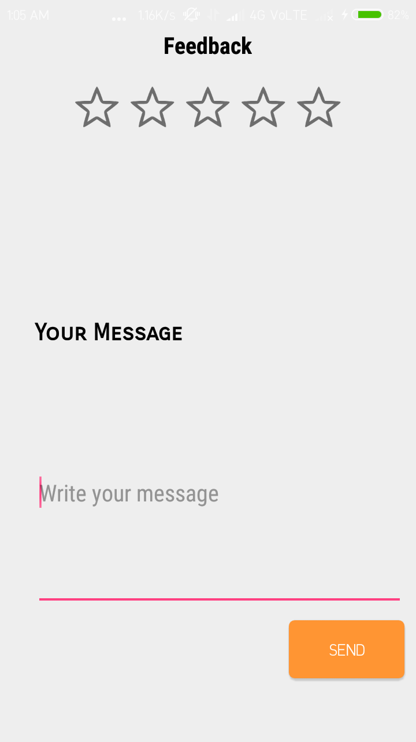

***rating.xml***

|  |
| --- |
| *<?xml version="1.0" encoding="utf-8"?>*  *<RelativeLayout xmlns:android="http://schemas.android.com/apk/res/android"*  *xmlns:app="http://schemas.android.com/apk/res-auto"*  *xmlns:tools="http://schemas.android.com/tools"*  *android:layout_width="match_parent"*  *android:layout_height="match_parent"*  *tools:context=".MainActivity">*  *<TextView*  *android:layout_width="wrap_content"*  *android:layout_height="wrap_content"*  *android:text="Feedback"*  *android:textColor="#000000"*  *android:textSize="20dp"*  *android:textStyle="bold"*  *android:fontFamily="sans-serif-condensed"*  *android:layout_centerHorizontal="true"*  */>*  *<RatingBar*  *android:id="@+id/ratingbar"*  *android:layout_width="wrap_content"*  *android:layout_height="wrap_content"*  *android:layout_alignParentTop="true"*  *android:layout_centerHorizontal="true"*  *android:layout_marginTop="43dp" />*  *<TextView*  *android:layout_width="wrap_content"*  *android:layout_height="wrap_content"*  *android:text="Your Message"*  *android:layout_marginTop="250dp"*  *android:layout_marginLeft="30dp"*  *android:textColor="#000000"*  *android:fontFamily="sans-serif-smallcaps"*  *android:textStyle="bold"*  *android:textSize="20dp"*  */>*  *<EditText*  *android:layout_width="320dp"*  *android:layout_height="200dp"*  *android:hint="Write your message"*  *android:fontFamily="sans-serif-condensed"*  *android:layout_marginTop="300dp"*  *android:layout_marginLeft="30dp"*  *android:textColor="#000000"*  *android:textSize="20dp"*  */>*  *<Button*  *android:id="@+id/button"*  *android:layout_width="100dp"*  *android:layout_height="50dp"*  *android:background="@drawable/confirm_button"*  *android:text="send"*  *android:layout_marginTop="510dp"*  *android:layout_marginLeft="250dp"*  *android:textColor="#ffffff"*  */>*  *</RelativeLayout>* |

***RateUs.java***

|  |
| --- |
| *package com.example.mohdarif.dostea;*  *import android.content.Intent;*  *import android.support.v7.app.AppCompatActivity;*  *import android.media.Rating;*  *import android.support.v7.app.AppCompatActivity;*  *import android.os.Bundle;*  *import android.view.View;*  *import android.widget.Button;*  *import android.widget.RatingBar;*  *import android.widget.Toast;*  *public class RateUs extends AppCompatActivity {*  *RatingBar ratingBar;*  *Button button;*  *@Override*  *protected void onCreate(Bundle savedInstanceState) {*  *super.onCreate(savedInstanceState);*  *setContentView(R.layout.rate_us);*  *addListenerOnButtonClick();*  *}*  *public void addListenerOnButtonClick() {*  *ratingBar = (RatingBar)findViewById(R.id.ratingbar);*  *button = (Button)findViewById(R.id.button);*  *button.setOnClickListener(new View.OnClickListener() {*  *@Override*  *public void onClick(View v) {*  *Toast.makeText(getApplicationContext(),"Thanks for your feedback",Toast.LENGTH_LONG).show();*  *Intent intent = new Intent(getApplicationContext(),HomePage.class);*  *startActivity(intent);*  *finish();*  *}*  *});*  *}*  *@Override*  *public void onBackPressed() {*  *super.onBackPressed();*  *Intent intent = new Intent(getApplicationContext(),HomePage.class);*  *startActivity(intent);*  *finish();*  *}*  *}* |

***AboutUs***

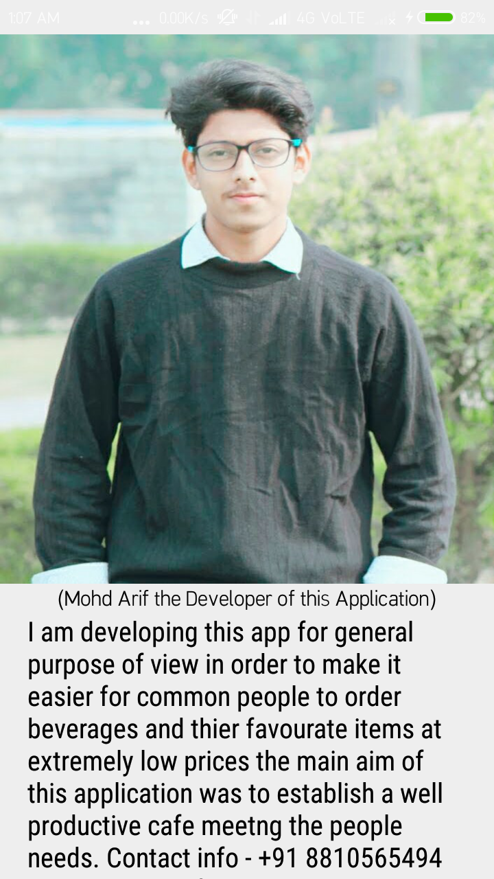

***aboutus.xml***

|  |
| --- |
| *<?xml version="1.0" encoding="utf-8"?>*  *<RelativeLayout*  *xmlns:android="http://schemas.android.com/apk/res/android" android:layout_width="match_parent"*  *android:layout_height="match_parent">*  *<RelativeLayout*  *android:layout_width="wrap_content"*  *android:layout_height="wrap_content"*  *android:id="@+id/about1">*  *<ImageView*  *android:layout_width="match_parent"*  *android:layout_height="400dp"*  *android:layout_centerHorizontal="true"*  *android:background="@drawable/myphoto"*  */>*  *<TextView*  *android:layout_width="wrap_content"*  *android:layout_height="wrap_content"*  *android:text="(Mohd Arif the Developer of this Application)"*  *android:textStyle="bold"*  *android:textSize="15dp"*  *android:layout_centerHorizontal="true"*  *android:textColor="#000000"*  *android:layout_marginTop="400dp"*  */>*  *</RelativeLayout>*  *<ScrollView*  *android:layout_width="wrap_content"*  *android:layout_height="wrap_content"*  *android:layout_below="@+id/about1"*  *>*  *<RelativeLayout*  *android:layout_width="match_parent"*  *android:layout_height="match_parent">*  *<TextView*  *android:layout_width="wrap_content"*  *android:layout_height="wrap_content"*  *android:text="I am developing this app for general purpose of view in order to make it easier for common people to order beverages and thier favourate items at extremely low prices the main aim of this application was to establish a well productive cafe meetng the people needs.*  *Contact info - +91 8810565494 mail - mohdaarif8299@gmail.com*  *"*  *android:layout_marginLeft="20dp"*  *android:layout_marginRight="30dp"*  *android:textColor="#000000"*  *android:textSize="20dp"*  *android:fontFamily="sans-serif-condensed"*  */>*  *</RelativeLayout>*  *</ScrollView>*  *</RelativeLayout>* |

***AboutUs.java***

|  |
| --- |
| *package com.example.mohdarif.dostea;*  *import android.content.Intent;*  *import android.os.Bundle;*  *import android.support.annotation.Nullable;*  *import android.support.v7.app.AppCompatActivity;*  *public class AboutPage extends AppCompatActivity {*  *@Override*  *protected void onCreate(@Nullable Bundle savedInstanceState) {*  *super.onCreate(savedInstanceState);*  *setContentView(R.layout.aboutpage);*  *}*  *@Override*  *public void onBackPressed() {*  *super.onBackPressed();*  *Intent intent = new Intent(getApplicationContext(),HomePage.class);*  *startActivity(intent);*  *finish();*  *}*  *}* |

***Privacy Policy***

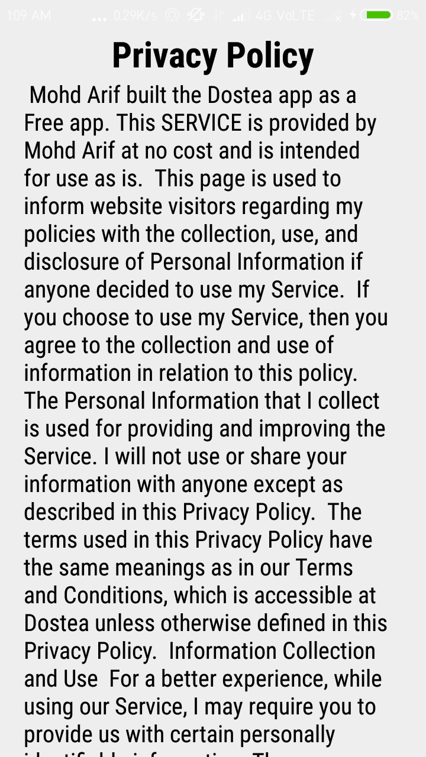

***privacypolicy.xml***

|  |
| --- |
| *<?xml version="1.0" encoding="utf-8"?>*  *<RelativeLayout*  *xmlns:android="http://schemas.android.com/apk/res/android" android:layout_width="match_parent"*  *android:layout_height="match_parent">*  *<RelativeLayout*  *android:layout_width="match_parent"*  *android:layout_height="wrap_content"*  *android:layout_alignParentTop="true"*  *android:id="@+id/header"*  *>*  *<TextView*  *android:layout_width="wrap_content"*  *android:layout_height="wrap_content"*  *android:text="Privacy Policy"*  *android:fontFamily="sans-serif-condensed"*  *android:textColor="#000000"*  *android:layout_centerHorizontal="true"*  *android:textSize="30dp"*  *android:textStyle="bold"*  */>*  *</RelativeLayout>*  *<ScrollView*  *android:layout_width="match_parent"*  *android:layout_height="match_parent"*  *android:layout_marginLeft="20dp"*  *android:layout_marginRight="30dp"*  *android:layout_below="@+id/header"*  *>*  *<TextView*  *android:layout_width="wrap_content"*  *android:layout_height="wrap_content"*  *android:layout_centerVertical="true"*  *android:textAlignment="textStart"*  *android:textSize="20dp"*  *android:textColor="#000000"*  *android:fontFamily="sans-serif-condensed"*  *android:text="*  *Mohd Arif built the Dostea app as a Free app. This SERVICE is provided by Mohd Arif at no cost and is intended for use as is.*  *This page is used to inform website visitors regarding my policies with the collection, use, and disclosure of Personal Information if anyone decided to use my Service.*  *If you choose to use my Service, then you agree to the collection and use of information in relation to this policy. The Personal Information that I collect is used for providing and improving the Service. I will not use or share your information with anyone except as described in this Privacy Policy.*  *The terms used in this Privacy Policy have the same meanings as in our Terms and Conditions, which is accessible at Dostea unless otherwise defined in this Privacy Policy.*  *Information Collection and Use*  *For a better experience, while using our Service, I may require you to provide us with certain personally identifiable information. The information that I request is retained on your device and is not collected by me in any way*  *The app does use third party services that may collect information used to identify you.*  *Link to privacy policy of third party service providers used by the app*  *Google Play Services*  *Log Data*  *I want to inform you that whenever you use my Service, in a case of an error in the app I collect data and information (through third party products) on your phone called Log Data. This Log Data may include information such as your device Internet Protocol (“IP”) address, device name, operating system version, the configuration of the app when utilizing my Service, the time and date of your use of the Service, and other statistics.*  *Cookies*  *Cookies are files with a small amount of data that are commonly used as anonymous unique identifiers. These are sent to your browser from the websites that you visit and are stored on your device's internal memory.*  *This Service does not use these “cookies” explicitly. However, the app may use third party code and libraries that use “cookies” to collect information and improve their services. You have the option to either accept or refuse these cookies and know when a cookie is being sent to your device. If you choose to refuse our cookies, you may not be able to use some portions of this Service.*  *Service Providers*  *I may employ third-party companies and individuals due to the following reasons:*  *To facilitate our Service;*  *To provide the Service on our behalf;*  *To perform Service-related services; or*  *To assist us in analyzing how our Service is used.*  *I want to inform users of this Service that these third parties have access to your Personal Information. The reason is to perform the tasks assigned to them on our behalf. However, they are obligated not to disclose or use the information for any other purpose.*  *Security*  *I value your trust in providing us your Personal Information, thus we are striving to use commercially acceptable means of protecting it. But remember that no method of transmission over the internet, or method of electronic storage is 100% secure and reliable, and I cannot guarantee its absolute security.*  *Links to Other Sites*  *This Service may contain links to other sites. If you click on a third-party link, you will be directed to that site. Note that these external sites are not operated by me. Therefore, I strongly advise you to review the Privacy Policy of these websites. I have no control over and assume no responsibility for the content, privacy policies, or practices of any third-party sites or services.*  *Children’s Privacy*  *These Services do not address anyone under the age of 13. I do not knowingly collect personally identifiable information from children under 13. In the case I discover that a child under 13 has provided me with personal information, I immediately delete this from our servers. If you are a parent or guardian and you are aware that your child has provided us with personal information, please contact me so that I will be able to do necessary actions.*  *Changes to This Privacy Policy*  *I may update our Privacy Policy from time to time. Thus, you are advised to review this page periodically for any changes. I will notify you of any changes by posting the new Privacy Policy on this page. These changes are effective immediately after they are posted on this page.*  *Contact Us*  *If you have any questions or suggestions about my Privacy Policy, do not hesitate to contact me.*  *This privacy policy page was created at privacypolicytemplate.net and modified/generated by App Privacy Policy Generator"*  */>*  *</ScrollView>*  *</RelativeLayout>* |

***PrivacyPolicy.java***

|  |
| --- |
| *package com.example.mohdarif.dostea;*  *import android.content.Intent;*  *import android.os.Bundle;*  *import android.support.annotation.Nullable;*  *import android.support.v7.app.AppCompatActivity;*  *public class PPolicy extends AppCompatActivity {*  *@Override*  *protected void onCreate(@Nullable Bundle savedInstanceState) {*  *super.onCreate(savedInstanceState);*  *setContentView(R.layout.privacy);*  *}*  *@Override*  *public void onBackPressed() {*  *super.onBackPressed();*  *Intent intent = new Intent(getApplicationContext(),HomePage.class);*  *startActivity(intent);*  *finish();*  *}*  *}* |